Home Learning- Year 2
If you are feeling well enough, please pick an activity from maths and English. Then choose one other lesson to enjoy each day. Please send some photos or bring any work you are able to complete back to school with you.

Maths
Monday-Friday
Log in to PowerMaths Active Learn (Log in details are in your Reading journal) https://www.activelearnprimary.com.au/login?e=-1&c=0
Click on Resources>PowerMaths on the green banner, click on year 2 and under TYPE choose Textbook 2B for explanations and Workbook 2B for questions.
Work through the following lessons covering properties of shape.
PowerMaths
Textbook 2B Unit 9 lessons 6-10 pp. 124-143
Workbook 2B Unit 9 lessons 6-10 pp. 90-103

English
Monday
This lesson we are going to compare the two ‘Rapunzel’ stories we have been learning about.
Remind yourself of each story:
https://www.youtube.com/watch?v=12OPa2hL914
https://www.youtube.com/watch?v=Xd97k149tvo
What is the same about these two stories?
What is different about these two stories?
Think about the following: characters, settings, main events and the ending.

Tuesday
Create a list of all the fairytales and traditional tales you know of. What makes a successful fairytale? Mind map all of your ideas. Consider characters, events, lessons, settings and endings.

Thursday
Today you are going to plan your very own fairytale. You can create a story map or story mountain to record your ideas. Things to include:
-Characters (hero and villain)
-Setting- where does this story take place?
-Problem-what goes wrong?
-Resolution- how is the problem solved/fixed?
-Ending
Friday
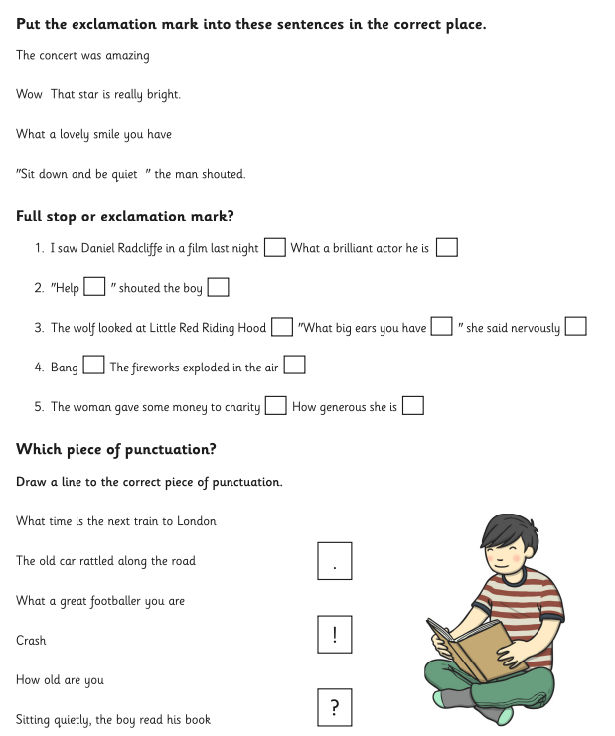

Other activities that you can choose from:
Grammar, Punctuation and Spelling:
https://www.bbc.co.uk/bitesize/topics/zkxxsbk
https://www.topmarks.co.uk/english-games/5-7-years/letters-and-sounds
https://spellingframe.co.uk/
https://sentenceplay.co.uk/games/dropping-in
Text Types/Genres:
https://classroom.thenational.academy/subjects-by-key-stage/key-stage-1/subjects/english

Wednesday- Challenge Day
Think carefully about your local community. Can you think of an area that is not supporting wildlife? For example, an area where the grass is always cut and nothing can grow? Make a list of ten things you could introduce to the area to improve the habitat for wildlife to thrive. Can you design and make a shoe-box habitat to show how you would like the area to look.

Tuesday P.E
We will be learning more gym movements which is hard to do at home.
Do some warm ups (with an adult) to stretch your muscles and get your heart pumping.
Then, to ensure you get some exercise visit YouTube and do a session 5 times a week of Joe Wicks/Go Noddle/Cosmic Kids Yoga.

Thursday- Science
Look through some pictures of you and your family as babies. The human life cycle happens to all of us. We first grow inside our mothers, then we are born as a baby… What comes after being a baby?
Watch these videos and draw the different stages of the human life cycle.
https://www.youtube.com/watch?v=FfBfk4bTUhY
https://www.youtube.com/watch?v=egeDXHcNeNw
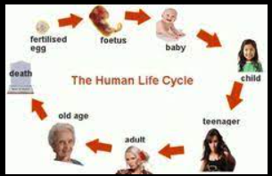

Friday - RE
Look at the picture of salvation from The Big Freeze.
What can you see?
Do you notice any of the Easter symbols we have studied?
What do you think the road and bridge symbolise?
What do you think the coloured area in the corner represents?
Jesus wants Christians to rescue those who are suffering.
Can you think of ways that Christians can help these that are suffering?
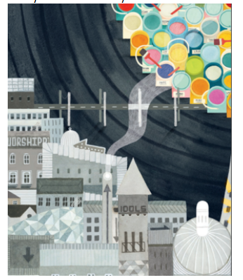

Daily
Keep reading!
Read a magazine/newspaper article.
Arithmetic (20 minutes a day) – Count in 2s 5s and 10s
Watch Newsround
Phonics – Play a phonics phase 3 and 5 game on phonics play.
https://www.phonicsplay.co.uk/resources/phase/3

Times Tables – practise your times tables as much as you can!
Useful websites for times tables:
https://www.topmarks.co.uk/maths-games/7-11-years/times-tables
https://www.timestables.co.uk/

French
Use the powerpoint attached to learn the school subjects in French
- Practise numbers 1-31 in French. Have a go playing these games and familiarising yourself with the spelling/reading of the words. You can play interactive games, watch videos or create posters/flashcards to help you.
https://wordwall.net/resource/3027772/french/french-numbers-1-30
https://www.bbc.co.uk/bitesize/topics/zpy8q6f/resources/1
- Revise months of the year in French
- Revise colours in French
https://www.youtube.com/watch?v=acvUtipaC5Y

