This week’s learning 21.03.22
Spellings - This week’s spellings are – flowers, apples, dishes, peaches, clouds

Your spelling rule - Adding s and es to words (plurals) If the ending sounds like /s/ or /z/, it is spelled as –s. If it forms an extra syllable, then it is spelled as –es.
Monday
Maths – Comparing lengths and heights. Complete the attached sheet.
English – Look at the following picture of the masked lady. Who do you think she is? What do you think she is doing? Make a wanted poster for her to display in the Art Gallery to help Claude.

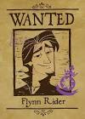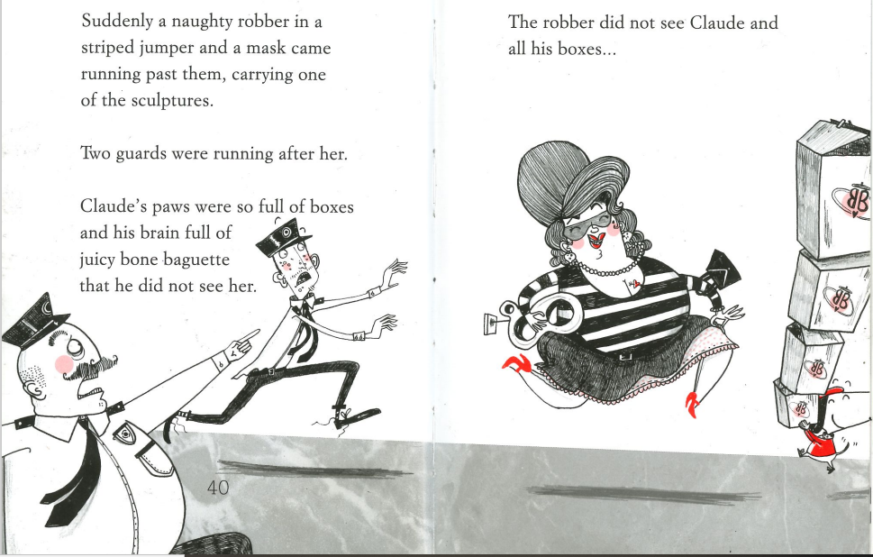

Science – Find some objects around your house and sort them into materials – metal, plastic and fabric. Maybe you could write a sentence about their properties, bendy, hard, smooth etc.

Phonics – Play a phonics phase 4 and 5 game on phonics play.
https://www.phonicsplay.co.uk/resources/phase/5/buried-treasure
Tuesday
Maths – Non-standard unit of measure. Get a group of toys and objects around your house and measure them all with the same unit of measure. For example - the teddy is 12 coins high, the toy plane is 8 paperclips long.
English – Write a prediction of how you think the story of Claude in the city will end. If you can’t remember the beginning take a look at this link - https://www.youtube.com/watch?v=aMZhxYGvdjc
Global Learning – Look at the attached PowerPoint and imagine what your own sustainable garden would include and design it. Remember compost bins, solar powered lights and not forgetting the hedgerow for all of the wildlife and bees.

Phonics – Play a phonics phase 4 and 5 game on phonics play.
https://www.phonicsplay.co.uk/resources/phase/5/buried-treasure
Wednesday
Maths – Non-standard unit of measure. Find larger objects around your house and measure them using your hand spans or the length of your foot.
English – Look at the picture and write some descriptive sentences. Don’t forget your capital letters, finger spaces and full stops. Remember all your material properties from your Science lesson.


French - https://www.youtube.com/watch?v=pfkQ9e10sT0
Phonics – Play a phonics phase 4 and 5 game on phonics play.
https://www.phonicsplay.co.uk/resources/phase/5/buried-treasure

Thursday
Maths – Measuring using a ruler. Measure different objects around your house using a ruler.

English – Complete the attached comprehension. Read the text and answer the questions.

RE – Watch the Easter story, what can you remember about why it is such an important event for Christians. https://www.youtube.com/watch?v=Wnbo2AmS3OI

Phonics – Play a phonics phase 4 and 5 game on phonics play.
https://www.phonicsplay.co.uk/resources/phase/5/buried-treasure

Friday
Maths – Practise your maths skills by playing some games on your Abacus account. There are lots to choose from! https://www.activelearnprimary.co.uk/login?c=0 (Log ins are in the children’s reading diaries and the school code is kmm7).

Phonics – Play a phonics phase 4 and 5 game on phonics play.
https://www.phonicsplay.co.uk/resources/phase/5/buried-treasure

English – (SPAG) Practice your handwriting using the year 1 common exception words and/or high frequency words.
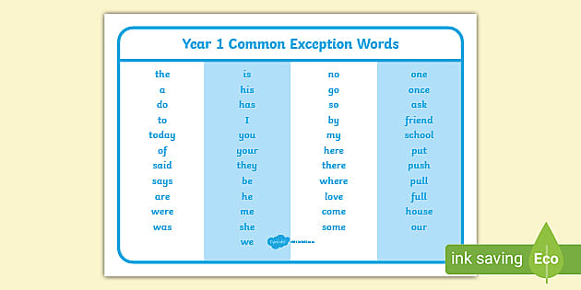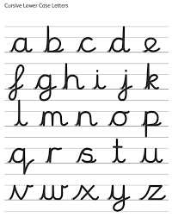
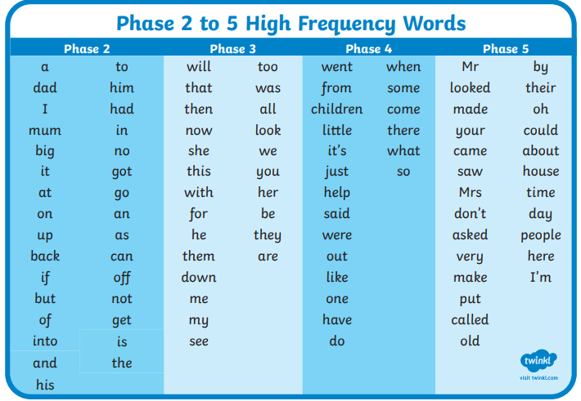
Daily
Abacus - https://www.activelearnprimary.co.uk/login?c=0 (Log ins are in the children’s reading diaries and the school code is kmm7).
Keep reading!
Read a magazine/newspaper article.
Arithmetic (20 minutes a day) – Count to 100 aloud whist doing body percussion, challenge yourself and now count in tens.
Phonics – Play a phonics phase 4 and 5 game on phonics play.
https://www.phonicsplay.co.uk/resources/phase/5/buried-treasure

Practice your typing skills
https://www.bbc.co.uk/bitesize/topics/zf2f9j6/articles/z3c6tfr

PE
Visit Youtube and do a session 5 times a week of Joe Wicks/Go Noodle/Cosmic Kids Yoga.

