Home Learning- Year 2
If you are feeling well enough, please pick an activity from maths and English. Then choose one other lesson to enjoy each day. Please send some photos or bring any work you are able to complete back to school with you.

Maths
Monday-Friday
Log in to PowerMaths Active Learn (Log in details are in your Reading journal) https://www.activelearnprimary.com.au/login?e=-1&c=0
Click on Resources>PowerMaths on the green banner, click on year 2 and under TYPE choose Textbook 2B for explanations and Workbook 2B for questions.
Work through the following lessons covering data handling tally charts and pictograms
PowerMaths
Textbook 2B Unit 8 lessons 1-5 p78-101
Workbook 2B Unit 8 lesson5 1-5 p58-74

English
Monday
Co-ordinating conjunctions
Use this website to learn about co-ordinating conjunctions and the play the quiz to check your understanding.
Tuesday
Plan a diary entry pretending you are Rapunzel to explain all about the day that the Witch climbed up your hair and came in the tower. Think about how you feel when you see her coming towards the tower, when she brushes your hair and how you feel when she cuts your hair to sell it. Make a list of the events of the day and then write next to each event how you
Thursday
Write your diary entry today. Remember your diary is your friend and your language can be friendly and informal.
Friday
Revise the use of subordinating conjunctions using this website.
https://www.bbc.co.uk/bitesize/topics/zwwp8mn/articles/zqk37p3

Other activities that you can choose from:
Grammar, Punctuation and Spelling:
https://www.bbc.co.uk/bitesize/topics/zkxxsbk
https://www.topmarks.co.uk/english-games/5-7-years/letters-and-sounds
https://spellingframe.co.uk/
https://sentenceplay.co.uk/games/dropping-in
Text Types/Genres:
https://classroom.thenational.academy/subjects-by-key-stage/key-stage-1/subjects/english

Wednesday Topic day

Using an atlas can you draw a map of the world and colour each continent in a different colour. Label each continent carefully.
Make a list ordering the continents from smallest to largest.
Research the journey of The Titanic.

Tuesday P.E
We will be learning more gym movements which is hard to do at home.
Do some warm ups (with an adult) to stretch your muscles and get your heart pumping.
Then, to ensure you get some exercise visit YouTube and do a session 5 times a week of Joe Wicks/Go Noddle/Cosmic Kids Yoga.

Thursday- Science
What is the difference between a habitat and a microhabitat?
Use the sheet attached to describe different habitats. In the 4th box can you draw a microhabitat?
Extension
Can you describe a food chain in the picture below?
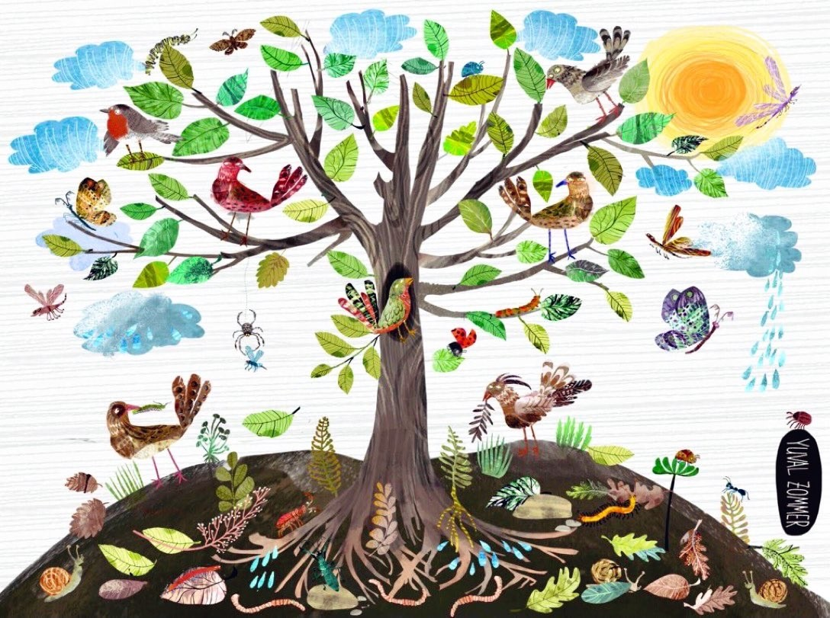

Friday - RE
Make a story map of the Easter Story, make sure you include the Last Supper and Jesus’s trial. Can you add the Easter Symbols that we thought about last week in RE.

Daily
Keep reading!
Read a magazine/newspaper article.
Arithmetic (20 minutes a day) – Count in 2s 5s and 10s
Watch Newsround
Phonics – Play a phonics phase 3 and 5 game on phonics play.
https://www.phonicsplay.co.uk/resources/phase/3

Times Tables – practise your times tables as much as you can!
Useful websites for times tables:
https://www.topmarks.co.uk/maths-games/7-11-years/times-tables
https://www.timestables.co.uk/
French
Use the powerpoint attached to learn the school subjects in French
- Practise numbers 1-31 in French. Have a go playing these games and familiarising yourself with the spelling/reading of the words. You can play interactive games, watch videos or create posters/flashcards to help you.
https://wordwall.net/resource/3027772/french/french-numbers-1-30
https://www.bbc.co.uk/bitesize/topics/zpy8q6f/resources/1
- Revise months of the year in French
- Revise colours in French
https://www.youtube.com/watch?v=acvUtipaC5Y

