This week’s learning 07.03.22
Spellings - This week’s spellings are – catch, hutch, fetch, witch, patch.

Your spelling rule – tch follows a short vowel.

Monday
Maths – Tens and ones. Please complete the attached worksheet.
English – Make your city poem. You can use this poem to inspire you and listen to the sounds of the city in the following link. Don’t forget to use your sense.
This is the city
buildings, buses, trains and cars
concrete, metal, bricks and glass
houses, lights and cinemas
shops and offices and bars
this is where the people are.
This is the city.
By Kathy Henderson
https://www.youtube.com/watch?v=LZbEIxhiJRM

Science – Make a kite and explore at different times of the day and/or different days if the wind always blows in the same direction.
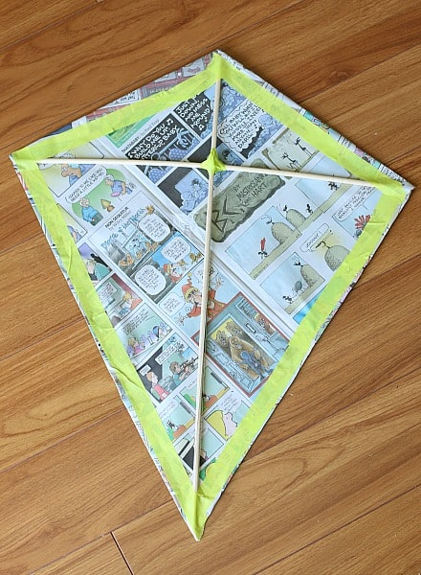

Phonics – Play a phonics phase 4 and 5 game on phonics play.
https://www.phonicsplay.co.uk/resources/phase/5/buried-treasure
Tuesday
Maths – Representing numbers to 50. Complete the attached sheet.
English – Draw a picture of Claude’s tour of the city. Include all the shops he found on the way –
Shoe shop, loo shop, chip shop, chop shop (butcher’s shop), Betty’s Beret boutique, fancy café, roads and other buildings.

Global Learning – We are learning about how houses were built during the Tudor times. See if you can make a wall with a wattle and daub affect, maybe you can use pasta and playdough. You can also research why Buckden Towers were built.

Phonics – Play a phonics phase 4 and 5 game on phonics play.
https://www.phonicsplay.co.uk/resources/phase/5/buried-treasure
Wednesday
Maths – Comparing numbers of objects to 50. Complete the attached sheet.
English – Write a postcode to Mr and Mrs Shiney shoes from Claude and Sir Bobblysock about your tour of the city.

French - https://www.youtube.com/watch?v=pfkQ9e10sT0
Phonics – Play a phonics phase 4 and 5 game on phonics play.
https://www.phonicsplay.co.uk/resources/phase/5/buried-treasure

Thursday
Maths – Comparing numbers. Complete the attached sheet.

English – Comprehension – See attached text and answer the questions.

RE – Watch the Easter story, what can you remember about why it is such an important event for Christians. https://www.youtube.com/watch?v=Wnbo2AmS3OI

Phonics – Play a phonics phase 4 and 5 game on phonics play.
https://www.phonicsplay.co.uk/resources/phase/5/buried-treasure

Friday
Maths – Practise your maths skills by playing some games on your Abacus account. There are lots to choose from! https://www.activelearnprimary.co.uk/login?c=0 (Log ins are in the children’s reading diaries and the school code is kmm7).

Phonics – Play a phonics phase 4 and 5 game on phonics play.
https://www.phonicsplay.co.uk/resources/phase/5/buried-treasure

English – (SPAG) Practice your handwriting using the year 1 common exception words and/or high frequency words.
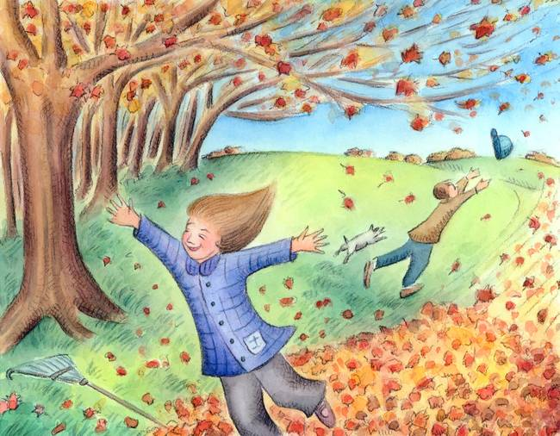
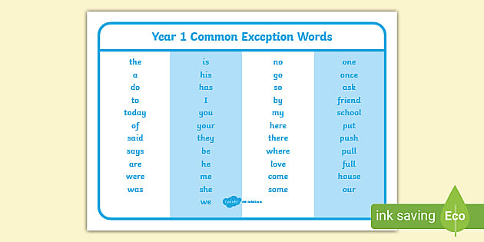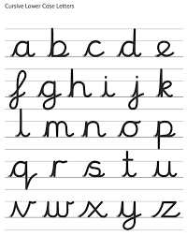
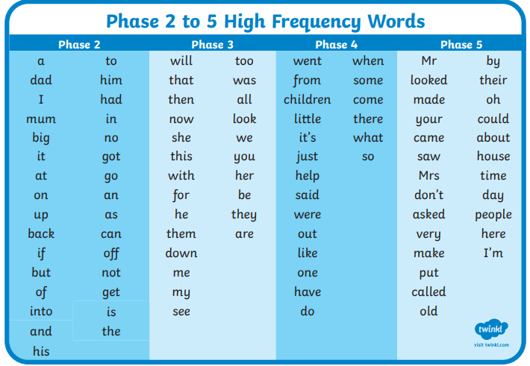
Daily
Abacus - https://www.activelearnprimary.co.uk/login?c=0 (Log ins are in the children’s reading diaries and the school code is kmm7).
Keep reading!
Read a magazine/newspaper article.
Arithmetic (20 minutes a day) – Count to 100 aloud whist doing body percussion, challenge yourself and now count in tens.
Phonics – Play a phonics phase 4 and 5 game on phonics play.
https://www.phonicsplay.co.uk/resources/phase/5/buried-treasure

Practice your typing skills
https://www.bbc.co.uk/bitesize/topics/zf2f9j6/articles/z3c6tfr

PE
Visit Youtube and do a session 5 times a week of Joe Wicks/Go Noodle/Cosmic Kids Yoga.

