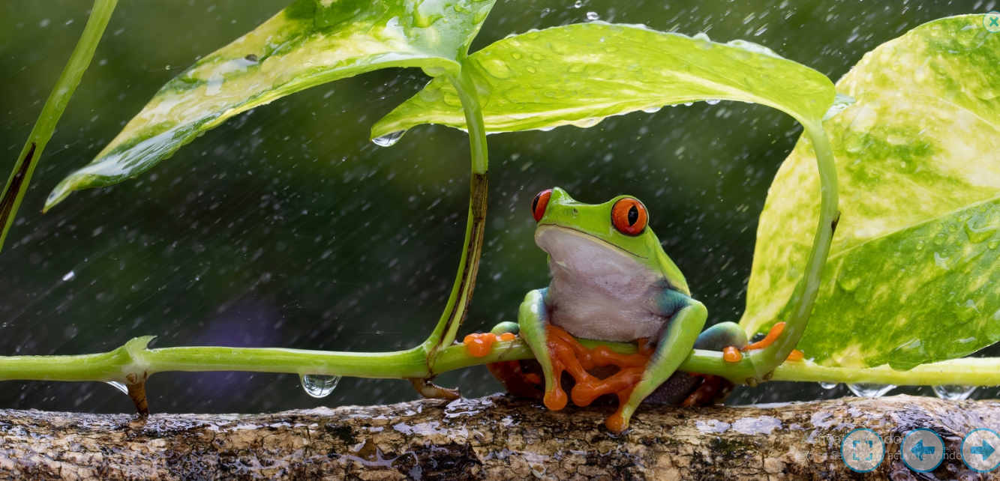

Read the story below and continue:

It was another stiflingly humid day in the rainforest. The rain was a welcome and refreshing break from it. Kermit could hear a rumble of distant thunder: a sure sign that this was just the beginning of the storm. Sheltering under a lush leaf, he sat comfortably on the tree stump. Raindrops drummed on the flat surface of the leaf like impatient fingertips but Kermit didn’t mind.
He stared into the forest, wondering when his companions would return…

