Home Learning- Year 2
If you are feeling well enough, please pick an activity from maths and English. Then choose one other lesson to enjoy each day. Please send some photos or bring any work you are able to complete back to school with you.

Maths
Monday-Friday
Log in to PowerMaths Active Learn (Log in details are in your Reading journal) https://www.activelearnprimary.com.au/login?e=-1&c=0
Click on Resources>PowerMaths on the green banner, click on year 2 and under TYPE choose Textbook 2B for explanations and Workbook 2B for questions.
Work through the following lessons covering data handling tally charts and pictograms
PowerMaths
Textbook 2A Unit 7 lessons p2-6
Workbook 2B Unit 7 lesson p46-71

English
Monday
https://www.youtube.com/watch?v=n_foMADqjSc
Watch the video above that explains the 4 types of sentence that you can use when you write.
Now try to write a sentence of each type of your own.
Tuesday
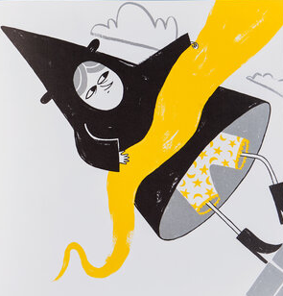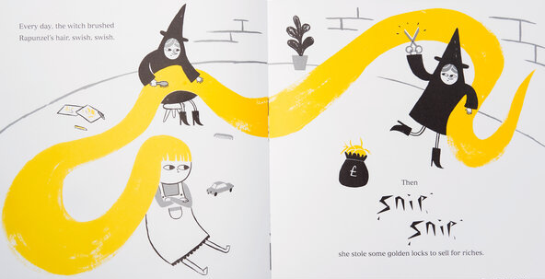
Look at these pictures and start to describe what you notice about Rapunzel and the witch.
What is your opinion of Rapunzel and the witch?
e.g. The rich is unkind because she sells Rapunzel’s hair.
Thursday
See the beach habitat comprehension attached.
Friday
Look at the character’s facial expressions and explain how they are feeling and why?
e.g. The witch is angry because her eyebrows are pointing downwards.
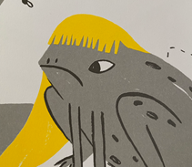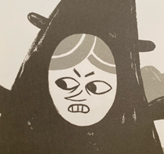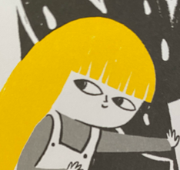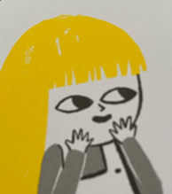

Other activities that you can choose from:
Grammar, Punctuation and Spelling:
https://www.bbc.co.uk/bitesize/topics/zkxxsbk
https://www.topmarks.co.uk/english-games/5-7-years/letters-and-sounds
https://spellingframe.co.uk/
https://sentenceplay.co.uk/games/dropping-in
Text Types/Genres:
https://classroom.thenational.academy/subjects-by-key-stage/key-stage-1/subjects/english

Wednesday Topic day

Sort pictures of the people and the rooms on the Titanic into what you might think are 1st, 2nd and 3rd class.

See the sheets attached to explore the structure of the Titanic and colour in the areas that are 1st, 2nd and 3rd class.

What do you know now about the titanic that you didn’t know before?

Was there equality or inequality on the Titanic?

Tuesday P.E
We will be learning more gym movements which is hard to do at home.
Do some warm ups (with an adult) to stretch your muscles and get your heart pumping.
Then, to ensure you get some exercise visit YouTube and do a session 5 times a week of Joe Wicks/Go Noddle/Cosmic Kids Yoga.

Thursday- Science

How do you look after your pet (choose a different animal to the one you researched at school)?

Interview somebody you know about how they look after their pet.
If you have some books at hand, look up anything you would still like to know, maybe research a particular question you have using the internet with an adult’s permission and help.

Prepare a pet owner’s guide using the templates attached.

Deeper thinking extensions:
Compare the types of food that different animals require.
Explain the concept of humans’ need for clean water and why this is not so important for other animals.
What did I use to help me today?
Friday - RE
Recap the Easter story,
https://www.bbc.co.uk/teach/class-clips-video/religious-studies-ks1-the-christian-story-of-easter/zhgv47h
Make a story mountain to retell the important parts of the story.

Use second video to
Include cleansing of the temple, the Last Supper, Jesus’ trial.
https://www.google.com/search?q=lego+video+for+easter+story&rlz=1C1GCEU_enGB974GB974&oq=lego+video+for+easter+story&aqs=chrome..69i57.7854j0j15&sourceid=chrome&ie=UTF-8
Now decide what you think are the most interesting, puzzling, enjoyable, upsetting, and most important moments, and why.
Daily
Keep reading!
Read a magazine/newspaper article.
Arithmetic (20 minutes a day) – Count in 2s 5s and 10s
Watch Newsround
Phonics – Play a phonics phase 3 and 5 game on phonics play.
https://www.phonicsplay.co.uk/resources/phase/3

Times Tables – practise your times tables as much as you can!
Useful websites for times tables:
https://www.topmarks.co.uk/maths-games/7-11-years/times-tables
https://www.timestables.co.uk/
French
Use the powerpoint attached to learn the school subjects in French
- Practise numbers 1-31 in French. Have a go playing these games and familiarising yourself with the spelling/reading of the words. You can play interactive games, watch videos or create posters/flashcards to help you.
https://wordwall.net/resource/3027772/french/french-numbers-1-30
https://www.bbc.co.uk/bitesize/topics/zpy8q6f/resources/1
- Revise months of the year in French
- Revise colours in French
https://www.youtube.com/watch?v=acvUtipaC5Y

