This week’s learning 28.02.22
Spellings - This week’s spellings are - bank, honk, think, skin, basket.

Your spelling rule - sound is spelt as k rather than as c before e, i and y.

Monday
Maths – Addition and subtraction word problems. Complete the attached sheet.
English – What adventures do you think Claude and Sir Bobblysock will have? Where will they go? What will they do there? Now draw a picture of Claude and Sir Bobblysock on their adventure and add a thought bubble to explain where they are.
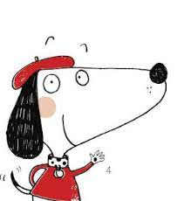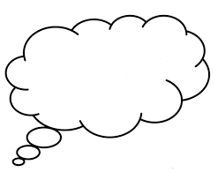

Science – Watch JoJo and GranGran https://www.bbc.co.uk/iplayer/episode/m000nqtw/sign/jojo-gran-gran-autumn-1-its-time-for-autumn-leaves?seriesId=m000ghpw
Create a seasons art picture of an Autumn tree - (If you can you could do a brown leaf rubbings).
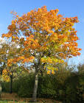

Phonics – Play a phonics phase 4 and 5 game on phonics play.
https://www.phonicsplay.co.uk/resources/phase/5/buried-treasure
Tuesday
Maths – Numbers to 50. Count aloud to 50. Can you challenge yourself and count backwards? Complete the attached sheet.
English – Think about the character Claude and Sir Bobblysock as they go through the city – Imagine what they can see and hear? How does it feel to be there? Listen to the city soundscape to help you imagine - http://www.youtube.com/watch?v=LZbEIxhiJRM.
Watch a video of a city such as London to help you imagine, what senses are you using? http://www.youtube.com/watch?v=8QANU2VWNTQ
On strips of paper, divided into 5 sections, draw a picture and describe something they could see, hear, touch, taste and smell. Now write how the city makes you feel.
Here are some examples - People rushing everywhere, Cars beeping, lights flashing. Buildings reaching to the sky, the taste of hotdogs fly’s through the air.

Global Learning – Find out what the Tudors are. How is Henry VIII and Catherine of Aragon. Write a fact about them and draw a picture.

Phonics – Play a phonics phase 4 and 5 game on phonics play.
https://www.phonicsplay.co.uk/resources/phase/5/buried-treasure
Wednesday
Maths – Numbers to 50. Complete the attached sheet.
English – Write some sentences describing the Buckden Towers. Don’t forget to use some exciting adjectives, fullstops, fingerspaces and capital letters.
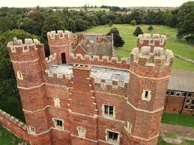
French - https://www.youtube.com/watch?v=pfkQ9e10sT0
Phonics – Play a phonics phase 4 and 5 game on phonics play.
https://www.phonicsplay.co.uk/resources/phase/5/buried-treasure

Thursday
Maths – Count your steps around your house until you get to 50. Where did you finish? Now challenge yourself and count backwards from 50, did you end up where you started?

English – Comprehension – See attached text and answer the questions.

RE – Watch the Easter story, what can you remember about why it is such an important event for Christians. https://www.youtube.com/watch?v=Wnbo2AmS3OI

Phonics – Play a phonics phase 4 and 5 game on phonics play.
https://www.phonicsplay.co.uk/resources/phase/5/buried-treasure

Friday
Maths – Practise your maths skills by playing some games on your Abacus account. There are lots to choose from! https://www.activelearnprimary.co.uk/login?c=0 (Log ins are in the children’s reading diaries and the school code is kmm7).

Phonics – Play a phonics phase 4 and 5 game on phonics play.
https://www.phonicsplay.co.uk/resources/phase/5/buried-treasure

English – (SPAG) Practice your handwriting using the year 1 common exception words and/or high frequency words.
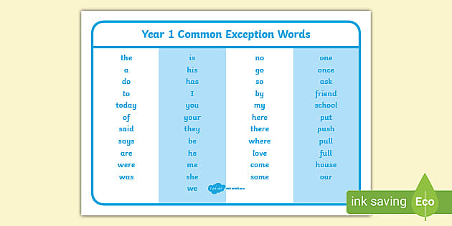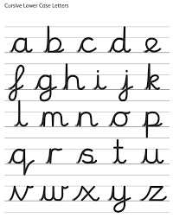
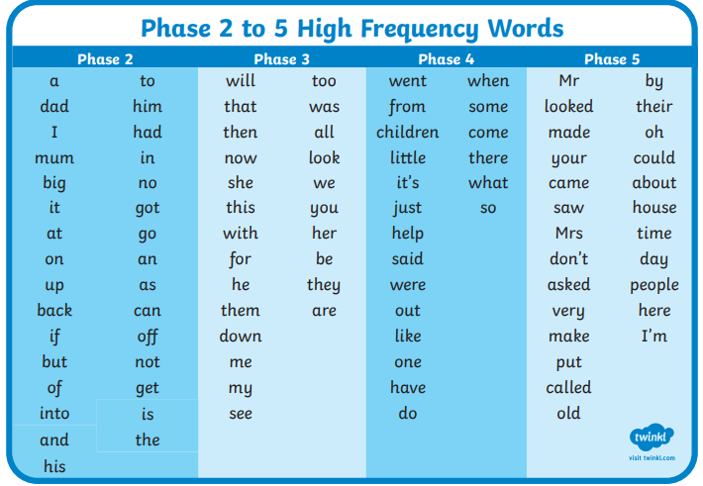
Daily
Abacus - https://www.activelearnprimary.co.uk/login?c=0 (Log ins are in the children’s reading diaries and the school code is kmm7).
Keep reading!
Read a magazine/newspaper article.
Arithmetic (20 minutes a day) – Count to 100 aloud whist doing body percussion, challenge yourself and now count in tens.
Phonics – Play a phonics phase 4 and 5 game on phonics play.
https://www.phonicsplay.co.uk/resources/phase/5/buried-treasure

Practice your typing skills
https://www.bbc.co.uk/bitesize/topics/zf2f9j6/articles/z3c6tfr

PE
Visit Youtube and do a session 5 times a week of Joe Wicks/Go Noodle/Cosmic Kids Yoga.

