This week’s learning 21.02.22
Monday
Maths – Addition and subtraction facts to 20. Complete the attached sheet.
English – Choose an activity from the home learning sheet attached.

Science – https://www.youtube.com/watch?v=CtP83CWOMwc
Watch the video. Build a houses using a range of materials (straws, hay/straw, little twigs or lolly sticks, playdough, clay and Lego), predict which materials is the strongest. Now test your houses by using the hair dryer to see which material lasts the longest.
Tuesday
Maths – Compare addition and subtraction. Complete the attached sheet.
English – Choose an activity from the home learning sheet attached.

Global Learning – Research the UK cities and label them on the attached map.
Wednesday
Maths – Solving word and picture problems, addition and subtraction. Complete the attached sheet.
English – Write some sentences describing the city. Don’t forget to use some exciting adjectives.

French - https://www.youtube.com/watch?v=pfkQ9e10sT0
Thursday
Maths – Addition and subtraction calculation colouring sheet.
English – Comprehension – See attached text and answer the questions.

RE – https://www.youtube.com/watch?v=Wnbo2AmS3OI

Friday
Maths – Practise your maths skills by playing some games on your Abacus account. There are lots to choose from! https://www.activelearnprimary.co.uk/login?c=0 (Log ins are in the children’s reading diaries and the school code is kmm7).
English – (SPAG) Practice your handwriting using the year 1 common exception words.
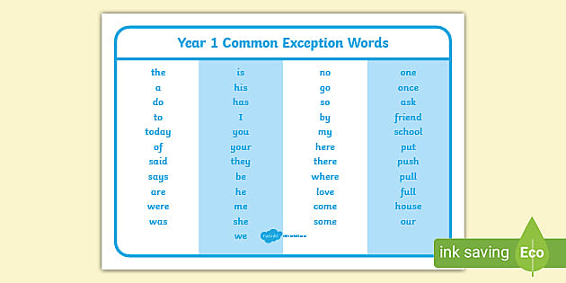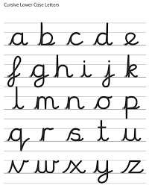
Daily
Abacus - https://www.activelearnprimary.co.uk/login?c=0 (Log ins are in the children’s reading diaries and the school code is kmm7).
Keep reading!
Read a magazine/newspaper article.
Arithmetic (20 minutes a day) – Count to 100 aloud whist doing body percussion, challenge yourself and now count in tens.
Phonics – Play a phonics phase 2 and 3 game on phonics play.
https://www.phonicsplay.co.uk/resources/phase/2/picnic-on-pluto

Practice your typing skills
https://www.bbc.co.uk/bitesize/topics/zf2f9j6/articles/z3c6tfr

PE
Visit Youtube and do a session 5 times a week of Joe Wicks/Go Noodle/Cosmic Kids Yoga.

