Week beg: 04.02.22
Talk homework: Tell an adult about the birds you saw during birdwatch. Why is it important that we report our findings to the RSPB?
Good afternoon all,
We hope you had a lovely week. It’s certainly been a busy week in school.
Today, we did the RSPB school birdwatch. Everyone really enjoyed getting out into nature, exploring not just what birds we have in school but the myriad of nature that grows all around us too. We saw snowdrops in bloom and daffodils yet to flower. We went to the wildlife area and looked at the hedgehog houses and bird feeders.
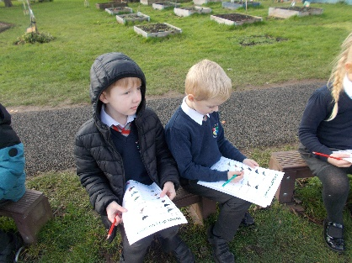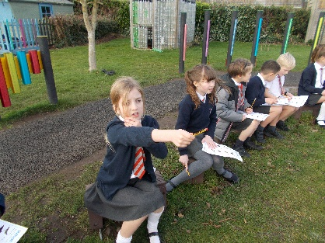

Dylan and James really liked music this week. We created seascapes with a range of musical instruments of our choice. We learned how to record using audio on power point. Once we had all recorded our seascapes, we went inside to listen and critique them.
Sonny enjoyed dance this week, where we explored deep sea divers, shipwrecks and movement in our lesson.
Ellie-Louise enjoyed writing our setting descriptions in English. We improved every day and have just written an independent write today. We are still finding writing in 3rd person narrative a little tricky but, as always, we are persevering.
Lucas enjoyed hockey and is looking forward to participating in inter house next week.

We hope you have a lovely week.

Regards
Hawthorn class

