Home Learning- Year 2
If you are feeling well enough, please pick an activity from maths and English. Then choose one other lesson to enjoy each day. Please send some photos or bring any work you are able to complete back to school with you.

Maths
Monday
Choose and play a maths quiz: addition, subtraction, multiplication and division- Year 2. You could even challenge yourself and try a word problem quiz!
https://www.educationquizzes.com/ks1/maths/

Tuesday
Time to recall your multiplication and division facts- can you beat your score? Try practising your 2,5 and 10 times tables. https://www.topmarks.co.uk/maths-games/hit-the-button

Thursday
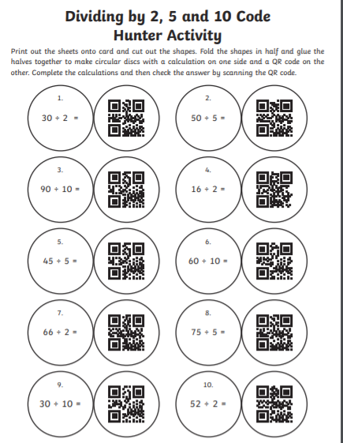
Friday
Create a poster explaining the difference between grouping and sharing (division).
English
Monday
This week we will be writing a narrative about the video ‘Something Fishy’. Today, spend time watching the video a few times and making notes on the things that stand out to you. Think about what you may choose to describe in more depth. Create a word mat of key vocabulary you would include. For example: jeans, washing machine, shark, fish, turtle, ocean…
https://www.literacyshedplus.com/en-gb/resource/something-fishy-5-7--en-gb

Tuesday
Today you will draw a story map about ‘Something Fishy’. Watch the video again and pause it to draw the key events. https://www.literacyshedplus.com/en-gb/resource/something-fishy-5-7--en-gb
Thursday & Friday
Now it is time to show off everything you have learnt so far! Time to write your ‘Something Fishy’ story.
Things to remember:
-Expanded noun phrases e.g. The silver, sneaky shark
-Conjunctions e.g. because, when, if, that
-Similes (using ‘as’ or ‘like’ to compare)
-Punctuation

Grammar, Punctuation and Spelling:
https://www.bbc.co.uk/bitesize/topics/zkxxsbk
https://www.topmarks.co.uk/english-games/5-7-years/letters-and-sounds
https://spellingframe.co.uk/
https://sentenceplay.co.uk/games/dropping-in
Text Types/Genres:
https://classroom.thenational.academy/subjects-by-key-stage/key-stage-1/subjects/english

Wednesday DT – Sliders and Levers
Today we will be making a poster or booklet with all the facts we have learnt about clean water and sanitation. Think back to all you learnt about Joseph Bazelgette too. In this booklet we will be including mechanisms such as levers and sliders.
https://www.youtube.com/watch?v=9-bG8BM3d3Y
https://education.theiet.org/primary/teaching-resources/moving-pictures-with-levers-and-sliders/
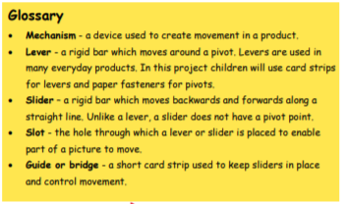
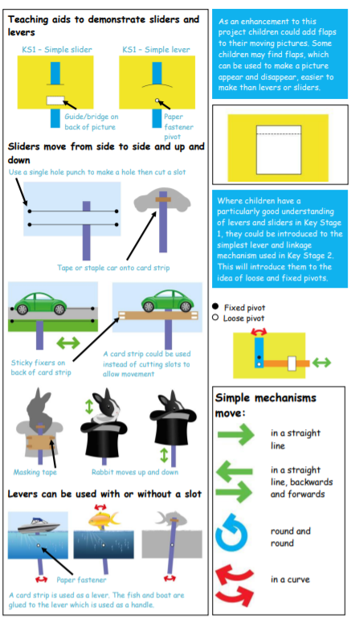

Tuesday P.E
We will be continuing to learn our dance.
Do some warm ups (with an adult) to stretch your muscles and get your heart pumping.
Use this website to watch the dancers, dance to 3 pieces of classical music based on water (remember we watched this last week).
https://www.bbc.co.uk/teach/class-clips-video/physical-education--music-ks1-water/zbm2t39
Try to walk in time to the music just like we did last week.
Can you create a routine combining everything we have learnt so far. Think about different sea creatures, speeds and movement through water.
Some things to consider to improve your dance.
- If the music is loud can you add height to your dance but if it goes quiet can you dance at a lower level?
- Remember to point your toes and extend your hands.
- Make sure your transitions e.g. a turn into a kick, are smooth.
Cool down by lying flat on the floor for 2 minutes. Close your eyes and sink into the floor.
NOW IT IS TIME TO PERFECT AND RECORD YOUR AMAZING PERFORMANCE
Thursday- Science
Continuing our learning of food chains, choose two very different habitats and research and create a food chain within this habitat. You could create a model, use playdough or create a poster. Can you remember the meanings of these words and identify these in your food chain?
Producer
Consumer
Predator
Prey
Energy
What does an owl like to eat?
Draw a food chain that ends in a sparrow hawk.
Name sources of food.
Explain the difference in food chain for a herbivore and a carnivore.
Always, sometimes or never? Food chains end with a carnivore.
Friday - RE
Watch this clip to find out about Ramadan.
http://www.bbc.co.uk/education/clips/zxbgd2p
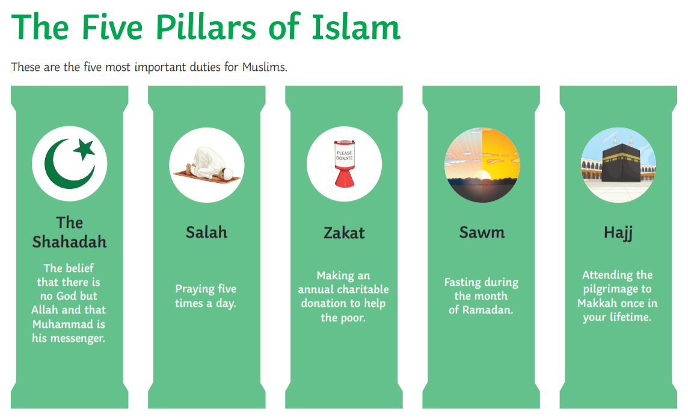
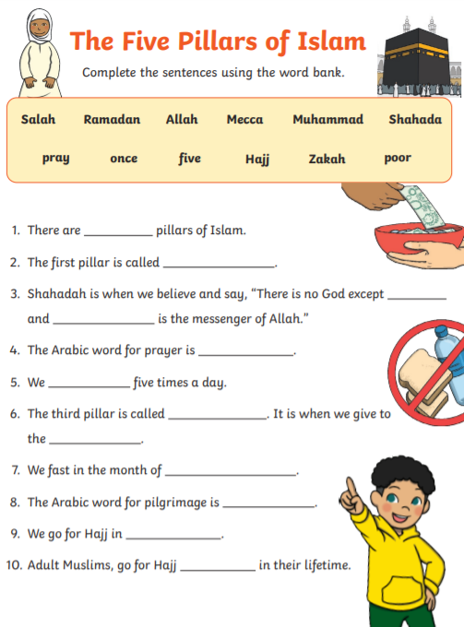
Daily
Keep reading!
Read a magazine/newspaper article.
Arithmetic (20 minutes a day) – Count in 2s 5s and 10s
Watch Newsround
Phonics – Play a phonics phase 3 and 5 game on phonics play.
https://www.phonicsplay.co.uk/resources/phase/3

Times Tables – practise your times tables as much as you can!
Useful websites for times tables:
https://www.topmarks.co.uk/maths-games/7-11-years/times-tables
https://www.timestables.co.uk/

PE

Visit YouTube and do a session 5 times a week of Joe Wicks/Go Noddle/Cosmic Kids Yoga.

French-
- Practise numbers 1-31 in French. Have a go playing these games and familiarising yourself with the spelling/reading of the words. You can play interactive games, watch videos or create posters/flashcards to help you.
https://wordwall.net/resource/3027772/french/french-numbers-1-30
https://www.bbc.co.uk/bitesize/topics/zpy8q6f/resources/1
- Revise months of the year in French
- Revise colours in French
https://www.youtube.com/watch?v=acvUtipaC5Y

