Home Learning- Year 2
If you are feeling well enough, please pick an activity from maths and English. Then choose one other lesson to enjoy each day. Please send some photos or bring any work you are able to complete back to school with you.

Maths
Monday
Log in to PowerMaths Active Learn (Log in details are in your Reading journal) https://www.activelearnprimary.com.au/login?e=-1&c=0
Click on Resources>powermaths on the green banner, click on year 2 and under TYPE choose Textbook 2B for explanations and Workbook 2B for questions.
PowerMaths Dividing by 5 Textbook 2B Unit 6 lesson 5 p24-27, Workbook 2B Unit 6 lesson 5 p18-20

Tuesday
PowerMaths Dividing by 10 Textbook 2B Unit 6 lesson 6 p28-31, Workbook 2B Unit 6 lesson 6 p.21-1923

Thursday
PowerMaths Making a tally chart Textbook 2B Unit 7 lesson 1 p48-51, Workbook 2B Unit 7 lesson 1 p35-37

Friday
PowerMaths End of unit check for multiplication and division Textbook 2B p44-45, Workbook 2B p33-34.

English
Monday
Look at and read the attached newspaper article about seahorses. Can you find the following features:
- Name of newspaper
- Headline
- Quote
- Caption
- Introduction
Read again to find where, when, who, why and what happened in the story.

Tuesday
Today we will start planning our own newspaper report for The Lonely Beast- making sure we are trying to find him a friend. Can you remember to features of a newspaper report? Firstly, we need to decide on a newspaper name and a headline? What is the purpose of a headline? Can you think of some different headlines to gain the reader’s attention and express the need for finding the beast a friend?
Choose a headline.
Draw a picture of The Lonely Beast or your newspaper report.
Can you add a caption to your picture?
Thursday
The next step is to write the introduction for your newspaper report. What is the purpose of your newspaper report? Remember- our introduction must tell the reader: who, what, why, when, where and how? Now start writing a short article- another two short paragraphs. These only need to be 2-3 sentences long. Can you add a quote?
Friday
Conjunctions: https://www.bbc.co.uk/bitesize/articles/z6rvbdm
Watch the video and complete the activities.
Can you write your own sentences using conjunctions about this picture?
‘because’, ‘but’, ‘so’ or ‘as’.
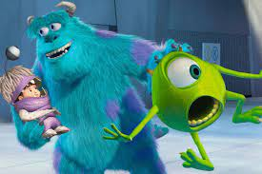

Grammar, Punctuation and Spelling:
https://www.bbc.co.uk/bitesize/topics/zkxxsbk
https://www.topmarks.co.uk/english-games/5-7-years/letters-and-sounds
https://spellingframe.co.uk/
https://sentenceplay.co.uk/games/dropping-in
Text Types/Genres:
https://classroom.thenational.academy/subjects-by-key-stage/key-stage-1/subjects/english
Wednesday Global Learning day- Art
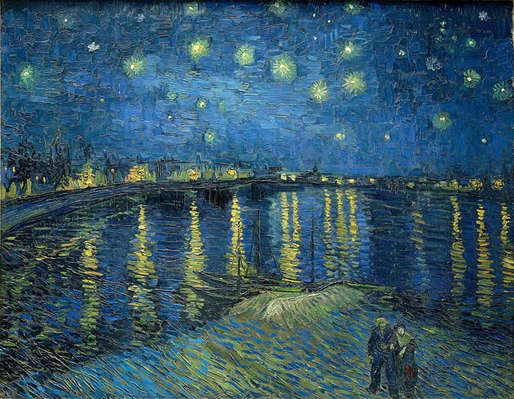
Vincent van Gogh, Starry Night Over The Rhone, 1888
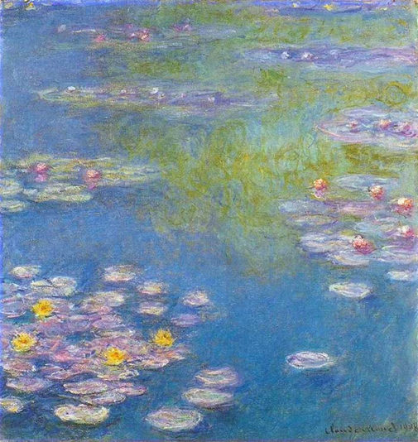
Claude Monet, Water Lilies,1908
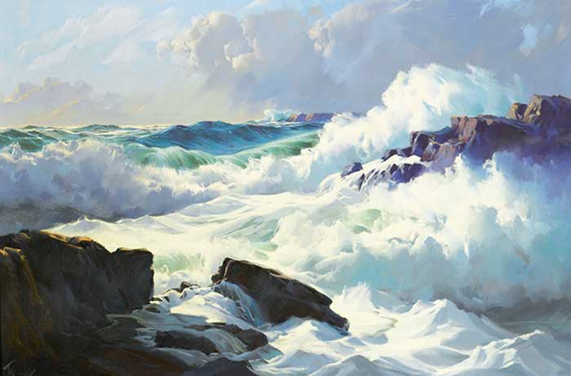
Frederick Judd Waugh, Breaking Surf
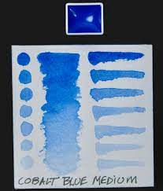
Look at the pictures above and decide which ones you like the best and why? Which picture do you like the least and why is that?
If you have some paints can you try to mix a tonal range. So start with white and slowly add another colour to create a tonal range like this.
If you don’t have any paints then can you find items from around your house that are all the different tones of blue.

Wednesday pm History
We will continue learning about Joseph Bazalgette today.
Use this website to learn all about him,
https://www.bbc.co.uk/teach/class-clips-video/science-ks2-discovering-the-work-of-Joseph-Bazalgette/zbc2scw
Then use this video to make a model of him.

Tuesday P.E
We will be continuing to learn our dance.
Do some warm ups (with an adult) to stretch your muscles and get your heart pumping.
Use this website to watch the dancers, dance to 3 pieces of classical music based on water (remember we watched this last week).
https://www.bbc.co.uk/teach/class-clips-video/physical-education--music-ks1-water/zbm2t39
Try to walk in time to the music just like we did last week.
Can you create a routine combining everything we have learnt so far. Think about different sea creatures, speeds and movement through water.
Some things to consider to improve your dance.
- If the music is loud can you add height to your dance but if it goes quiet can you dance at a lower level?
- Remember to point your toes and extend your hands.
- Make sure your transitions e.g. a turn into a kick, are smooth.
Cool down by lying flat on the floor for 2 minutes. Close your eyes and sink into the floor.

Thursday- Science
Continuing our learning of food chains, choose two very different habitats and research and create a food chain within this habitat. You could create a model, use playdough or create a poster. Can you remember the meanings of these words and identify these in your food chain?
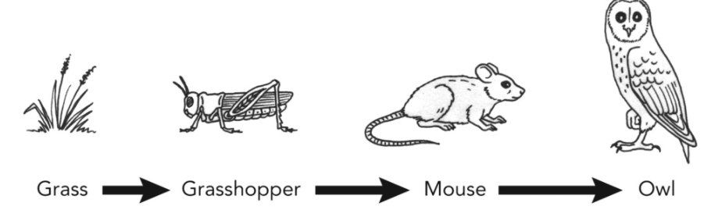
Producer
Consumer
Predator
Prey
Energy

Friday - RE
Watch this clip to find out about Ramadan.
http://www.bbc.co.uk/education/clips/zxbgd2p
Read the statements below about Ramadan. Can you add a face to show how you feel when you read each one.
This year I fasted for the first time as the Qur’an teaches. I only did one day but I was pleased. I felt hungry at the end. | Mum and dad gave me a present for trying to fast. When I am older, I will fast for more days.
In the morning I got up early and had a big breakfast before it was light. Then I didn’t have anything to eat or drink for the rest of the day. | I was very glad when it got dark and we could break our fast. I ate some dates and had a drink. We also said special prayers.
Ramadan is supposed to help you think more about other people. When I felt very hungry, I thought about starving children. | I promised Allah I would give some of my pocket money to help feed people who never have enough food.
At the mosque our teachers said Muslims fast to help them think more about God and important things like how we treat each other. | Mum said Ramadan is not just about giving up food but giving up doing bad things like lying and cheating.

Daily
Keep reading!
Read a magazine/newspaper article.
Arithmetic (20 minutes a day) – Count in 2s 5s and 10s
Watch Newsround
Phonics – Play a phonics phase 3 and 5 game on phonics play.
https://www.phonicsplay.co.uk/resources/phase/3

Times Tables – practise your times tables as much as you can!
Useful websites for times tables:
https://www.topmarks.co.uk/maths-games/7-11-years/times-tables
https://www.timestables.co.uk/

PE

Visit YouTube and do a session 5 times a week of Joe Wicks/Go Noddle/Cosmic Kids Yoga.

French-
- Practise numbers 1-31 in French. Have a go playing these games and familiarising yourself with the spelling/reading of the words. You can play interactive games, watch videos or create posters/flashcards to help you.
https://wordwall.net/resource/3027772/french/french-numbers-1-30
https://www.bbc.co.uk/bitesize/topics/zpy8q6f/resources/1
- Revise months of the year in French
- Revise colours in French
https://www.youtube.com/watch?v=acvUtipaC5Y

