Step 1
I start with a graphite pencil sketch. I draw two rounded shapes for the bird’s head and body.
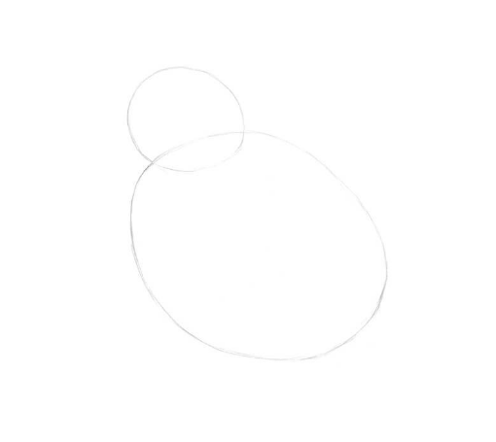
Step 2
I draw the rough shape of the beak.
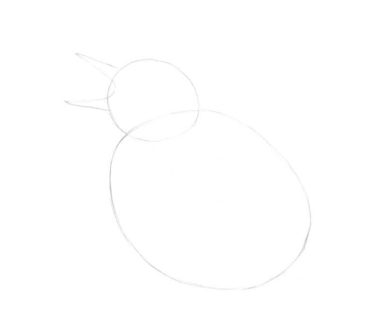
Step 3
I draw the stylised framework of the feet, marking the joints with small circles and adding the claws.
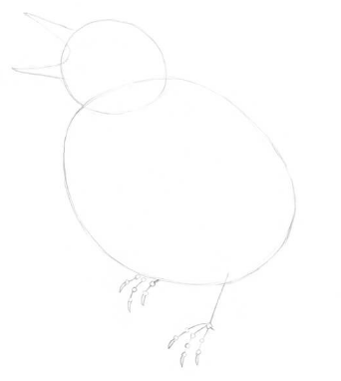

Step 4
I draw the rough shape of the tail; it resembles a triangle.
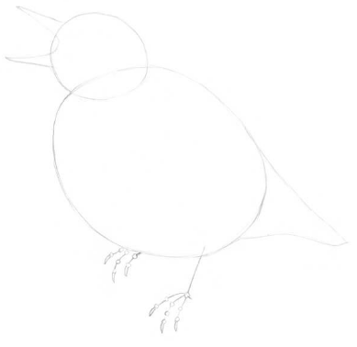
Step 5
I add the stylised figure of the tree, imagining that the bird is sitting on it. Then I mark the eye of the bird. This step is optional as these are seabirds.
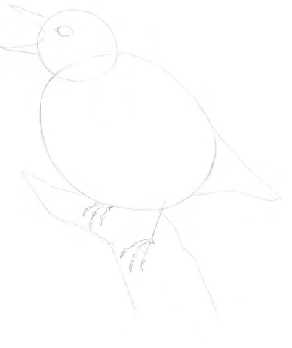

Step 6
I refine the bird, joining the head and the body with a smooth, curved line. I also mark the wing and add the back side of the open beak.
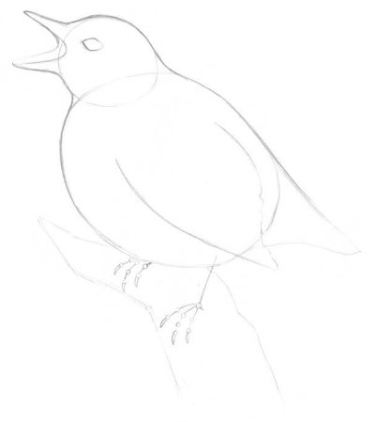

Step 7
I refine the shapes of the bird’s feet, based on the framework.
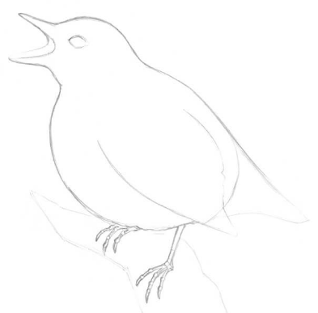

Step 8
I create an outline of the tree, using irregular, organic lines. I also add two groups of small leaves; they will vary the composition and make the drawing more interesting. Alternatively, you could add the feet to a bench or a rock as this is more realistic for seabirds.
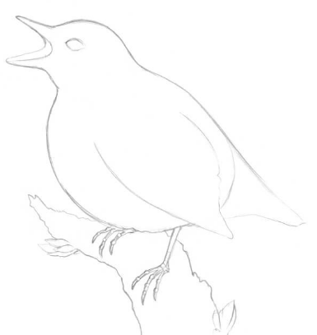

Step 9
I add some details to my sketch, like the feathers in the wing, particular face or body markings and the nuances of the bark.
This is not an obligatory step; it’s just useful to think over the drawing before delving into the coloured pencil part.


