Home Learning- Year 2
If you are feeling well enough, please pick an activity from maths and English. Then choose one other lesson to enjoy each day. Please send some photos or bring any work you are able to complete back to school with you.

Maths
Monday
Division- sharing
Gather some resources and see if you can share them into equal groups. Try these:
10 pencils shared between 2 people =
15 pasta shapes shared between 3 people =
20 buttons shared between 4 people =
https://www.bbc.co.uk/bitesize/topics/zqbg87h/articles/zfxtnrd
Can you create a poster representing this?

Tuesday
Log in to PowerMaths Active Learn (Log in details are in your Reading journal) https://www.activelearnprimary.com.au/login?e=-1&c=0
Click on Resources>powermaths on the green banner, click on year 2 and under TYPE choose Textbook 2B for explanations and Workbook 2B for questions.
PowerMaths Making Equal Groups Textbook 2A Unit 6 lesson 1 p8-11, Workbook 2B Unit 6 lesson 1 p6-8

Thursday
PowerMaths Sharing and Grouping Textbook 2A Unit 6 lesson 2 p12-15, Workbook 2B Unit 6 lesson 1 p9-11

Friday
PowerMaths Dividing by 2 Textbook 2A Unit 6 lesson 1 p16-19, Workbook 2B Unit 6 lesson 1 p. 12-19

English
Monday
Read the pdf of ‘The Lonely Beast’.
Now re-read the underwater section of the Beast’s journey to the city. ‘He jumped in and started to swim…’ until ‘Just when he could swim no more…’.
Think about the different sea creatures- how would they move in the water?
Watch Michael Rosen’s poem ‘The Jellyfish’ https://clpe.org.uk/videos/video/michael-rosen-jellyfish - how does he describe what the jellyfish looks like and movement in water? How does this compare to when it is beached?
Create a mind-map with adjectives and adverbs to describe how the jellyfish looks and moves.
Tuesday
Similes- https://www.bbc.co.uk/bitesize/topics/zmfc7ty/articles/zrrhpg8
https://www.youtube.com/watch?v=95Tc8qIJRuI Draw a picture of a jellyfish write your own similes and expanded noun phrases to describe it.
Thursday
Reread or think back to your (Beast’s) diary entry. You have spent your first night in the city park after your journey.
In full sentences, answer these questions:
How is the Beast feeling?
Who do you think lives in the buildings in the city? (Are they old or young? Do they live alone?)
How do you think the residents feel about a beast living there?
Imagine a resident is not very happy that there is a beast living in the park near their home. Write 5 questions you would like to ask them.
Friday
Contractions:
https://www.bbc.co.uk/bitesize/articles/z3j4vwx
What would the contractions be for these words?
I am
You are
Do not
You are
It is
They are

Grammar, Punctuation and Spelling:
https://www.bbc.co.uk/bitesize/topics/zkxxsbk
https://www.topmarks.co.uk/english-games/5-7-years/letters-and-sounds
https://spellingframe.co.uk/
https://sentenceplay.co.uk/games/dropping-in
Text Types/Genres:
https://classroom.thenational.academy/subjects-by-key-stage/key-stage-1/subjects/english
OR
Practise writing sentences: use correct punctuation and extend them using ‘because’, ‘but’, ‘so’ or ‘as’.

Wednesday Global Learning day- Geography.
SEE ATTACHED POWERPOINT.
Key points:
- Where do we get our water from? How many bodies of water can you name? Watch videos in powerpoint.
- Google Maps- can you find Buckden, Grafham, Grafham Water, A14 and where you live?
- Compare Grafham in 1950 to 2020.
- How does climate impact water supply?

Tuesday P.E
We will be learning to dance.
Do some warm ups (with an adult) to stretch your muscles and get your heart pumping.
Use this website to watch the dancers, dance to 3 pieces of classical music based on water (remember we watched this last week).
https://www.bbc.co.uk/teach/class-clips-video/physical-education--music-ks1-water/zbm2t39
Try to walk in time to the music just like we did last week.
This week we will be imagining that we are moving through water. How could you change your body to go through the water at different speeds?
Can you put your three moves together into a routine?
Cool down by lying flat on the floor for 2 minutes. Close your eyes and sink into the floor.

Thursday Science
SEE attached powerpoint- underwater food chain.
Friday RE
This half term we will be learning about Islam. Last week in school we explored the importance of compassion. 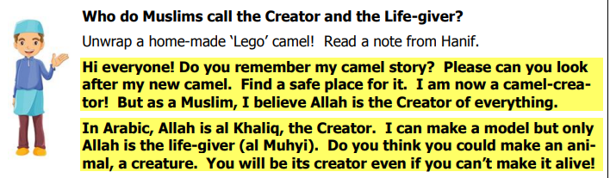
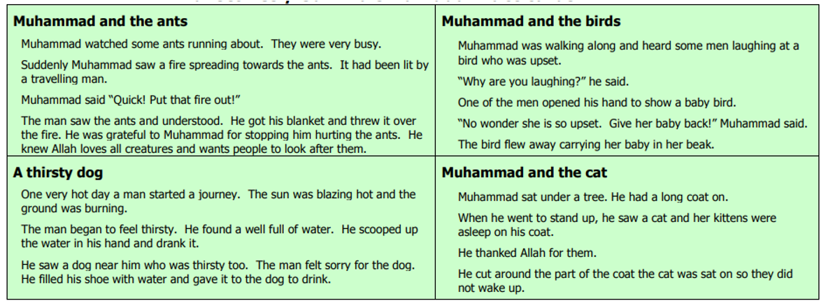
How do these stories show compassion for living things?

Daily
Keep reading!
Read a magazine/newspaper article.
Arithmetic (20 minutes a day) – Count in 2s 5s and 10s
Watch Newsround
Phonics – Play a phonics phase 3 and 5 game on phonics play.
https://www.phonicsplay.co.uk/resources/phase/3

Times Tables – practise your times tables as much as you can!
Useful websites for times tables:
https://www.topmarks.co.uk/maths-games/7-11-years/times-tables
https://www.timestables.co.uk/

PE

Visit YouTube and do a session 5 times a week of Joe Wicks/Go Noddle/Cosmic Kids Yoga.

French-
- Practise numbers 1-31 in French. Have a go playing these games and familiarising yourself with the spelling/reading of the words. You can play interactive games, watch videos or create posters/flashcards to help you.
https://wordwall.net/resource/3027772/french/french-numbers-1-30
https://www.bbc.co.uk/bitesize/topics/zpy8q6f/resources/1
- Revise months of the year in French
- Revise colours in French
https://www.youtube.com/watch?v=acvUtipaC5Y

