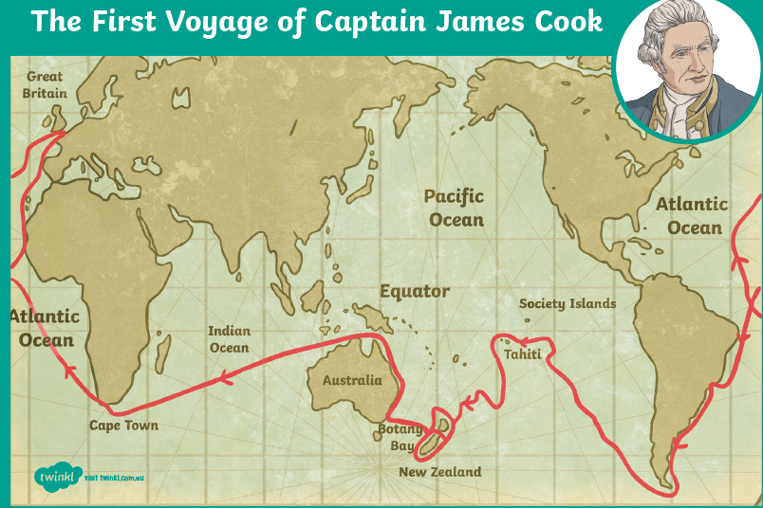
Thursday 13th January

Captain James Cook

