Week commencing : 10^{h} January 2022 EYFS Enhancements Continuous Provision Plan
Story: The Gingerbread Man |  | Skills Builder: Leadership |  | Enhancement: Visit to plant trees on Friday- parent helpers needed
RE Theme:
Area | Learning Intention |  | Enabling Environment |  | Adult Questioning/ Support/ Vocabulary
Writing | To write independently- simple sentences/ individual words. |  | Speech bubbles for the characters from the Gingerbread man  Have masks available for children to verbalise their sentences. |  | Assist to use a tripod grip.  Teach to write from left to right.  What can you hear? (initial sounds)  What can you remember from the story- repeated refrain- run run as fast as you can.  Letter formation rhymes/sound mat  What are the sounds?  Can you blend the sounds?
Reading | To read for enjoyment and fun. |  | Selection of traditional tales available for children to read.  Create a reading den space- children to choose how this looks and what to put in it. |  | Can you read the question?  What are the sounds?  Can you blend them to say the word?  Can you reread the sentence?  Do you think the answer is yes or no?  Can you find your name?  Which pot should you put your name in?  What nursery rhyme do you think match these props?  Can you remember the nursery rhyme?
Maths | To recognise ‘one more’ as numbers increase in size. |  | Use large blocks to build steps. Add chalk to note the matching digit. |  | What can you see?  How many would be in the next tower?  Can you change the steps to start with 10 and count downwards?  Support digit formation- use number line to help children if needed.
PD | To carry an item from one place to another over an obstacle course. |  | Use outdoor equipment to build an obstacle course to carry a tray with items across. Use a timer/ stopwatch to see how quickly you can complete it. |  | Discuss core strength and balance skills.  Turn taking.
EAD | To use the work of Lottie Reigner as inspiration for own art work. |  | Create background wash colour for piece using powder paints. Will need to have decided upon setting of painting- forest, castle, meadow etc. |  | Which colour do you need to mix for your setting?  Talk about shades of the same colour and how to create a wash/ ombre effect.
UW | To read and enjoy a traditional tale from across the globe and locate.  To show respect for the environment- rejuvenation of an environment. |  | Caribbean Cinderella book- locate Caribbean on globe.  Tree planting outing to plant trees. |  | What is different about the Caribbean version of Cinderella to the more familiar one we know.
PSHE | To be able to name and talk about foods they like and dislike. |  | Use ‘Yuck’ book to discuss what animals and humans eat. What would you like/ dislike?  Use website www.foodafactoflife.org.uk |  | Discuss food tasting experiences the children have had and enjoyed or had and disliked.
C+L  French | To learn colours in French |  | https://www.youtube.com/watch?v=fZR66TjjrDc
Music | To know about rhythm- tapping it out. |  | Sing and learn Row Row Row the Boat  Use instruments to tap out the rhythm |  | Beat, pulse, volume, crescendo.
Nature School | Make mud paint to use outside. |  | 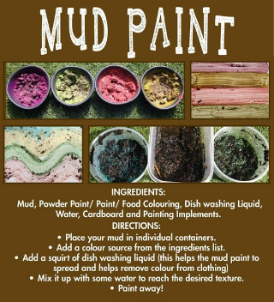 |  | Can you help me make mud paint?
Mind Up | Reset and emphasise technique of brain breaks.
Skills Builder | To teach skill of leadership step 0. |  | Use skills builder step 0 video on leadership.
Oak academy links for literacy lessons in case of Covid absence https://classroom.thenational.academy/units/the-gingerbread-man-2250
For maths https://classroom.thenational.academy/units/numbers-within-6-9e95

