This week’s learning 10.01.22
Please return any work that you complete back to school.
Monday
Maths – https://classroom.thenational.academy/lessons/understand-what-a-percentage-is-and-its-connection-to-fractions-6rrk2c
English – https://classroom.thenational.academy/lessons/to-explore-the-four-types-of-sentence-statement-command-exclamation-and-question-c9jked
PSHE – Talk with an adult at home about why it is important to follow advice on the box/advice from a doctor about how you should take medicines. Discuss which medicines you can buy over the counter and which might be prescribed by a doctor.

Tuesday
Maths – https://classroom.thenational.academy/lessons/recall-and-use-equivalences-between-fractions-decimals-and-percentages-6dh6cc
English – https://classroom.thenational.academy/lessons/to-practise-and-apply-knowledge-of-silent-letters-including-test-6mw6cd
RE – From the Bible, read The Parable of the Unforgiving Servant (Matthew 18: 21-35), draw a sketch to show what point Jesus was trying to make.
Wednesday
Maths – https://classroom.thenational.academy/lessons/solve-problems-involving-the-calculation-of-percentages-of-amounts-c5gkge
English – https://classroom.thenational.academy/lessons/to-explore-prepositions-6wwkcd
Art –Look at some examples of David Hockney Art based which is based on swimming pools (see some examples below). Choose one piece you like and write a paragraph to explain why you like it.
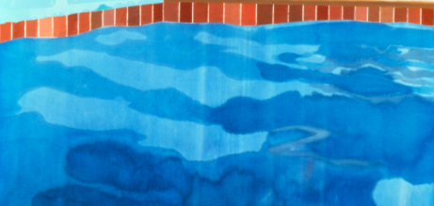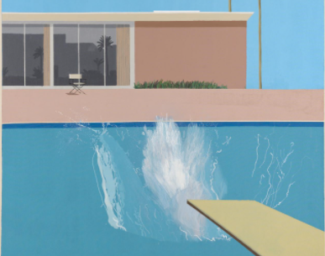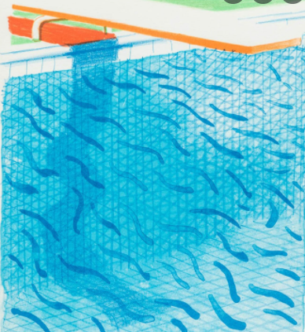

Thursday
Maths – https://classroom.thenational.academy/lessons/solve-problems-involving-the-use-of-percentages-for-comparison-6mtk6t
English – https://classroom.thenational.academy/lessons/to-explore-prepositions-further-68r3cd
Global Learning- Geography – Choose a famous river from anywhere in the world and create a Fact File about it. Aim to include some interesting facts such as where it is located – you could draw a map, how wide it is, where the source is, which animals can be found living there.

Friday
Maths – https://classroom.thenational.academy/lessons/interpret-mean-as-an-average-60t32d
English – https://classroom.thenational.academy/lessons/to-explore-modal-verbs-c9k34d
Science – https://classroom.thenational.academy/lessons/what-are-the-different-animal-kingdoms-6cvp6r

Daily
Log into SATs Companion and do any practise session.
TT Rockstars: https://ttrockstars.com/
Keep reading – at least 20 minutes every day. As well as your reading books try to look at a newspaper/magazine article, recipe or non-fiction book.

PE
Visit YouTube and do a session of Joe Wicks.

French
Use Linguascope to learn the names for different family members in French.

