Year 3 - Live lessons
In order to find live lessons please go to the channel for the day.
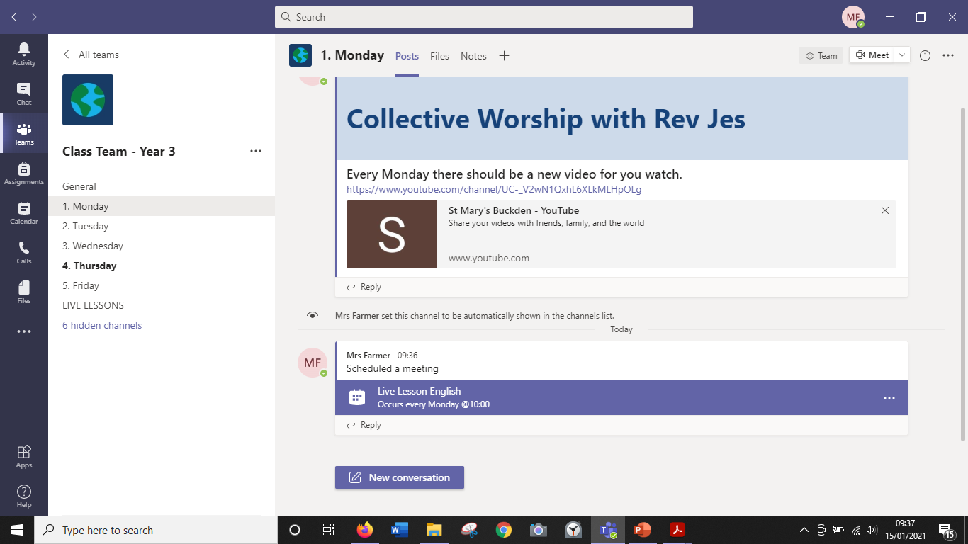
Once you are on the channel you should see the meeting that are scheduled for that day. These are your live lessons.
In the example above you can see in the red box there are lessons scheduled with the date and time. You can scroll down on the right hand side to see more lessons.
If you click on the blue box for the lesson you want you should be able to view the meeting details.
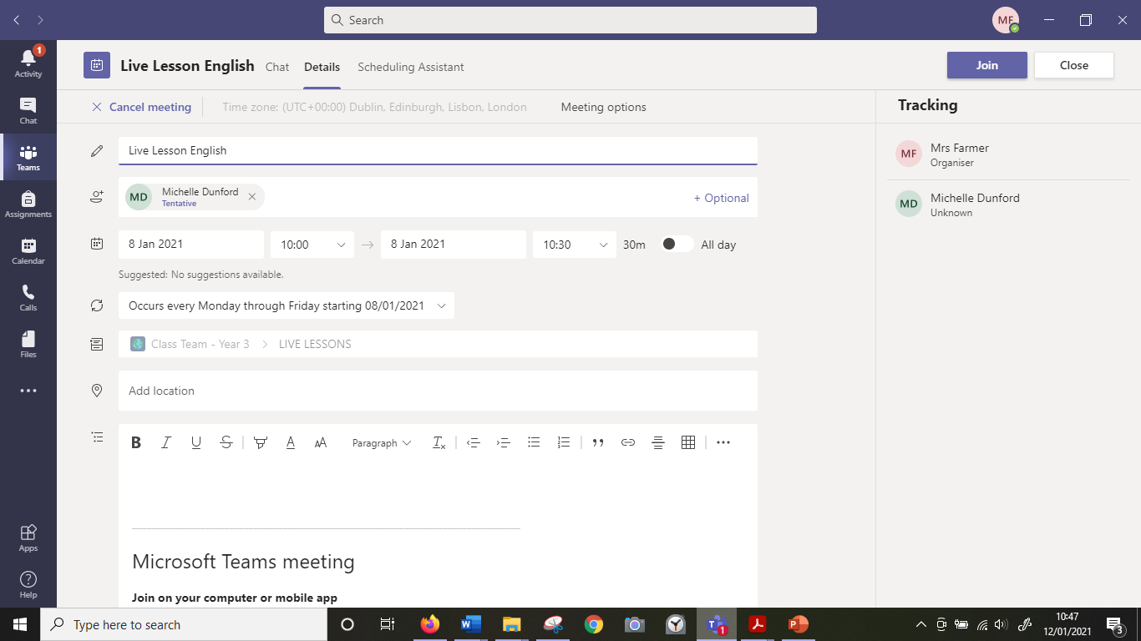

You will need to click on the ‘Join’ button in the top right hand corner in order to join a live lesson. Please see the area in red above.
You will be presented with the screen below. Please ensure your microphone is muted by clicking the button in red and then click the join button at the bottom.
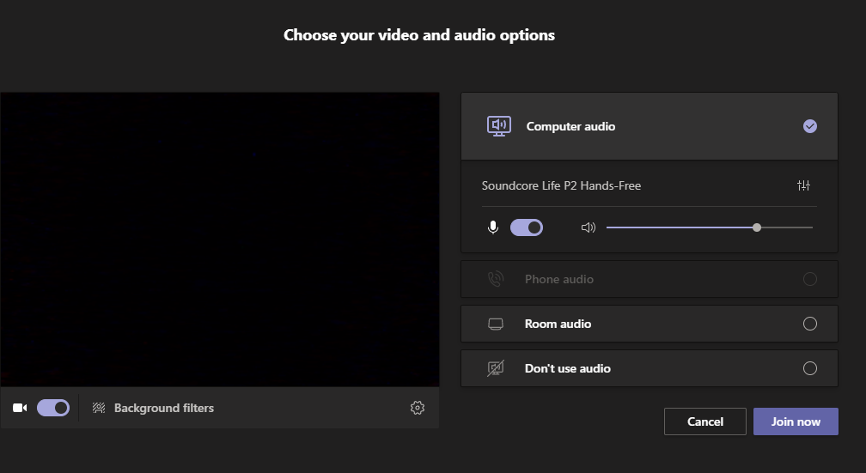

Once you have done this you will be in a live lesson. If you are unable to attend the live lesson the you can always watch the recording afterwards. This can be found underneath the scheduled sessions and you will need to download this to watch it. Once you click download you may need to do into your computer files- downloads, to find the video. It should appear as below.
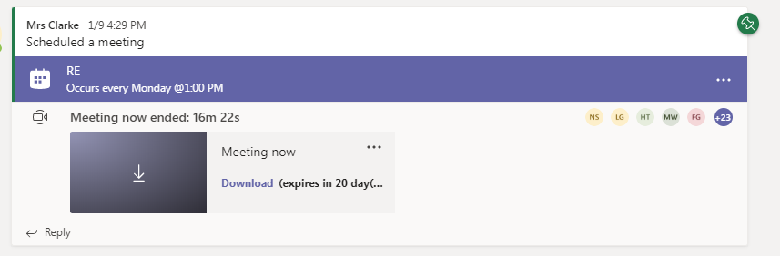
Or I have set up files and folders with the recordings in for you to watch without downloading them. Below is how to access these.


