Home Learning- Year 2
If you are feeling well enough, please pick an activity from maths and English. Then choose one other lesson to enjoy each day. Please send some photos or bring any work you are able to complete back to school with you.

Maths
Monday
https://classroom.thenational.academy/lessons/calculating-multiplications-of-two-by-skip-counting-6th6cd
OR
This is an array for 2 x 8. Try to make arrays for each x2 table fact by printing with lego bricks and paint. Don’t forget to write the number sentence and then count in 2s to calculate the answer. If you don’t have lego use your finger and a small amount of paint.
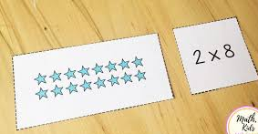

Tuesday
https://classroom.thenational.academy/lessons/calculating-multiplication-of-fives-by-skip-counting-70r3cd
OR
Print arrays as above but for the 5 x table

Wed
Games and interactive resources: https://mathsframe.co.uk/en/resources/category/22/most-popular
Try Tommy’s Trek times tables choose 2 x table, 5 x table

Thursday
https://classroom.thenational.academy/lessons/calculating-multiplications-of-ten-by-skip-counting-61k62e
OR
Print arrays as above but for the 10 x table

Friday
https://www.coloringsquared.com/wp-content/uploads/2016/11/1225-Santa-Claus-Addition-Holiday-Coloring.pdf
see attachment

English
Monday
We will be continuing to write our story in school that follows the structure of the Magic Finger. Last week we spent a lot of time thinking about characters and settings. In school today we will be writing the beginning of the story which will introduce the characters and the setting. We will move on to describe the action that the group of characters did wrong and how this upsets the main character. Write each sentence on a piece of scrap paper. Then read it aloud, does it sound right? Try to correct it a little and then write it down as part of your story. Enjoy your writing.
If at home last week you just wrote your story you might like to start another story. The children in school certainly kept thinking of new ideas for different stories!
Alternatively, you may choose to practise your grammar skills using the resources below.
Tuesday
We will be continuing to write our story in school that follows the structure of the Magic Finger. In school today, we will be writing how the main character used their magic power to teach the other group of characters a lesson! Just like when the girl turned the Gregg family into ducks. We will move on how the other charcaters then put the situation right and how they were returned to normal. Write each sentence on a piece of scrap paper. Then read it aloud, does it sound right? Try to correct it a little and then write it down as part of your story. Enjoy your writing.
Alternatively, you may choose to practise your grammar skills using the resources below.
Wednesday
Use the resources below to practise your grammar and punctuation skills.
The BBC bitesize website offers good activities to learn about nouns, verbs and adjectives.
Thursday
Write up your story neatly and make it into a little story book. Leave some spaces to add pictures.
Friday
Illustrate you story book. We hope you are proud of it.

Grammar, Punctuation and Spelling:
https://www.bbc.co.uk/bitesize/topics/zkxxsbk
https://www.topmarks.co.uk/english-games/5-7-years/letters-and-sounds
https://spellingframe.co.uk/
https://sentenceplay.co.uk/games/dropping-in
Text Types/Genres:
https://classroom.thenational.academy/subjects-by-key-stage/key-stage-1/subjects/english
OR
Practise writing sentences: use correct punctuation and extend them using ‘because’, ‘but’, ‘so’ or ‘as’.

Global Learning
On Monday and Tuesday, we will be conducting a skills builder project to make some Christmas decorations out of waste products and natural resources.
Have a go to make some of these decorations for your trees at home.
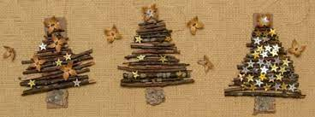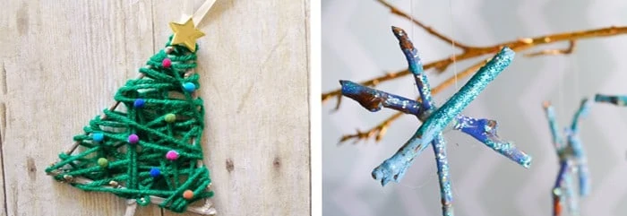
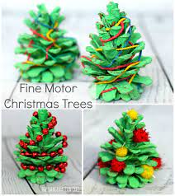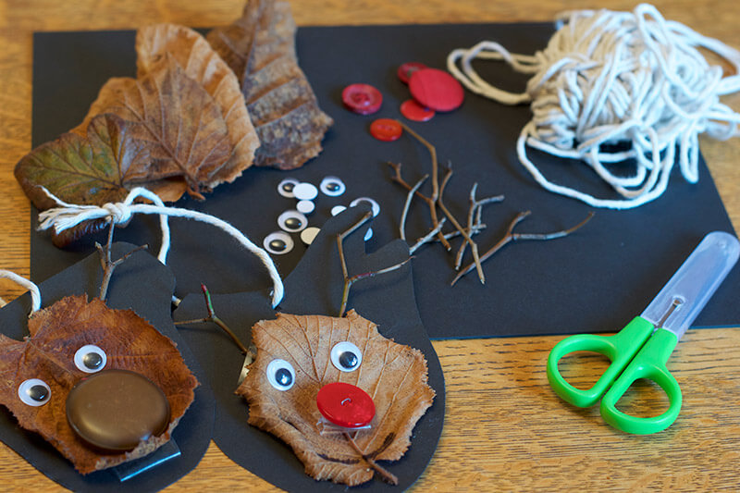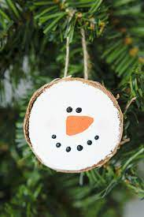
Science
Wednesday

Use your knowledge of animals and discuss which animal is the odd one out and why you think so!
Think about:
- appearance
- what they do
- where they might be found

RE
Thursday
https://www.bbc.co.uk/bitesize/clips/zntfgk7
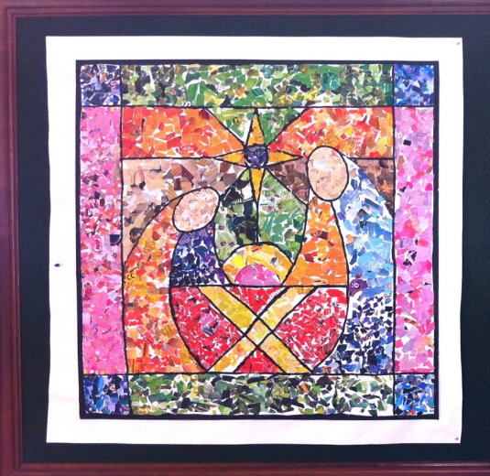
Use the website above to reflect on the Christmas story you have been learning about.
The classroom idea suggests to make a gift for baby Jesus using your collage skills.
Last week in school we made these cards to practise collaging. We just cut up old magazines for the coloured paper. You could ask an adult to draw you a template like this or of a picture of a gift for baby Jesus and have a go at making a collaged picture.
Friday
Christmas fun!
Make a Christmas hat out of waste cardboard.
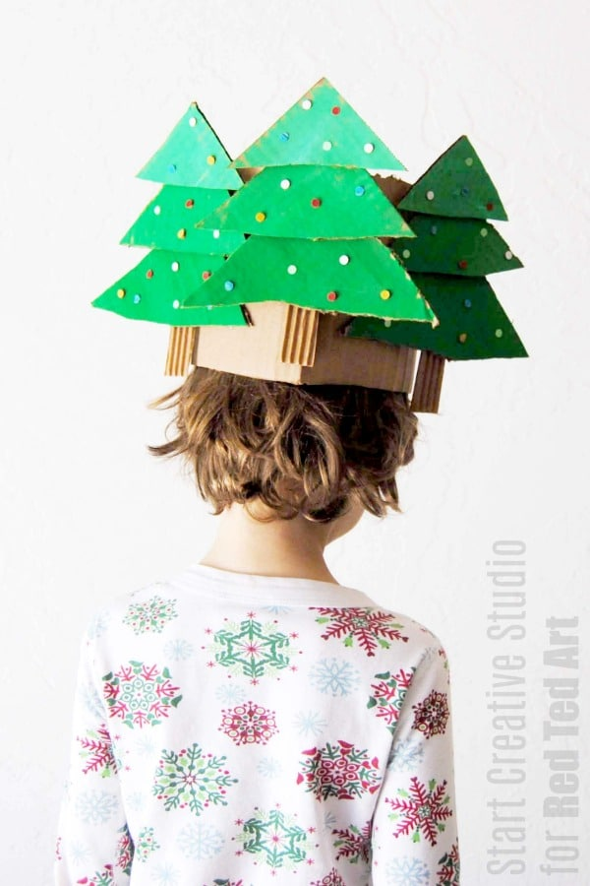

Daily
Keep reading!
Read a magazine/newspaper article.
Arithmetic (20 minutes a day) – Count in 2s 5s and 10s
Watch Newsround
Phonics – Play a phonics phase 3 and 5 game on phonics play.
https://www.phonicsplay.co.uk/resources/phase/3

Times Tables – practise your times tables as much as you can!
Useful websites for times tables:
https://www.topmarks.co.uk/maths-games/7-11-years/times-tables
https://www.timestables.co.uk/

PE

Visit YouTube and do a session 5 times a week of Joe Wicks/Go Noddle/Cosmic Kids Yoga.

French-
- Practise numbers 1-31 in French. Have a go playing these games and familiarising yourself with the spelling/reading of the words. You can play interactive games, watch videos or create posters/flashcards to help you.
https://wordwall.net/resource/3027772/french/french-numbers-1-30
https://www.bbc.co.uk/bitesize/topics/zpy8q6f/resources/1
- Revise months of the year in French
- Revise colours in French
https://www.youtube.com/watch?v=acvUtipaC5Y

