Microhabitats for minibeasts. 8.12.21

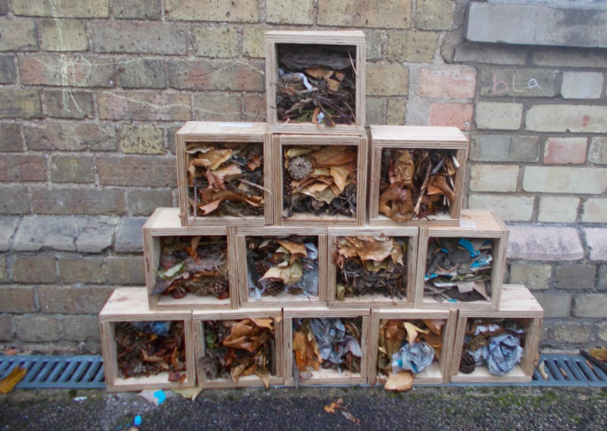
- Which mini-beasts might live in our bug hotel?
____________________________________________________________
____________________________________________________________

- Why do you think those mini-beasts will live in our hotel?
____________________________________________________________
____________________________________________________________

