Week commencing : 6th December 2021 EYFS Enhancements Continuous Provision Plan
Story: variety of Christmas stories |  | Skills Builder: Aiming High |  | Enhancement: Performing Nativity
RE Theme:
Area | Learning Intention |  | Enabling Environment |  | Adult Questioning/ Support/ Vocabulary
Writing | To encourage writing for a purpose within their play. |  | Write captions and labels in floor book.  Santa’s post office role play (DC) |  | What would you like to say about this?  What sounds do you hear?  Who are you sending it to?
Reading | To practise reading and noticing words within an environment. |  | Santa’s post office role play (DC) |  | What is the first sound?  Can you blend the sounds together?  What is the word?
Maths | To practise counting 1:1 correspondence and counting to 20 as well as recognising and writing digits up to 5.  Revisit 3D shapes |  | Fill Santa’s stockings with the required items (DH)  Santa’s post office role play (DC) |  | How many of that item to you need?  Did you check the list to make sure you have everything?  What type of box shape would work best for that toy?  How much will it cost to send?
PD | To use our fine motor skills with play doh.  To use our gross motor skills and increase confidence and strength with climbing and moving |  | Red glitter playdoh (KW)  Gingerbread playdoh (DH)  Risk assessment:  Leave space between yourself and the person in front of you, go in the same direction, no jumping on the bridge, do not go past the musical instruments, do not move Miss Lizell’s cones |  | Is it your turn?  Which way will you go?  Do you know where to put your hand/foot next?  What would you like to make with play doh?
EAD | To make Christmas cards  To design and make Christmas decorations for the classroom.  Learn the song: When Santa Got Stuck Up the Chimney dance and play instruments to Sleigh Ride, learn the Makaton Silent Night. |  | Red and green paper, scissors, glue, pompoms, box for chimney, various examples of crafts that children can use to inspire their own creations.  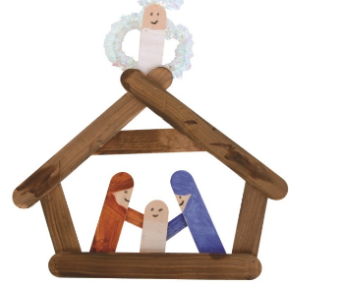 |  | What would you like to make?  What materials do we need to make them?  How can you move to the music?  Can you remember the words?
UW | To learn about Christmas. |  | Various books about Christmas, nativity figures, costumes (DH and KW) |  | What questions do you have about Christmas?
PSHE | To understand that people and families have different beliefs and customs that are important and special to them. |  | Children bring in Celebration artefacts from their homes for show and tell. |  | What questions do you have for the person showing their artefacts?
C+L  French | To listen to Jingle Bells in French and learn the chorus. |  | https://www.youtube.com/watch?v=-4kNeFGBAcw  Jingle Bells in french
Music | To learn the songs for the Nativity and see notes for EAD. |  | Nativity
Nature School | To design and create bird feeders. |  | Lard, toilet roll holders, milk containers, etc.  Birdseed (KW) |  | What design would work best for the birds?
Mind Up | To instil an appreciation of moments of calm. |  | Brain breaks |  | Adrenalin associated with a performance.
Skills Builder | To learn skill level 1 for Aiming High. |  | View level 1 Aiming High. (DH)

