This week’s learning 29.11.21
Monday
Maths – Complete the Maths sheet attached where we have been looking at subtraction by looking at how many there were, how many were taken away and how many are now left. Write the number sentence to show what each picture sequence shows.
English – Last week in our English learning we decided whether Baby Bear should or should not forgive Goldilocks for her actions in the story ‘Goldilocks and the Three Bears’.
Write a letter as Goldilocks to say sorry to Baby Bear for the things you did that upset him.
i.e. breaking his chair, eating his porridge and for sleeping in his bed. Make sure you remember to add his address (below) and to write who the letter is from at the end!
Four Bears Cottage, The Woods
RE – Mitzvah – Good Deeds
Taking care of God’s world and all of its creations in the Jewish Faith is a very important Mitzvah called ‘TIKKUN OLAM’ Listen to the song: https://www.sheldonlow.com/track/568519/i-m-gonna-fix-the-world-tikun-olam?feature_id=74832
Our friend Zoe has sent us a note this week.
Hi everyone. Zoe here. Sometimes our world feels like it is broken. Things which are spoilt, wrong, frightening or unhappy need repairing but glue and tape won’t work.

Gran says that all the good deeds I can do and all of God’s mitzvot are ways to help mend the world and make it better. It is a special privilege to be allowed to help mend the world. Gran called it ‘Tikkun Olam’. What do you think can help mend the world?
What do you think can help us mend the world? Think about the little things we can do each day to help look after our planet, i.e. recycling, helping others. Draw some pictures of different ways that we can help to mend/look after the world.
Tuesday
Maths – Complete the number line subtraction sheet to 10 attached. You can also draw pictures and cross out the subtracted number to help you.
English – Look around the house for some letters. Can you spot any with a stamp on?
Design your own Christmas stamp that could be used to put on a letter.
Global Learning – (Music)
Watch the links below to learn our Christmas Carols ready for our Christmas Carol Concert.
https://youtu.be/a-PBixyD_GU
We wish you a merry Christmas
https://youtu.be/VhA5NRacmLc
Little Donkey
Wednesday
Maths – Complete the number line subtraction sheet to 20 attached. You can also draw pictures and cross out the subtracted number to help you.
English – Write a letter to your teacher telling them what you have been doing at home today! Don’t forget to tell them your favourite part and include any interesting details!
Science – Umbrella Investigation
Ted is due to go outside today, but it is due to rain! We need to make him an umbrella, but which material would be the best material to use?
Materials – a small toy, a jar, an elastic band, a piece of paper, an old sock (cut up and stretched out), any other materials you want to test.
Follow the PowerPoint to conduct a fair test investigation to find out which material would make the best umbrella for Ted!
Thursday
Maths – Top Marks – Subtraction Game https://www.topmarks.co.uk/subtraction/subtraction-to-10
English – SPAG – Last week we looked at joining two clauses together using the conjunction ‘and’. We looked at two pictures and wrote a sentence to describe what we could see.
Look at the pictures below. Write a sentence to describe what you can see using the sentence starter ‘I can see...’ and use the conjunction ‘and’ to join the two words together.
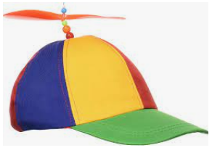
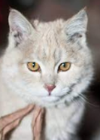
Can you write some sentences of your own using the word ‘and’ to join two clauses together?
French – Watch the video https://www.youtube.com/watch?v=fZR66TjjrDc. Sing the song and practise saying the different colours in French.
Friday
Maths – Practise your maths skills by playing some games on your Abacus account. There are lots to choose from! https://www.activelearnprimary.co.uk/login?c=0 (Log ins are in the children’s reading diaries and the school code is kmm7).
English – (SPAG) Practice your handwriting using the year 1 common exception words.
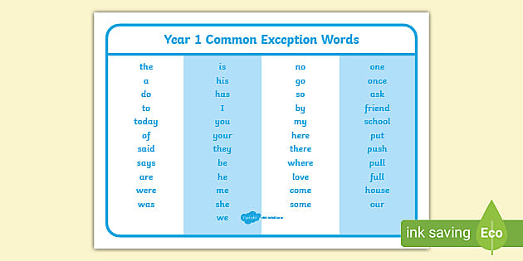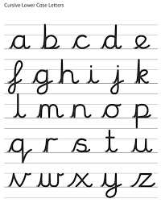
Daily
Abacus - https://www.activelearnprimary.co.uk/login?c=0 (Log ins are in the children’s reading diaries and the school code is kmm7).
Keep reading! Read a magazine/newspaper article.
Spellings! Please see attached this week’s spellings to practise.
Arithmetic (20 minutes a day) – Count to 100 aloud whist doing body percussion, challenge yourself and now count in tens.
Phonics – Play a phonics phase 2 and 3 game on phonics play.
https://www.phonicsplay.co.uk/resources/phase/2/picnic-on-pluto

PE
Visit Youtube and do a session 5 times a week of Joe Wicks/Go Noodle/Cosmic Kids Yoga.

