Wk beg: 01.11.21
Talk homework: Identify and discuss push and pull forces
Good afternoon,
We have really embraced our first week back.
Freddie has really enjoyed science this week. We have been learning about forces and whether a push or a pull is required to stop or start a movement.
James enjoyed our gym session this week. We were thinking about all the different ways we could travel. We then demonstrated our work. What a range!!
Ellie-Louise worked hard in our Maths this week. We have been using our addition and subtraction skills to check our answers in our calculations..
Sonny and Lucas have enjoyed learning about the beginnings of The Industrial Revolution. They are looking forward to learning about how railways and trains evolved.
Arya loved playing Simon dit (Simon says) in French this week. We have been learning the imperatives and had a great time outside demonstrating our knowledge. Kitty really loved learning French for the first time.
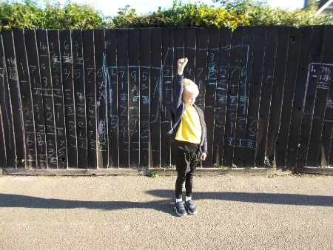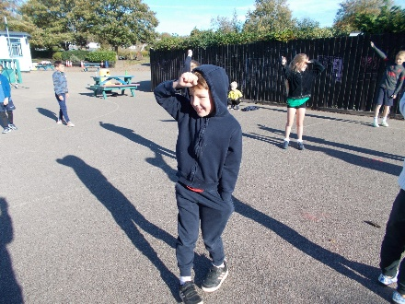
In literacy, Dylan was really proud of his powerful adjectives work. He particularly liked the use of the word traumatised in his sentence, instead of shocked.
We hope you have a lovely weekend.

Hawthorn Class

