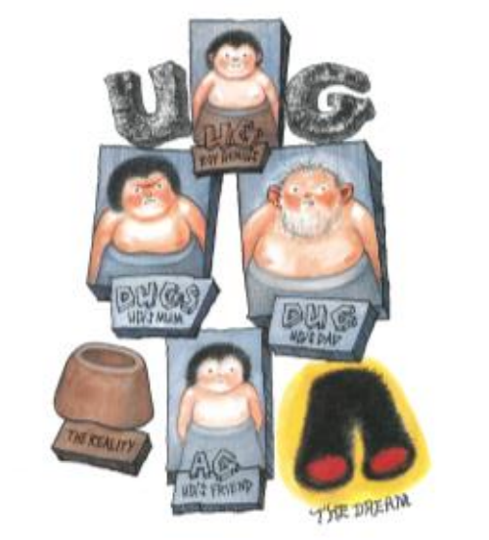

- What is the first thing you notice about the illustration?
- What can you tell about these characters?
- What assumptions might we make about them based on their appearance, their dress, their facial expressions, etc.
- What clues are there that might allow us to starting predicting what this story might be about?
- Who is the main character?
- Where might it be set? What could happen?
- What position might the character be in at the start of the story and how might this have changed by the end?
What do you know about the Stone Age?
What I know about the Stone Age | What I would like to know | What I have found out

