This week’s learning 18.10.21

Monday
Maths – Oak Academy
https://classroom.thenational.academy/lessons/adding-and-subtracting-two-2-digit-numbers-ctk3gr
English – Create a poster showing all the impact that building lots of houses is having on forests, green spaces and natural habitats. Use your ideas from last week and what we discussed when we wrote our letter to the council to help you.
Global learning/DT/Science – This week spend time finishing your bug house.
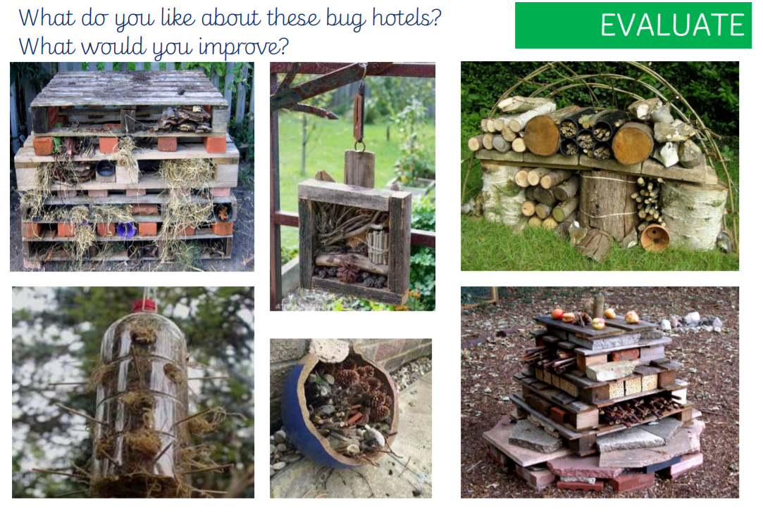

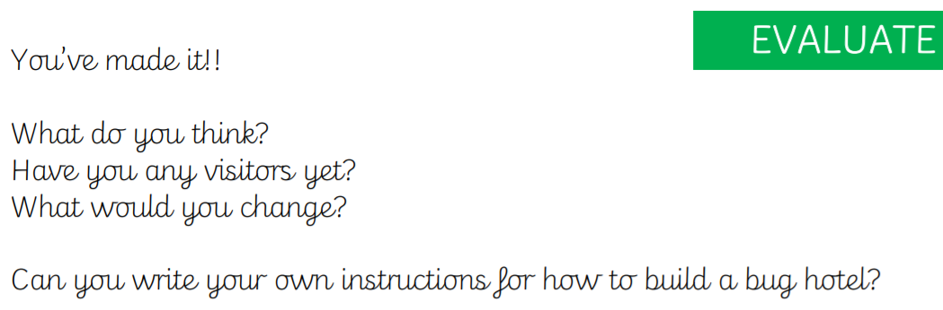

Tuesday
Maths – Adding two digit numbers with regrouping
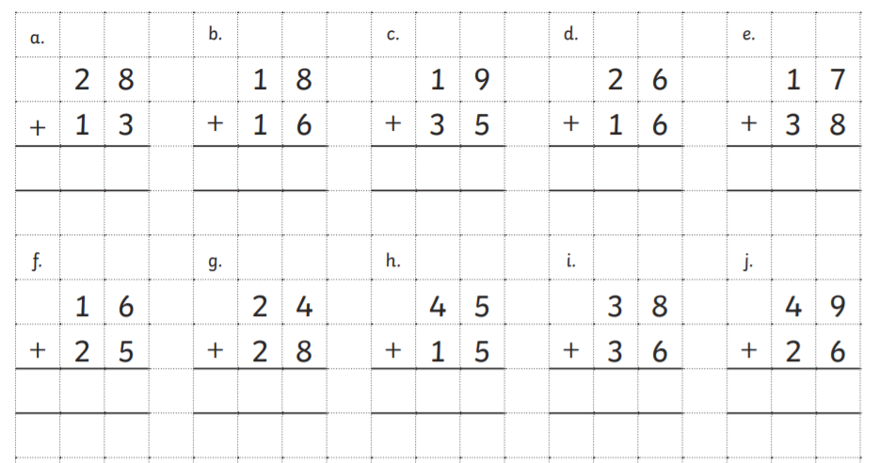

English & Global – Research skylarks. Use this template to record all the information you have found.
https://www.rspb.org.uk/birds-and-wildlife/wildlife-guides/bird-a-z/skylark/
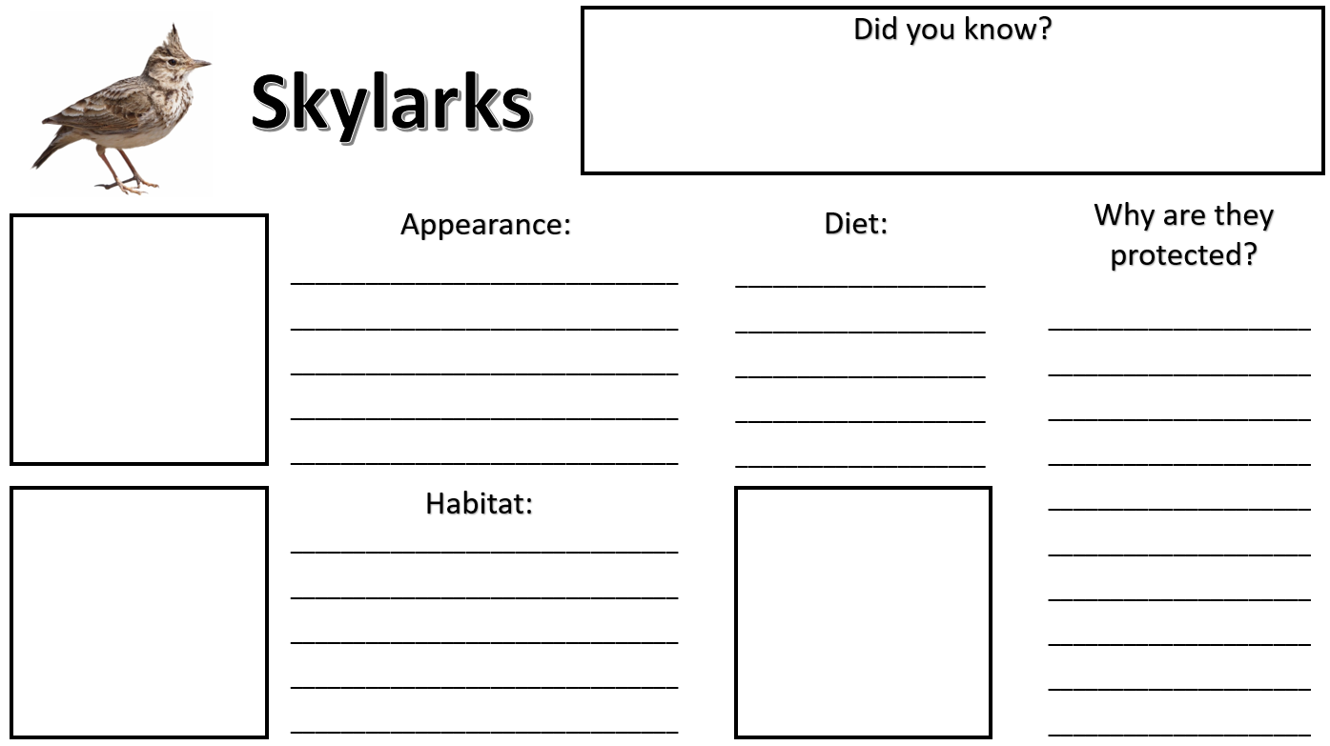

Wednesday
Maths – Oak National Academy
https://classroom.thenational.academy/lessons/exploring-strategies-to-add-three-1-digit-numbers-61j32c
English – Sentence Play: use this interactive sentence game to make your sentences more exciting using adjectives.
https://sentenceplay.co.uk/games/dropping-in
Science- Trees. Watch these videos about trees and the different types of trees in the UK. Make a poster with key facts. Draw and label the different types of trees in the UK.
https://www.youtube.com/watch?v=5I7u5FMQxHA
https://www.youtube.com/watch?v=Zo_gfajkj8c

Thursday
Maths – Oak National Academy
https://classroom.thenational.academy/lessons/consolidating-addition-and-subtraction-of-2-digit-numbers-6rr3ae
English – Today we will finish reading The Last Wolf. What was your favourite part? Why? What shocked you? How will you try to make a difference to our environment?
https://www.youtube.com/watch?v=gQ4yjGGYhcA
French- Practise numbers 1-31 in French. Have a go playing this game and familiarising yourself with the spelling/reading of the words.
https://wordwall.net/resource/3027772/french/french-numbers-1-30
Can you create a poster to help you remember them?

Friday
Maths – Try Level 7
https://www.sheppardsoftware.com/math/addition/fruit-splat-game/
English – Choose an activity from here- they are all linked to your learning and understanding of The Last Wolf- have fun!
http://www.lovemybooks.co.uk/the-last-wolf

R.E. – In R.E. we have learnt how Christians believe God made our planet in 7 days. In PSHE we have learnt the importance of rules. Can you make a poster to show some rules of how to look after our planet?

Daily
Keep reading!
Read a magazine/newspaper article.
Arithmetic (20 minutes a day) – Count in 2s 5s and 10s
Phonics – Play a phonics phase 3 and 5 game on phonics play.
https://www.phonicsplay.co.uk/resources/phase/3

Times Tables – practise your times tables as much as you can!
Useful websites for times tables:
https://www.topmarks.co.uk/maths-games/7-11-years/times-tables
https://www.timestables.co.uk/

PE

Visit youtube and do a session 5 times a week of Joe Wicks/Go Noddle/Cosmic Kids Yoga.

