8th October 2021

The silent blue book
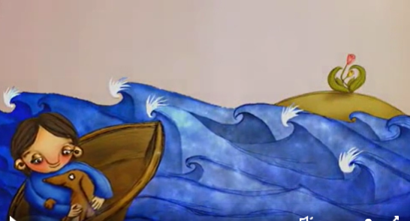

8th October 2021

The silent blue book

8th October 2021

The silent blue book
The story is about______________________________________________________________________________________________________________________________________________________________________________________________________________

8th October 2021

The silent blue book

The girl is feeling_____________ (sad happy)

The dog ___________ the girl. (loves hates)

