This week’s learning 27.09.21

Monday
Maths – Adding and subtracting 2 digits and 3 digit numbers
Find items in your homes to use as dienes and create your own questions, use the resources to help you answer the questions
English – Research and note down facts about the Earth. You could use these links
https://www.natgeokids.com/uk/discover/science/space/facts-about-the-earth/
https://www.ducksters.com/science/composition_of_the_earth.php
https://www.natgeokids.com/uk/discover/geography/physical-geography/structure-of-the-earth/
https://nineplanets.org/kids/earth/#:~:text=Earth%20Notes,than%204%20billion%20years%20old.&text=Earth%20is%20the%20third%20planet%20from%20the%20Sun%2C%20and%20the,planets%20of%20the%20Solar%20System.
https://www.coolkidfacts.com/earth-facts-for-kids/
https://childwellbeing.asu.edu/earthfacts
Global learning – Quality education – Middle Ages
Learn about the Magna Carta and the Bayeux Tapestry
- What are they?
- Why are they significant?
Tuesday
Maths – Adding 2 digit and 3 digit numbers
English – Design your own ‘Did You Know’ page using the information gathered yesterday.
French – Practise writing different greetings
You could use linguascope to help.
Buckden
octopus
Wednesday
Maths – Subtracting 2 digit and 3 digit numbers
English – Edit your poster ideas to improve it. Can you include more exciting vocabulary? Check your punctuation. Find the images that you want to use.
RE – Look at the image below. What would you need to do to look after it? Write at least 5 sentences to describe how you would care for it just like humans are ‘caretakers’ of the world for God.
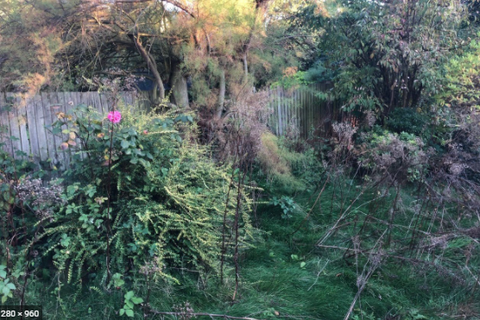

Thursday
Maths – Fluency – practise number bonds to 20
English – (Comprehension) Pobble 365.
Look at the image and answer the questions. Remember, there is no right or wrong answer. Be as imaginative as you can.
Science – Sort and classify rocks into Igneous, Metamorphic and Sedimentary.
Then use that information to create a rock classifying key.
https://www.learner.org/wp-content/interactive/rockcycle/identifyrock/
Friday
Maths- Use natural resources to demonstrate place value to 3 digits.
English – (Comprehension) Pobble 365.
Look at the image and answer the questions. Remember, there is no right or wrong answer. Be as imaginative as you can.
Mind up/PHSE– Recap the parts of the brain – amygdala, hippocampus, prefrontal cortex
What are their functions?

Daily
Hit the button – Times table practise

Keep reading a range of fiction and non-fiction!
Read a magazine/newspaper article.
Arithmetic (20 minutes a day) – Practise your 5 and 10 times tables
PE

Visit YouTube and do a session 5 times a week of Joe Wicks/Go Noddle/Cosmic Kids Yoga.

