Wk beg: 27.09.21
Talk homework:
Tell an adult everything you know about The Earth.

This week Emily-Rose really enjoyed maths. She enjoyed learning how to use column addition and subtraction. We will be practising this again next week.
Alex is enjoying learning about society during The Middle Ages. We will be creating a word document next week and learning how to amend it.
Kara particularly liked learning about The Earth this week. We researched lots of facts using books and the internet. Mrs Anderson was so impressed with all the details we gathered.
Sofia really enjoyed writing her diary entry this week. Earlier on in the week, we used cave art to draw what life might have been like for our prehistoric boy. We then wrote a diary entry about this.
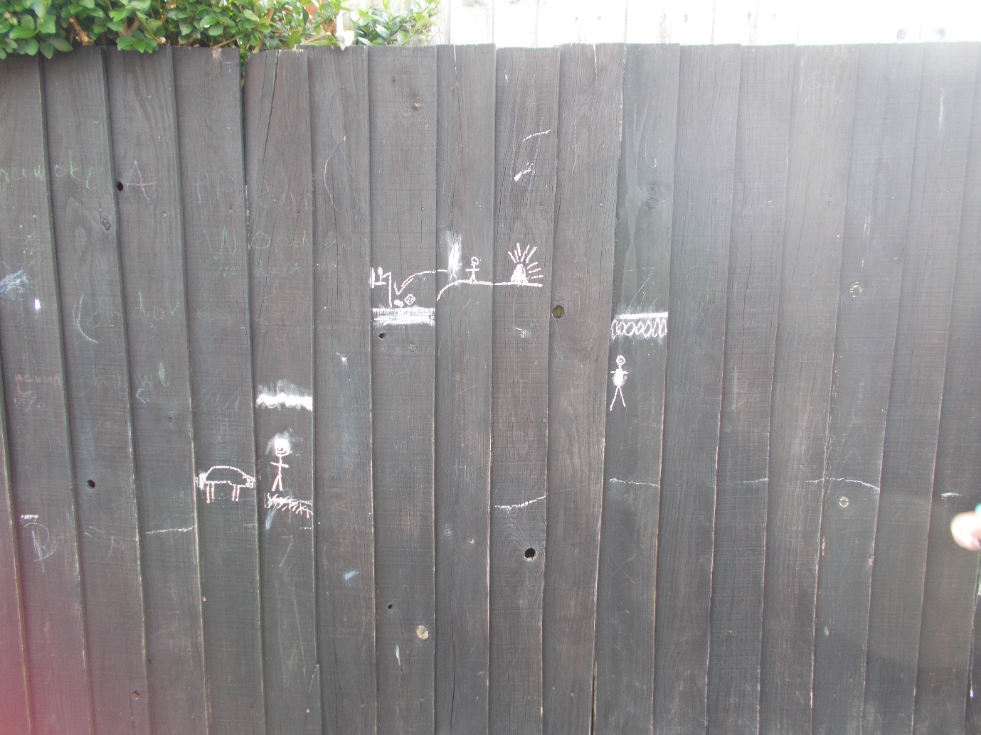
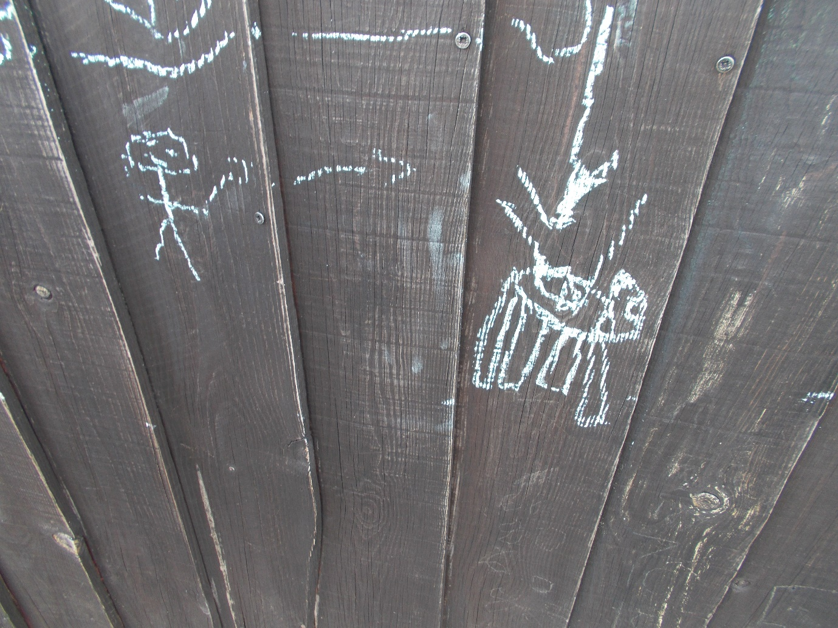
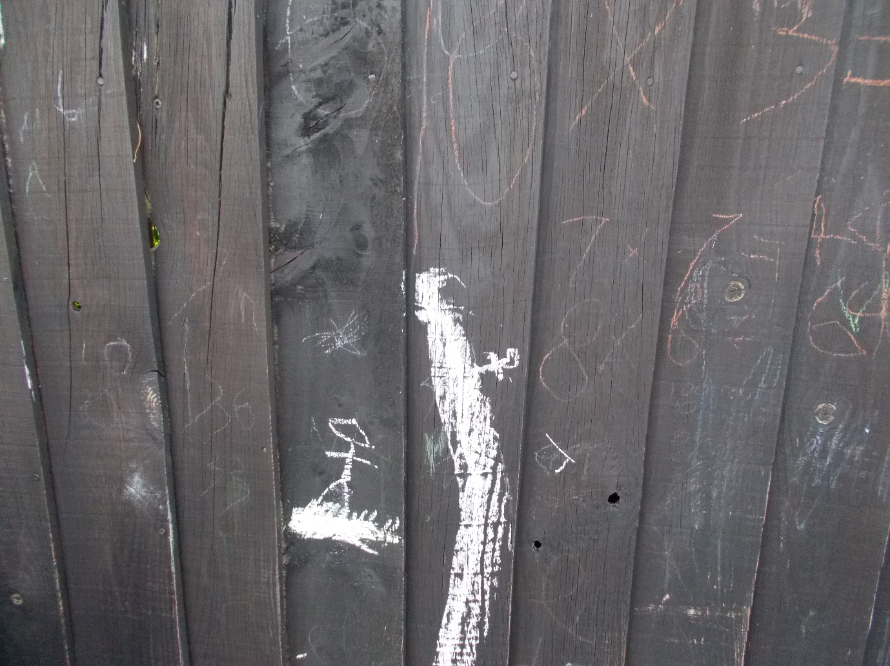
Sonny is enjoying reading. We have daily opportunities to read and quiz and everyone is getting much more confident using the A/R system.
Everyone enjoyed playing stuck in the mud/Bulldog in PE. It gave us the opportunity to practise our marking and dodging skills.

We hope you have a lovely weekend.

Hawthorn class

