This week’s learning 4.10.21

Monday
Maths – Oak Academy –
Adding and subtracting tens from a 2-digit number
https://classroom.thenational.academy/lessons/adding-and-subtracting-tens-from-a-2-digit-number-69h3jt
English – Little Red continues exploring the woods looking for a wolf. She stumbles across a door and is let in by a wolf. This is what she finds- a cosy cave! How do you think Little Red felt when she saw this? What was she thinking? Label some of the different things you can see, what might they be?

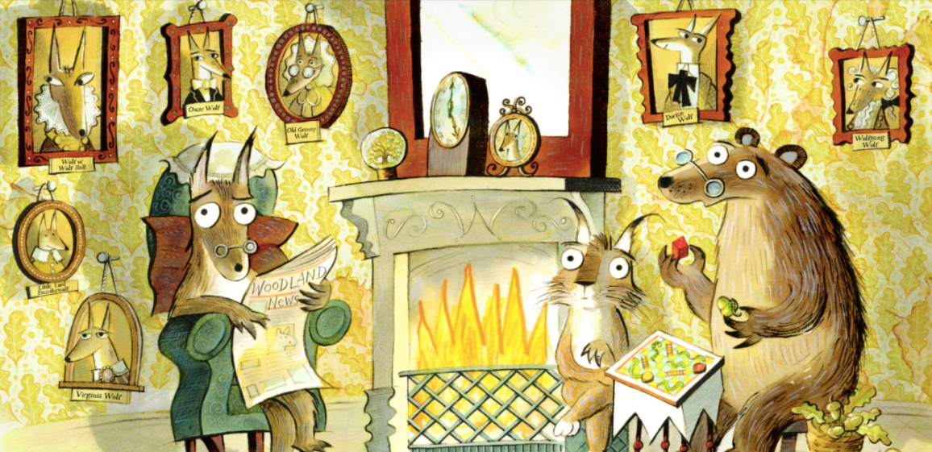
PSHE – What does it mean to reflect? Why is it important to reflect?
https://youtu.be/RMFF_wDrUts

Tuesday
Maths – Adding two digit numbers
https://classroom.thenational.academy/lessons/adding-two-2-digit-numbers-crvk6d
English – This week we will looking at endangered and protected species. Read all about what it means to be endangered here: https://kids.britannica.com/kids/article/endangered-species/353099
Can you find the meanings of these words?
- Protected
- Habitat
- Threat
- extinct
- environment
Research which animals are endangered in the UK.
PE-
As we have been looking closely at life on land and Little Red’s adventure in the forest, try this yoga class- it is called ‘Outside in the woods’!
https://www.youtube.com/watch?v=L8eMSTZ1LbI

Wednesday
Maths – Subtracting 10s. https://classroom.thenational.academy/lessons/subtracting-two-2-digit-numbers-6gup2t
English – Today we are starting our fact files and research on protected species in our local area. First we will be researching badgers. You can watch videos, use the internet, books.
http://www.sciencekids.co.nz/sciencefacts/animals/badger.html
https://easyscienceforkids.com/all-about-badgers/
Can you find out the following:
- Appearance
- Habitat
- Diet
- Why is it protected/endangered?
- Interesting fact
You can use this template to help you present your findings or create your own. Include writing and drawings.
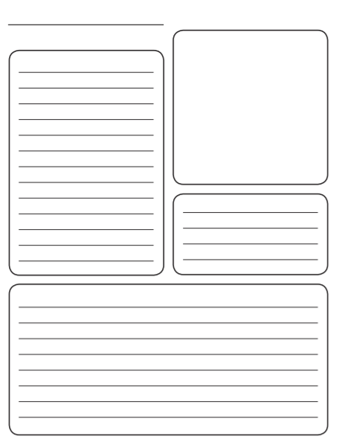
Global: Sir David Attenborough. Read these fact files/biographies and write/draw some facts you have learnt about him. Why do you think he is an inspirational person? Extend your learning by watching some of his work.
https://www.natgeokids.com/uk/discover/science/nature/david-attenborough-facts/
https://www.activityvillage.co.uk/david-attenborough
Here is a video with his message about plastic https://youtu.be/IW3jEIYBFzg

Thursday
Maths – Try this interactive game. Draw place value grids to help you.
https://eng.mathgames.com/skill/2.64-subtract-tens
English – Today we are continuing our fact files and research on protected species in our local area. Next we will be researching skylarks. You can watch videos, use the internet, books.
https://www.rspb.org.uk/birds-and-wildlife/wildlife-guides/bird-a-z/skylark/
Can you find out the following:
- Appearance
- Habitat
- Diet
- Why is it protected/endangered?
- Interesting fact
You can use the template above to help you present your findings or create your own. Include writing and drawings.
French- Practise numbers 1-31 in French use this video to help you https://www.youtube.com/watch?v=DnrTrbJ6mYs
Can you create a poster to help you remember them?

Friday
Maths – Oak Academy- Adding and Subtracting two-digit numbers
https://classroom.thenational.academy/lessons/adding-and-subtracting-two-2-digit-numbers-ctk3gr
English – Today we are continuing our fact files and research on protected species in our local area. Next we will be researching bats. You can watch videos, use the internet, books.
http://www.sciencekids.co.nz/sciencefacts/animals/bat.html

Can you find out the following:
- Appearance
- Habitat
- Diet
- Why is it protected/endangered?
- Interesting fact
You can use the template above to help you present your findings or create your own. Include writing and drawings.

R.E. –

Harvest
Harvest refers to the time during autumn when farmers traditionally brought in the crops that supplied their community through the year. Although our food today is more likely to come from the supermarket, Christians believe it is still important to remember God as creator and thank Him for the good things He provides.
Many churches do this annually at a Harvest Thanksgiving service. At this service, members of the congregation might bring gifts of food and flowers to decorate the church building as a sign of their thanks to God. These gifts may later be taken to needy or elderly people in the neighbourhood.
Can you write an acrostic poem about Harvest? Use each letter to write a word or sentence about it.
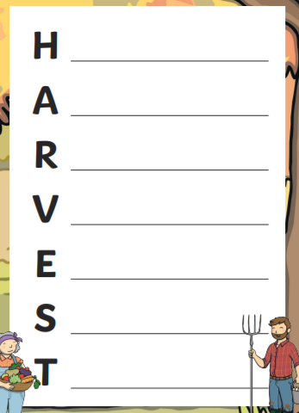

Daily
Keep reading!
Read a magazine/newspaper article.
Arithmetic (20 minutes a day) – Count in 2s 5s and 10s
Phonics – Play a phonics phase 3 and 5 game on phonics play.
https://www.phonicsplay.co.uk/resources/phase/3

Times Tables – practise your times tables as much as you can!
Useful websites for times tables:
https://www.topmarks.co.uk/maths-games/7-11-years/times-tables
https://www.timestables.co.uk/

PE

Visit youtube and do a session 5 times a week of Joe Wicks/Go Noddle/Cosmic Kids Yoga.

