This week’s learning 13.09.21

Monday
Maths – Oak Academy – Addition and subtraction lesson 1 Using number bonds within 20 for addition.
https://classroom.thenational.academy/lessons/using-number-bonds-within-20-for-addition-cgw3cd

English – We will be learning about word classes, e.g. nouns, verbs and adjectives
Watch this video to remind yourself of what a noun, verb or adjective is.
https://www.youtube.com/watch?v=CxrxUyxMnxA
Now look at this picture and find five nouns, five adjectives and five verbs.
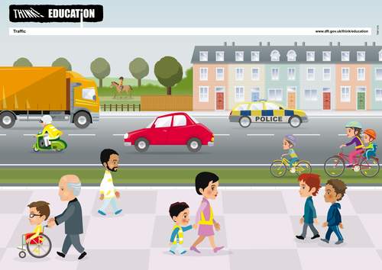

PSHE – Who makes the rules? We have established our class rules and Mrs Heather told us all about our school rules in assembly. We know our rules are important because we imagined our school without rules. Now let’s think about who makes those rules.
Answer these questions:
Who makes the rules in our classroom?
Who makes the rules in our school?
Who makes the rules in Buckden?
Who makes the rules in England?

Tuesday
Maths – Oak Academy - lesson 2 Adding and subtracting ones
https://classroom.thenational.academy/lessons/adding-and-subtracting-ones-from-a-2-digit-number-60wkar

English – In school today we will be writing our description of Little Red in the forest.
Try to remember everything you drew on your plan last week in school. Remember you drew a forest with a stream and lots of trees. Perhaps you added a footpath, bridge, mushrooms, puddles, bracken and a wolf! Then you imagined you were wolf and thought about the sounds you might here when in a forest e.g. whooling winds, snapping branches and howling wolves. Try to write as much as you can to describe the forest.
Computing – Today we will be thinking about how to draw a branching diagram in our book using animal pictures.
Look at this picture with an adult to understand branching diagrams.
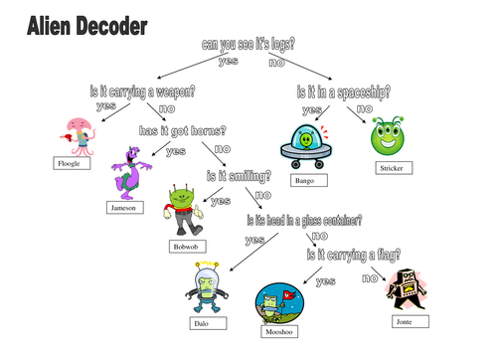
Choose 3 animals from the pictures below. Think of a question that separates 1 from the other 2 e.g. Does it have 2 legs? Then think of another question that separates those 2 animals from each other, maybe Does it have spots? Make a branching diagram to separate your animals.
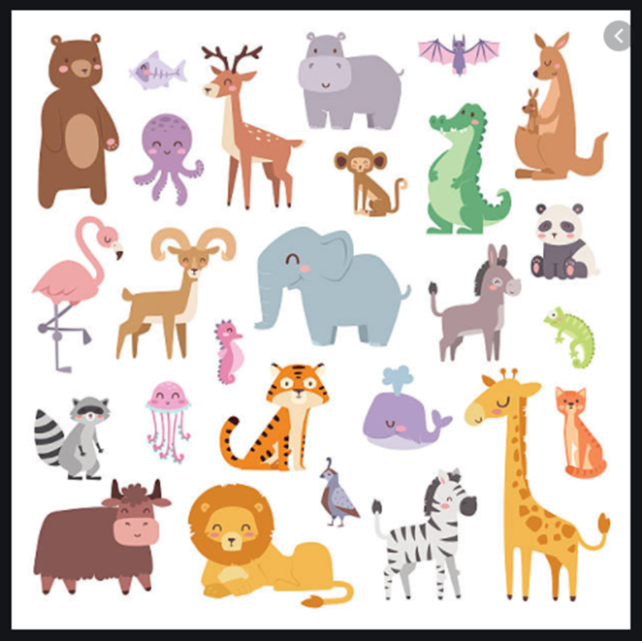

Wednesday
Maths – Oak Academy - lesson 4 Adding and subtracting multiples of ten
https://classroom.thenational.academy/lessons/adding-and-subtracting-multiples-of-ten-64wp8c
English – Edit your work from yesterday with an adult. Take each sentence and read it out loud. Does it sound right? Make sure every sentence started with a capital letter and ended with a full stop. Did you use a capital letter for proper nouns (names). Check a few spellings with your adults too.
Global learning– What is a habitat?
https://classroom.thenational.academy/lessons/adding-and-subtracting-multiples-of-ten-64wp8c

Thursday
Maths – Oak Academy - lesson 5
https://classroom.thenational.academy/lessons/adding-and-subtracting-tens-from-a-2-digit-number-69h3jt
English – Look at the pictures below and find the similarities and differences.
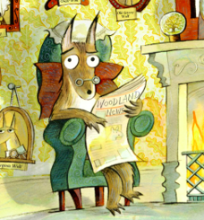

French- Practise numbers 1-31 in French use this video to help you https://www.youtube.com/watch?v=DnrTrbJ6mYs

Friday
Maths – Can you think of all the number bonds to 100? E.g. 10+90=100
Use this number square to help you.
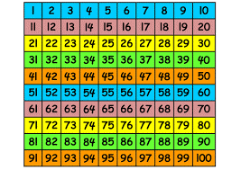
English – https://www.bbc.co.uk/bitesize/articles/z942kty
Choose an activity

R.E. – Can you recall what happens on days 1-7 in the Creation story? If you can’t remember them all use this to help you, https://www.youtube.com/watch?v=qsQHClXz6VA
Now finish this statement,
‘The best thing about the world is……….’
Maybe draw a picture of it too.

Daily
Keep reading!
Read a magazine/newspaper article.
Arithmetic (20 minutes a day) – Count in 2s 5s and 10s
Phonics – Play a phonics phase 3 and 5 game on phonics play.
https://www.phonicsplay.co.uk/resources/phase/3

Times Tables – practise your times tables as much as you can!
Useful websites for times tables:
https://www.topmarks.co.uk/maths-games/7-11-years/times-tables
https://www.timestables.co.uk/

PE

Visit youtube and do a session 5 times a week of Joe Wicks/Go Noddle/Cosmic Kids Yoga.

