This week’s learning 20.09.21

Monday
Maths – Oak Academy - follow the links and complete the activities.
https://classroom.thenational.academy/lessons/counting-sets-within-10-c4w30t

English – Have a look at the front cover of our new Power of Reading book. Write a prediction – I think Beegu will…
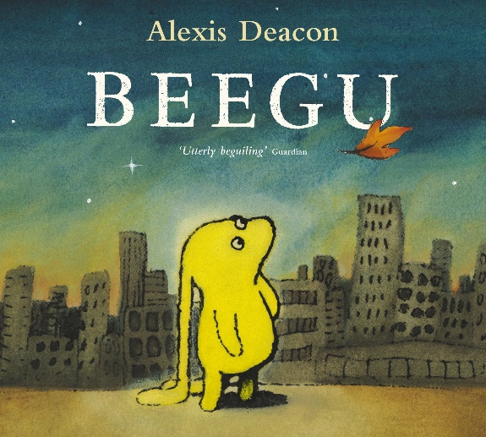
RE – Watch the creation story and draw a picture of your favourite part.
https://www.youtube.com/watch?v=teu7BCZTgDs

Tuesday
Maths – Oak Academy - follow the links and complete the activities.
https://classroom.thenational.academy/lessons/representing-numbers-within-10-71jkec

English – What do think Beegu is saying in this picture. Write what you think in a speech bubble.
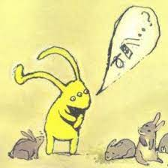

Global Learning – Green week - Look out of your window and see what vehicles are on the road. Can you make a tally of them all for 10 minutes?

Wednesday
Maths – Oak Academy - follow the links and complete the activities.
https://classroom.thenational.academy/lessons/recognising-number-bonds-to-five-and-six-cmw3jt

English – Read your favourite book at home and make your own play performace about it.

French – Practice saying hello and goodbye in French.
https://www.youtube.com/watch?v=NXkJ88ygPY0

Thursday
Maths – Oak Academy - follow the links and complete the activities.
https://classroom.thenational.academy/lessons/recognising-number-bonds-to-seven-and-eight-60r6cc

English – (Comprehension) Oak Academy - follow the links and complete the activities.
https://classroom.thenational.academy/lessons/to-listen-and-respond-to-a-story-6cr66e

PSHE – Make your own feelings poster or chart at home to help you recognise your emotions.

Friday
Maths – Oak Academy - follow the links and complete the activities.
https://classroom.thenational.academy/lessons/recognising-number-bonds-to-nine-and-ten-c8v3ec

English – (SPAG) Practice your handwriting using the year 1 common exception words.
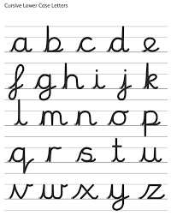
Science – Measure your body parts using objects around your house.

Daily
Abacus - https://www.activelearnprimary.co.uk/login?c=0 (Log ins are in the children’s reading diaries and the school code is kmm7).
Keep reading!
Read a magazine/newspaper article.
Arithmetic (20 minutes a day) – Count to 100 aloud whist doing body percussion, challenge yourself and now count in tens.
Phonics – Play a phonics phase 2 and 3 game on phonics play.
https://www.phonicsplay.co.uk/resources/phase/2/picnic-on-pluto

PE

Visit youtube and do a session 5 times a week of Joe Wicks/Go Noddle/Cosmic Kids Yoga.

