This week’s learning 13.09.21

Monday
Maths – Oak Academy - follow the links and complete the activities.
https://classroom.thenational.academy/lessons/partitioning-numbers-in-different-ways-cgw34d
English – Look at the images below and create a list of adjectives to describe the dragonflies. Think of what you see and how they move.
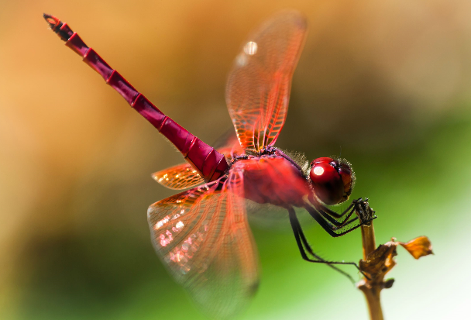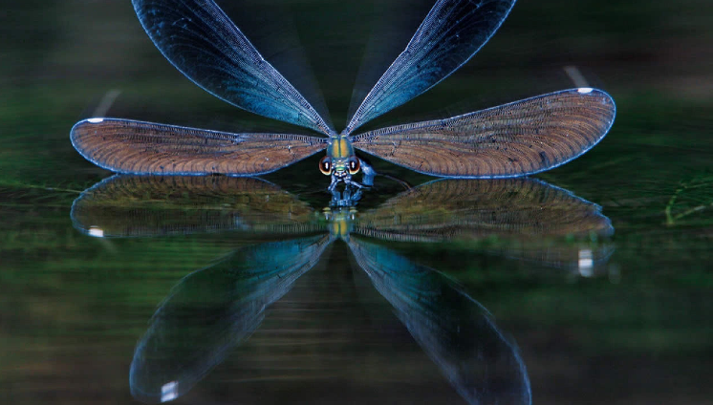

Global learning – Quality education - Draw a picture of a Victorian classroom.
Use the information attached to help you if you find it difficult to remember.
Tuesday
Maths – Place value
Complete the sheet, 10 more or less. Choose just one worksheet.
English – Using a simile, can you write at least 3 sentences to describe the dragonflies above? Remember, similes describe things as being like something, e.g. The dragonfly is as graceful as a ballerina or The dragonfly dances like a ballerina.
French – Practise our song Deux petits oiseaux.
https://www.youtube.com/watch?v=ej15Mp0Zjpw

Wednesday
Maths – Oak Academy - follow the links and complete the activities.
https://classroom.thenational.academy/lessons/ordering-and-comparing-3-digit-numbers-68w68d
English/Art – Draw a picture of a dragonfly, using any medium you like.
RE – Watch the creation story and draw a picture of your favourite part.
https://www.youtube.com/watch?v=teu7BCZTgDs
Thursday
Maths –Greater than, less than worksheet.
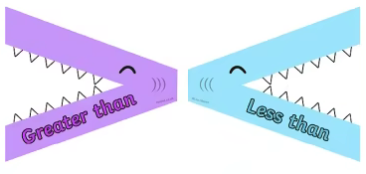
Complete one of the worksheets attached.
English – (Comprehension) Pobble 365.
Look at the image and answer the questions. Remember, there is no right or wrong answer. Be as imaginative as you can.
Science – Naturally occurring rocks.
Look at the slides on natural and man-made rocks. Then discuss with your adult whether the pictures of rocks are natural or man-made.

Friday
Maths – Ordering numbers.
Complete worksheet. Just choose one.
English – (SPAG) Practice your handwriting using the year 3 common exception words.
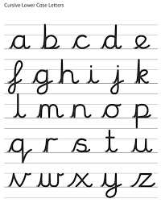
Mind up/PHSE– Let’s talk about feelings.
Look at the PPT and complete the activities.

Daily
Hit the button – Times table practise

Keep reading a range of fiction and non-fiction!
Read a magazine/newspaper article.
Arithmetic (20 minutes a day) – Practise your 4 and 8 times tables
PE

Visit YouTube and do a session 5 times a week of Joe Wicks/Go Noddle/Cosmic Kids Yoga.

