This week’s learning if you are having to self-isolate.

Please complete all work neatly in your books under the date and a short title.

Monday 12th April 2021

Maths
Use a ruler and see if you can find objects around the house that are 6cm, 14cm and 2cm. Use the sheet attached to practice measuring objects on a ruler. Do you always have to start at zero cm.
English
Watch this video https://www.youtube.com/watch?v=pAq0NSIQoYs to hear the end of Rapunzel. Write a review of the book answering the following questions. Did you like the story? Which was your favourite part? Who was your favourite character? Was there a part that you did not like? Why didn’t you like that part? Would you recommend the story to a friend?
P.E.
Choose a tall African animal and think about how it moves. Now think of an African animal that prowls and imagine you are that animal moving around.
Pretend you are a heavy hippo in a big space (https://www.youtube.com/watch?v=1QW85kfakJc), the Hippo moves around, lolling and lazily moving to the “waterhole” which is in the front centre of the hall. Then the hippo is napping at the “waterhole” in the hot sun and still. Make up a little dance listening to the music and pretending to be a hippo.
Suggestion for a further activity: Can you remember the names of shops in French?
Use the PowerPoint attached to learn the names of stationery in French.

Tuesday 13th April 2021

Maths
Use Power Maths Textbook page 88 to learn about comparing lengths. Then complete this challenge to find three things bigger and smaller than 40cm.
English
Today we are starting a new text. Look at the following picture clues and write a paragraph to describe what you think the story might be about? Remember to say your sentence out loud first and when you write it remember your capital letter and full stop.
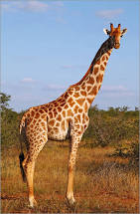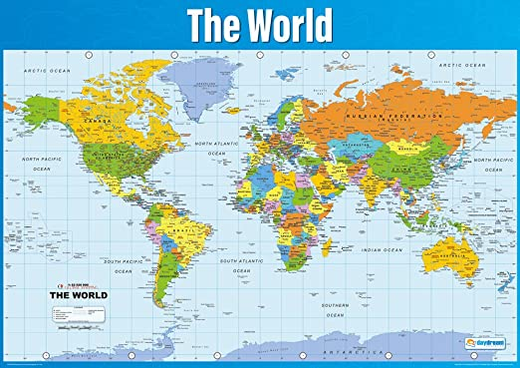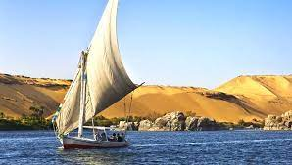
Global
We are going to learn about proportions when drawing a self-portrait. Watch this video to help you.
https://www.bbc.co.uk/teach/class-clips-video/how-to-draw-a-portrait/zk28qp3
Suggestion for a further activity: Practice your handwriting. Write a sentence then check it to make sure: The ascenders are all below the line, the ascenders are tall and straight and higher than the other letters, the lower case letters are all the same size, the capital letter is bigger than all of the lower case letters.

Wednesday 14th April 2021
Maths
Today we will learn about ordering lengths, use Power Maths Textbook on Abacus page 92. Use the questions attached to practise ordering lengths.
English
Use the attached picture to help you answer these questions:
What do we know about the giraffe?
What would you like to know about it?
Does anything puzzle you?
What especially caught your attention?
What sort of story are you expecting? Why?
Does it remind you of anything you have read before?

R.E. Good news: Jesus is a friend to the friendless.
If you could choose 5 people to change the world for the better, who would you choose? (maybe people you admire or people who have been very successful). Jesus chose 12
men to be his world-changers (disciples), but they were not who people might
expect. Watch this video: https://www.youtube.com/watch?v=0nqllVTt1bA START FROM 1.28 stop at 2.40
The video tells the story from Matthew 9:9–13 when Jesus chooses Matthew
the tax collector as one of his 12 disciples, a man nearly everyone disliked. Every time his name is mentioned, pupils can chorus ‘Oh no, Jesus, not him!’
Christians teach that Jesus brought good news because he was a friend to those left out by other people. Write in your book what you have learnt about Jesus and what we know about him as a friend.

Suggestion for a further activity:

Find a short poem and see if you can learn it so that you can recite it off by heart.

Thursday 15th April 2021
Maths
Practise solving measuring word problems using Power Maths Textbook 2b p96. Answer the questions attached to practice your skills.

English
Our story is set in the African plains. Watch this video to learn about this type of habitat.
Watch this video of giraffes in their natural habitat on the plains of Africa. https://www.youtube.com/watch?v=wZ_gyNalI_o
Draw a picture of an African plain including plants, animals and an indication of the weather e.g. sun and plants blowing in a wind.
Global
What can you remember about seeds and bulbs? We have set some seeds and bulbs in school. Can you remember what we set? Clues: The seeds will grow into trees and the bulbs were spring flowers that are yellow and red.
Cut open a tomato (ask an adult to help you). Clean the seeds and see if you can set them in some soil and watch them grow. Draw a picture of the seeds and then draw the seedlings as the grow.
Suggestion for a further activity: Make a pattern with a pencil on a piece of paper and colour each section in a different colour. Remember to colour in short strokes, colour in one direction and avoid any gaps in your colouring.
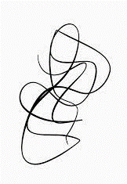

Friday 16th April 2021
Maths
Complete the end of unit check on measurement in Power Maths Practice book 2b p73-74
English
Use your picture from yesterday. Now write a description of the African plains? Remember to describe the weather, what is growing, what is growing for the giraffes to eat. Use lots of adjectives to describe the nouns e.g. wispy, pale green grass
Global
Research a Victorian workhouse.

Suggestion for a further activity: Continue to learn how to spell the year 2 common exception words which are written in your reading log. If you know them all learn the year 3 common exception words. Make sure you can read them first and that you understand what they mean, then learn the spellings.

Additional maths activities

You can use Abacus (Power Maths) and the Whiterose website with this week’s learning objective as a focus for learning all free of charge.
Whiterose - https://whiterosemaths.com/homelearning/year-2/
Abacus - https://www.activelearnprimary.co.uk
The children have their own log in details and the school code is kmm7 in the bottom box.
On Abacus your child has been assigned the Power Maths Textbook and Workbook that we use in school

Times Table Rock Star – practise your times tables as much as you can!
https://play.ttrockstars.com/auth/school/student/76329
Other useful websites for times tables:
https://www.topmarks.co.uk/maths-games/7-11-years/times-tables
https://www.timestables.co.uk/

Revision
Number and Place Value
- To read and write numbers to 100 in words and numerals.
- To find the next multiple of 10 from a given number.
- To find 10 more and 10 less than a given number.
- To find multiples of 10 more and less than a given number e.g. 17…….10 and 20
- To practise recall of number bonds to 10 and 20 mentally i.e. 6 + 4, 5 + 5, 16 + 4, 15 + 5
- To practise recall of number facts to 10 mentally i.e. 6 = 4 + 2, 3 + 3, 5 + 1.
Additional English activities
SPAG - https://www.topmarks.co.uk/english-games/7-11-years/spelling-and-grammar

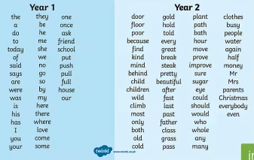
- Read and spell the Year 1 Common Exception Words
- Read the Year 2 Common Exception Words
- Spell the Year 2 Common Exception Words
Practise a few at a time, little and often. Remember – Look, Cover, Write, Check! Make your learning as active as you can, use chalks outside, lots of colour pencils, make the words in playdough or write letters on beans and use those to spell the words.

Some children (not all) have a Nessy login for – Reading and Spelling practise https://www.nessy.com/uk/

Phonics/Reading
Revise all phase 3 and phase 5 sounds
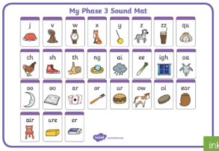 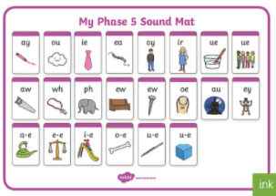
We have been looking at sound buttoning lots of ‘real’ and ‘alien’ words using these sounds, such as queek, splain, screet, scratch, train, etc. We have been spotting the digraphs and trigraphs in lots of words to help with blending and reading new and unfamiliar words correctly.
There are some apps which you may find useful to recap and practise the above sounds.
- Cambugs app (first one is free)
- Reading Eggs https://readingeggs.co.uk/ has many phonics games
Remember to read EVERYDAY.
When you read with your adult(s) at night, get them to ask you questions about the characters, the setting and the plot of the stories!
i.e. Can you describe the main character? What has just happened in the story? Where is the story set? What’s it like there? How does the character feel about what has happened? What do you think might happen next?
Here is a really useful website which offers lots of our banded books to read online, and is free to sign up! www.oxfordowl.co.uk
P.E. Stay active (2 hours a week)

Or you could try sessions of P.E. with Joe Wicks.
(I think he is running sessions on Mon, Wed and Fri starting 11th January)
https://www.youtube.com/c/TheBodyCoachTV/search?query=kids

Also try super movers to make sure you are keeping fit and active
https://www.bbc.co.uk/teach/supermovers/ks1-collection/zbr4scw

Mind Up https://mindup.org.uk/families/

Skills builder https://www.skillsbuilder.org/homelearning

Please take photos of any work you would like us to see and send to them to us at the year 2 email address Year2@buckdenacademy.org
or submit to your Microsoft class teams account by responding to an assignment.

