Wk beg 15.03.21
Talk homework: Tell the Easter Story
Daily reading 15-20 minutes
NESSY 40 minutes a week, if appropriate
TT Rockstars/Abacus/ Mathsframe/Topmarks (Hit the button) – as often as possible.
Here is this week’s learning. Any additional reading and support would be welcomed.
English – Varmints
Maths – Telling the time – to the minute and 5 minutes.
The children are finding this exceptionally difficult so your help would be greatly appreciated.
Science – Plants –How is water transported in plants?
SDG –Sustainable cities and communities– Creating a sustainable space
RE – Christianity – Salvation – The Easter Story
Good afternoon all,
I am so incredibly proud of the pupils this week.
In Maths, we have been continuing with learning the time. We played some outdoor games to consolidate their knowledge of 24 hr digital time.
In English, we wrote a letter to a varmint to try to help him decide whether to stay where he is or to leave in a pod to an unknown location. They all impressed me with the stamina they showed.
In our global learning and skills builder, we have been learning about mood boards, interior design and thinking about our own sustainable space.
In Science, we are learning about plants. This week, we set up a couple of observational experiments to test see how water is transported in plants.
In RE, the children created a fabulous display of the key events of The Easter Story.

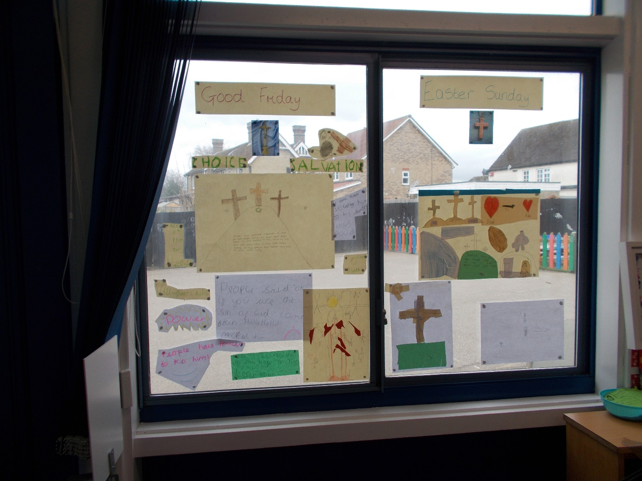

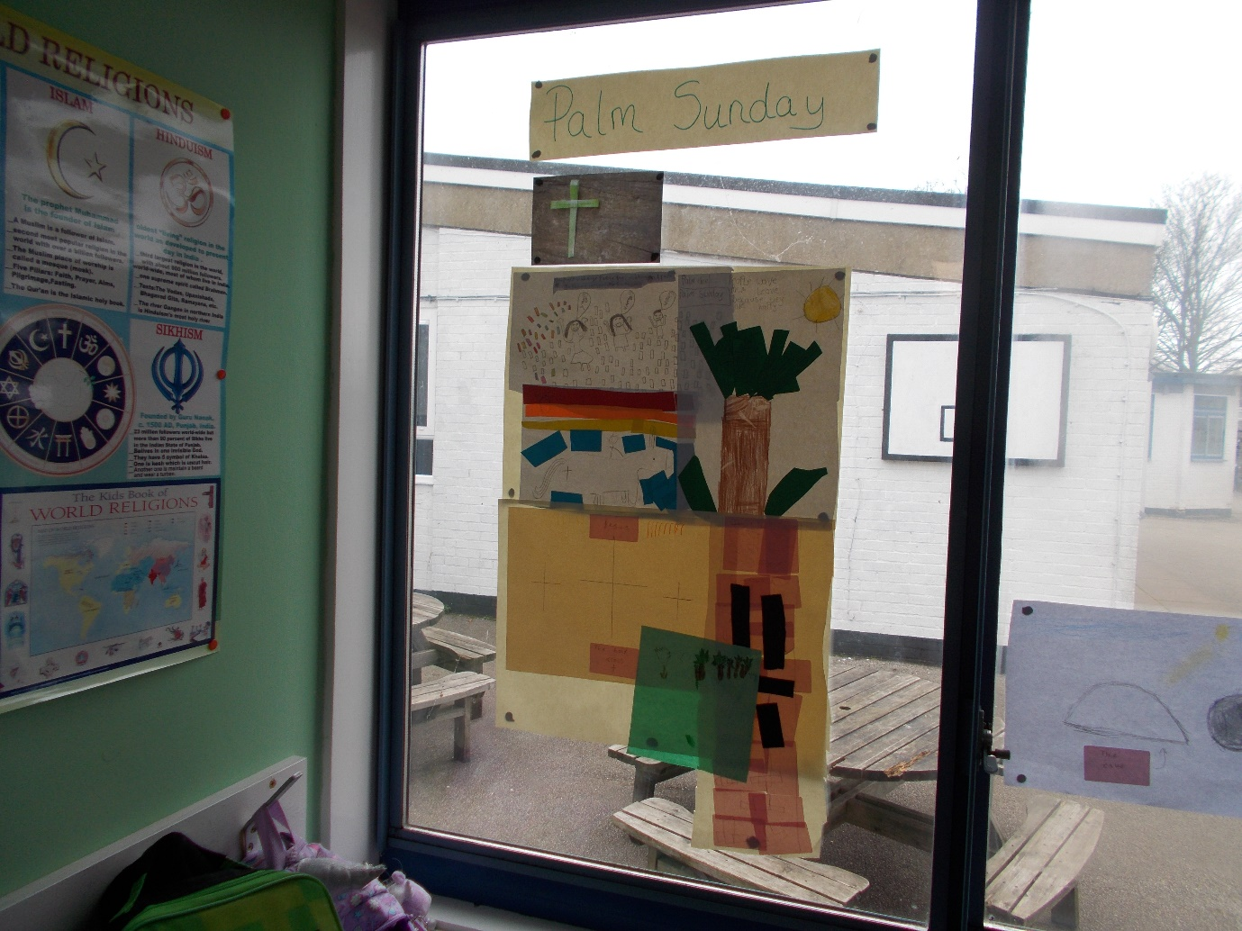
Have a lovely weekend.
From
Sylvia Earle

