This week’s learning if you are having to self-isolate.

Please complete all work neatly in your books under the date and a short title.

Monday 22nd March 2021

Maths
Complete questions 1-10 on the arithmetic quiz attached on the blog. Try to do these on your own without any help to see what you can do.
English
Start to write your story.
Include:
- An introduction to your characters
- A description of the setting that your story takes place in
- A description of the problem that takes place e.g. your villain (baddie) and the witch take over a city
Remember to use:
- Full stops
- Capital letters
- Conjunctions to extend your sentences e.g. because
- Adjectives to describe nouns, the wicked witch
Global
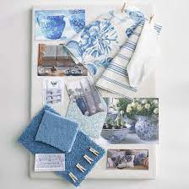
In the afternoons this week we will be designing a bedroom that would suit any child. Can you make a mood board for the design of the bedroom? Maybe choose some colours that you like, some samples of fabric that you could use in the room and some wallpaper/paper for the walls.

Suggestion for a further activity: Can you remember the names of shops in French?
Use the PowerPoint attached to learn the names of stationery in French.

Tuesday 23rd March 2021

Maths
Complete the arithmetic quiz that you started yesterday.
English
Continue to write your story.
Include:
- How the problem is resolved (sorted out)?
- How the witch is defeated/trapped using your ideas that you have planned
Remember to use:
- Full stops
- Capital letters
- Conjunctions to extend your sentences e.g. because
- Adjectives to describe nouns, the wicked witch
Global
Continue designing a bedroom that would suit a child. Choose a theme for the room e.g. sports, animals, the seaside etc. Make a mind map of things to include in the room e.g. beanbags, pictures, lights, toy storage. Be imaginative and add things that would make the room a dream bedroom for any child.

Suggestion for a further activity: Practice your handwriting. Write a sentence then check it to make sure: The ascenders are all below the line, the ascenders are tall and straight and higher than the other letters, the lower case letters are all the same size, the capital letter is bigger than all of the lower case letters.

Wednesday 24th March 2021
Maths
Find objects around the house e.g. a chair, table and a shoe and measure them using a ruler. Measure their length in metres and centimetres. Now compare their lengths and order them from longest to shortest.
English
Finish writing your story.
Include:
- How the story ends
- How the characters feel at the end of the story
Remember to use:
- Full stops
- Capital letters
- Conjunctions to extend your sentences e.g. because
- Adjectives to describe nouns, the wicked witch
Global
Draw a self-portrait but this time draw yourself by looking in the mirror. Then you could try another self-portrait following the instructions attached.
Suggestion for a further activity:

Find a short poem and see if you can learn it so that you can recite it off by heart.

Thursday 25th March 2021
Maths
Complete half of the reasoning test attached.
English
Read your story to a sibling or an adult.
Global
Draw a picture of the dream child’s bedroom that you are designing. Remember to include lots of detail, colour (using your mood board) and objects (using your mind map). Label your drawing.
Suggestion for a further activity: Make a pattern with a pencil on a piece of paper and colour each section in a different colour. Remember to colour in short strokes, colour in one direction and avoid any gaps in your colouring.
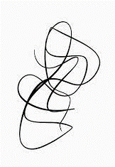

Friday 26th March 2021
Maths
Finish the reasoning maths paper attached
English
Read your story back through and play spot the mistake. Use this check list to help you find mistakes:
- Check every sentence starts with a capital letter
- Check every name starts with a capital letter
- Check every sentence ends with a full stop
- Have you missed out any words
- Use the lists of common exception words below to help you check spellings

Global
Make a model of the bedroom you have designed in a shoebox. Use objects that are from your recycling (ask an adult first).

Suggestion for a further activity: Continue to learn how to spell the year 2 common exception words which are written in your reading log. If you know them all learn the year 3 common exception words. Make sure you can read them first and that you understand what they mean, then learn the spellings.

Additional maths activities

You can use Abacus (Power Maths) and the Whiterose website with this week’s learning objective as a focus for learning all free of charge.
Whiterose - https://whiterosemaths.com/homelearning/year-2/
Abacus - https://www.activelearnprimary.co.uk
The children have their own log in details and the school code is kmm7 in the bottom box.
On Abacus your child has been assigned the Power Maths Textbook and Workbook that we use in school

Times Table Rock Star – practise your times tables as much as you can!
https://play.ttrockstars.com/auth/school/student/76329
Other useful websites for times tables:
https://www.topmarks.co.uk/maths-games/7-11-years/times-tables
https://www.timestables.co.uk/

Revision
Number and Place Value
- To read and write numbers to 100 in words and numerals.
- To find the next multiple of 10 from a given number.
- To find 10 more and 10 less than a given number.
- To find multiples of 10 more and less than a given number e.g. 17…….10 and 20
- To practise recall of number bonds to 10 and 20 mentally i.e. 6 + 4, 5 + 5, 16 + 4, 15 + 5
- To practise recall of number facts to 10 mentally i.e. 6 = 4 + 2, 3 + 3, 5 + 1.
Additional English activities
SPAG - https://www.topmarks.co.uk/english-games/7-11-years/spelling-and-grammar

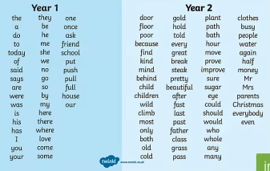
- Read and spell the Year 1 Common Exception Words
- Read the Year 2 Common Exception Words
- Spell the Year 2 Common Exception Words
Practise a few at a time, little and often. Remember – Look, Cover, Write, Check! Make your learning as active as you can, use chalks outside, lots of colour pencils, make the words in playdough or write letters on beans and use those to spell the words.

Some children (not all) have a Nessy login for – Reading and Spelling practise https://www.nessy.com/uk/

Phonics/Reading
Revise all phase 3 and phase 5 sounds
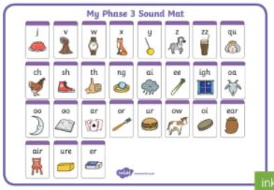 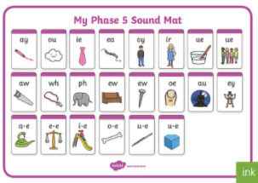
We have been looking at sound buttoning lots of ‘real’ and ‘alien’ words using these sounds, such as queek, splain, screet, scratch, train, etc. We have been spotting the digraphs and trigraphs in lots of words to help with blending and reading new and unfamiliar words correctly.
There are some apps which you may find useful to recap and practise the above sounds.
- Cambugs app (first one is free)
- Reading Eggs https://readingeggs.co.uk/ has many phonics games
Remember to read EVERYDAY.
When you read with your adult(s) at night, get them to ask you questions about the characters, the setting and the plot of the stories!
i.e. Can you describe the main character? What has just happened in the story? Where is the story set? What’s it like there? How does the character feel about what has happened? What do you think might happen next?
Here is a really useful website which offers lots of our banded books to read online, and is free to sign up! www.oxfordowl.co.uk
P.E. Stay active (2 hours a week)

Or you could try sessions of P.E. with Joe Wicks.
(I think he is running sessions on Mon, Wed and Fri starting 11th January)
https://www.youtube.com/c/TheBodyCoachTV/search?query=kids

Also try super movers to make sure you are keeping fit and active
https://www.bbc.co.uk/teach/supermovers/ks1-collection/zbr4scw

Mind Up https://mindup.org.uk/families/

Skills builder https://www.skillsbuilder.org/homelearning

Please take photos of any work you would like us to see and send to them to us at the year 2 email address Year2@buckdenacademy.org
or submit to your Microsoft class teams account by responding to an assignment.

