Year 5 – Home Learning Week Beg 01.03.21

Please find a timetable below for our weekly lessons on Microsoft Teams. The input for the sessions will be about 30 minutes and then you will be set independent tasks to do.

 | 9.30am | 11am | 1pm
Monday | Maths (Miss Conlong) | English (Miss Conlong) | Global Learning (Miss Conlong)
Tuesday | Maths (Miss Conlong) | English (Miss Conlong) | Global Learning (Miss Conlong)
Wednesday | Maths (Mrs Jaynes) | English (Mrs Jaynes) | RE (Mrs Jaynes)
Thursday | Maths (Mrs Jaynes) | English (Mrs Jaynes) | PE (Miss Lizell)
Friday | Maths (Mrs Jaynes) | English (Mrs Jaynes) | Offline Skills Builder

Monday
9am
Please visit Miss Lizell’s you tube channel for access to the morning wake up PE session which is at 9am everyday.
https://www.youtube.com/channel/UCo1Ce6-TzdWlBNvvJEF1K5w
9.30am
Maths – log onto the live lesson
11am
English – log onto the live lesson
1pm
Global Learning – log onto the live lesson

Extra lesson
This lesson is not live and to be completed in your own time.
French
Using linguascope practise your numbers 1 – 50. Complete the worksheet below. Using the number bank on the left hand side of the worksheet to help you write (and correctly spell) the numbers on the right hand side of the worksheet.

Tuesday
9am
Please visit Miss Lizell’s you tube channel for access to the morning wake up PE session which is at 9am everyday.
https://www.youtube.com/channel/UCo1Ce6-TzdWlBNvvJEF1K5w
9.30am
Maths – log onto the live lesson
11am
English – log onto the live lesson
1pm
Global Learning – log onto the live lesson
1.45pm
Collective Worship – log onto live lesson

Extra lesson
This lesson is not live and to be completed in your own time.
PSHE
Think about the last year and the lockdowns we have been in. If you were going to write to another child in another country who are also going through lockdown what would you suggest they do to stay positive? Think about what you have enjoyed about being in lockdown? What have you done or seen that has helped you to stay positive during this time? Write a letter to them, how would you cheer them up and make them feel positive and hopeful again.
Please bring these letters with you when you return to school on Monday (8th March) as they will be needed. The letters will be going on the excellence boards so make sure that they are presented neatly.

Wednesday
9am
Please visit Miss Lizell’s you tube channel for access to the morning wake up PE session which is at 9am everyday.
https://www.youtube.com/channel/UCo1Ce6-TzdWlBNvvJEF1K5w
9.30am
Maths – log onto the live lesson
11am
English – log onto the live lesson
11.45am
Parent drop-in
For your parents to ask us any questions that they may have. They will need to use your log in details to access teams.
1pm
RE – log onto the live lesson

Extra lesson
This lesson is not live and to be completed in your own time.
Spelling
Homphones and pairs of words that are often confused
In the pairs of words, nouns end –ce and verbs end –se. Advice and advise provide a useful clue as the word advise (verb) is pronounced with a /z/ sound – which could not be spelt c.
advice / advise
device / devise
licence / license
practice / practise
prophecy / prophesy
In your Handwriting books try the following activities to practise your spellings
- Hidden Words – draw and colour a picture. Hide your spelling words inside the picture. See if someone can find your hidden words.
- Choo Choo Words – write your whole list of spelling words end-to-end as one whole word. Write each new word in a different colour.

Thursday
9am
Please visit Miss Lizell’s you tube channel for access to the morning wake up PE session which is at 9am everyday.
https://www.youtube.com/channel/UCo1Ce6-TzdWlBNvvJEF1K5w
9.30am
Maths – log onto the live lesson
11am
English – log onto the live lesson
1pm
PE with Lizell – log onto the live lesson
1.45pm
Collective Worship – log onto live lesson

Extra lesson
This lesson is not live and to be completed in your own time.

World Book Day
Please choose one of the following activities to complete for World Book Day
*Create a poem about your favourite book character
*Find an interesting place to read a book and take a photo of you reading in that space
*Create your favourite book character using interesting objects that you find out on a walk or interesting items from around your house
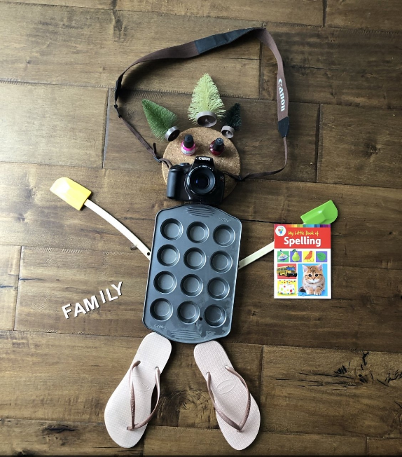

Friday
9am
Please visit Miss Lizell’s you tube channel for access to the morning wake up PE session which is at 9am everyday.
https://www.youtube.com/channel/UCo1Ce6-TzdWlBNvvJEF1K5w
9.30am
Maths – log onto the live lesson
11am
English – log onto the live lesson

Collective Worship – A link will be added onto teams so that you can watch the assembly at whatever time during the day suits you best.

Extra lesson
This lesson is not live and to be completed in your own time.
Friday 6th March
We hope you have enjoyed doing the Skills Builder Sessions and I hope you will consider how you will bring the skills you have learnt back into the classroom.
The skills challenges are same across the school, so that for families with more than one child in school, there is the opportunity to do the challenge together.
If appropriate upload a photograph for your teacher to see and answer the reflection questions at the level you feel you are, this will change for different skills.
 | Plan an indoor picnic. Work with members of your household to decide when and where you will have the picnic, what food you will need to prepare and what you will sit on. Make sure everyone has a job.  Reflection Questions  Beginner: When do you find it easier or more difficult to work with others in a positive way?  Intermediate: How have you contributed to the group decision making?  Advanced: What does it mean to support other people?  Expert: How can you ensure that you think about others’ ideas and recognise the value in them?
 | Imagine you are the prime minister and are going to deliver a speech at a press conference about schools reopening.  What would you say? Think carefully about making your points in a logical order and being clear so your audience will understand your message.  Extension: Challenge your family to do the same - would you all say something similar?  Reflection Questions  Beginner: How do we know if we are speaking clearly?  Intermediate: What is meant by your expression? How does expression affect the meaning of what someone is saying?  Advanced: How can you use tone, expression and gesture to make your speaking engaging?  Expert: How can you adapt the content of what you are saying, in response to listeners?
 | Organise a family quiz.  Choose a theme you know your family will enjoy. Make sure everyone has a job as you prepare for the quiz. You may need someone to set the questions, to ask the questions, to keep scores and to organise snacks. You could invite other friends and family to join in too over the internet.  Extension: Think about everyone's strengths - what job would they be best at? Manage any disagreements carefully.  Reflection Questions  Beginner: What are different emotions? When have you felt these today?  Intermediate: How can you identify strengths and weaknesses in others?  Advanced: Why is it important for a leader to be able to manage time and resources?  Expert: What are good leaders able to do?

Maths games
https://play.ttrockstars.com/auth/school/student/76329
https://www.topmarks.co.uk/maths-games/7-11-years/times-tables
https://www.timestables.co.uk/

Activities that could be used to help you learn your spellings
In your handwriting books try the following spelling activities:
- Choo Choo Words – write your whole list of spelling words end-to-end as one whole word. Write each new word in a different colour.
- UPPER and lower – write your words once with all uppercase letters and one time with all lowercase letters.
- Rainbow Write – first, write the words in pencil. Then trace over them in two different colours.
- Other Handed – first, write your words in the way you usually do. Then, write the list using your other hand.
- Magazine Words – Use an old magazine or newspaper and find your words or letters that make up words. Glue them down.
- Hidden Words – draw and colour a picture. Hide your spelling words inside the picture. See if someone can find your hidden words.
Reading
Keep reading! Remember to read EVERYDAY.

The Accelerated Reader (AR) programme is also accessible from home during this time too, so once you’ve finished your books make sure you log on and take a quiz.
https://ukhosted2.renlearn.co.uk/2152328/

Mind Up
https://mindup.org.uk/families/

Skills builder
https://www.skillsbuilder.org/homelearning

French
(Log in – Username - Buckden Password – octopus)
https://www.linguascope.com/



