Year 5 – Home Learning Week Beg 08.02.21

Please find a timetable below for our weekly lessons on Microsoft Teams. The input for the sessions will be about 30 minutes and then you will be set independent tasks to do.

 | 9.30am | 11am | 1pm
Monday | Maths (Miss Conlong) | English (Miss Conlong) | Global Learning (Miss Conlong)
Tuesday | Maths (Miss Conlong) | English (Miss Conlong) | Global Learning (Miss Conlong)
Wednesday | Maths (Mrs Jaynes) | English (Mrs Jaynes) | Science (Mrs Jaynes)
Thursday | English (Mrs Jaynes) | Maths (Mrs Jaynes) | PE (Miss Lizell)
Friday | Maths (Mrs Jaynes) | English (Mrs Jaynes) | RE (Mrs Jaynes)

Monday
9am
Please visit Miss Lizell’s you tube channel for access to the morning wake up PE session which is at 9am everyday.
https://www.youtube.com/channel/UCo1Ce6-TzdWlBNvvJEF1K5w
9.30am
Maths – log onto the live lesson
11am
English – log onto the live lesson
1pm
Global Learning – log onto the live lesson

Extra lesson
This lesson is not live and to be completed in your own time.

Using the data below, in your maths books draw two graphs. One to show the average monthly temperatures for both London and Canberra, Australia. The second graph is to show the average monthly rainfall for both London and Canberra. Once you have completed your graph can you tell me 5 things you notice from your graphs.
There is an example of what your graph may look like below – The example is for China and Chile however so your graph will not look exactly like the example.

Average temperature and rainfall - Canberra
 | January | February | March | April | May | June | July | August | September | October | November | December
Avg. Temperature (°C) | 20.5 | 20.2 | 17.7 | 13.2 | 9.2 | 6.5 | 5.5 | 7 | 9.6 | 12.7 | 15.7 | 18.6

Precipitation / Rainfall (mm) | 63 | 51 | 55 | 50 | 47 | 38 | 51 | 49 | 61 | 64 | 61 | 48

Average temperature and rainfall – London
 | January | February | March | April | May | June | July | August | September | October | November | December
Avg. Temperature (°C) | 4.9 | 5 | 7.2 | 9.7 | 13.1 | 16.6 | 18.7 | 18.2 | 15.5 | 11.6 | 7.7 | 5.6
Precipitation / Rainfall (mm) | 56 | 39 | 46 | 45 | 49 | 50 | 48 | 53 | 56 | 60 | 61 | 58

Example of what your graph looks like.
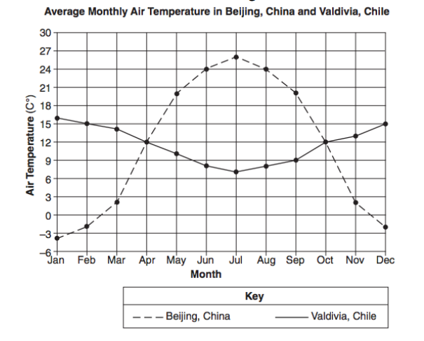

Tuesday
9am
Please visit Miss Lizell’s you tube channel for access to the morning wake up PE session which is at 9am everyday.
https://www.youtube.com/channel/UCo1Ce6-TzdWlBNvvJEF1K5w
9.30am
Maths – log onto the live lesson
11am
English – log onto the live lesson
1pm
Global Learning – log onto the live lesson
1.45pm
Collective Worship – log onto live lesson
2.15pm
Parents drop-in
For your parents to ask us any questions that they may have. They will need to use your log in details to access teams.

Extra lesson
This lesson is not live and to be completed in your own time.

Using linguascope look at hobbies. Create a weekly timetable of hobbies for different members of a family. Think about the time of day they are going to be doing these activities and how long they last for. Make sure it is all written in French. There are 5 people in the family.

Wednesday
9am
Please visit Miss Lizell’s you tube channel for access to the morning wake up PE session which is at 9am everyday.
https://www.youtube.com/channel/UCo1Ce6-TzdWlBNvvJEF1K5w
9.30am
Maths – log onto the live lesson
11am
English – log onto the live lesson
1pm
Science – log onto the live lesson

Extra lesson
This lesson is not live and to be completed in your own time.
Choose an object from around your house or in your garden, which has a lot of detail on it. This could be a flower, fruit bowl, a pattern on your wall paper or an ornament. Make an observational pencil drawing of the item. You could draw the whole object or choose a part of it which is interesting. Take your time, this should be an activity that takes a minimum of half an hour. Think about the tone and shading of your drawing as well.
See below for some examples
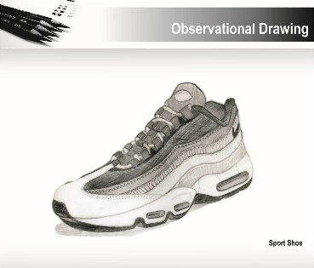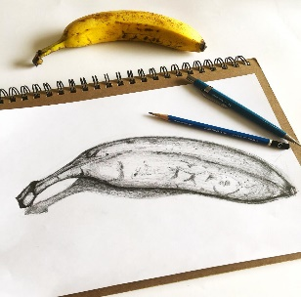

Thursday
9am
Please visit Miss Lizell’s you tube channel for access to the morning wake up PE session which is at 9am everyday.
https://www.youtube.com/channel/UCo1Ce6-TzdWlBNvvJEF1K5w
9.30am
English – log onto the live lesson
11am
Maths – log onto the live lesson
1pm
PE with Lizell – log onto the live lesson
1.45pm
Collective Worship – log onto live lesson
2.15pm
Parents drop-in
For your parents to ask us any questions that they may have. They will need to use your log in details to access teams.

Extra lesson
This lesson is not live and to be completed in your own time.
Spelling
Use of the hyphen
Hyphens can be used to join a prefix to a root word, especially if the prefix ends in a vowel letter and the root word also begins in one.
Co-ordinate, re-enter, co-own, co-operate, self-service, ice-cream, sugar-free

In your Handwriting books try the following activities to practise your spellings
- Hidden Words – draw and colour a picture. Hide your spelling words inside the picture. See if someone can find your hidden words.
- Choo Choo Words – write your whole list of spelling words end-to-end as one whole word. Write each new word in a different colour.

Friday
9am
Please visit Miss Lizell’s you tube channel for access to the morning wake up PE session which is at 9am everyday.
https://www.youtube.com/channel/UCo1Ce6-TzdWlBNvvJEF1K5w
9.30am
Maths – log onto the live lesson
11am
English – log onto the live lesson

Collective Worship – A link will be added onto teams so that you can watch the assembly at whatever time during the day suits you best.

Extra lesson
This lesson is not live and to be completed in your own time.

Friday 12th February
Here at Buckden we have written our own Buckden School Curriculum and we have incorporated the 8 skills identified by Skills Builder into our lessons. In order to help reduce the amount of screen time, each Friday we would like you to choose 1 of the three challenges to do on a Friday afternoon (or at a convenient time) to practise your skills. The skills challenges will be the same across the school so that for families with more than one child in school there is the opportunity to do the challenge together.
If appropriate upload a photograph for your teacher to see and answer the reflection questions at the level you feel you are, this will change for different skills.
 | Protect Our Planet. Research climate change and list or mindmap different things you could do at home to help protect our environment. Choose 3 simple things you will do differently as an individual this year to play your part in solving this problem.  Reflection Questions  Beginner: What are the instructions?  Intermediate: How can you use pros and cons to make a decision?  Advanced: Why is it important to consider a range of solutions for complex problems?  Expert: How might you choose between different solutions to a complex problem?
 | Create a Vlog or video diary. Speak clearly as you describe your daily routine. Talk about what you are doing in lockdown and how you feel.  Reflection Questions  Beginner: How do we know if we are speaking clearly?  Intermediate: What is meant by your expression? How does expression affect the meaning of what someone is saying?  Advanced: How can you use tone, expression and gesture to make your speaking engaging?  Expert: How can you adapt the content of what you are saying, in response to different listeners?
 | Design a new board game.  Base the design on Snakes and Ladders, but choose a new theme. Design the board, the pieces and the rules. Show the design to a family member.  Extension: Create the game using materials you have at home. Invite a member of your family to play it with you.  Reflection Questions  Beginner: When do you use your imagination?  Intermediate: How can we come up with lots of ideas?  Advanced: How can creativity be used in different areas of life?  Expert: Where can we get different perspectives from, to develop our ideas?

Maths games
https://play.ttrockstars.com/auth/school/student/76329
https://www.topmarks.co.uk/maths-games/7-11-years/times-tables
https://www.timestables.co.uk/

Activities that could be used to help you learn your spellings
In your handwriting books try the following spelling activities:
- Choo Choo Words – write your whole list of spelling words end-to-end as one whole word. Write each new word in a different colour.
- UPPER and lower – write your words once with all uppercase letters and one time with all lowercase letters.
- Rainbow Write – first, write the words in pencil. Then trace over them in two different colours.
- Other Handed – first, write your words in the way you usually do. Then, write the list using your other hand.
- Magazine Words – Use an old magazine or newspaper and find your words or letters that make up words. Glue them down.
- Hidden Words – draw and colour a picture. Hide your spelling words inside the picture. See if someone can find your hidden words.
Reading
Keep reading! Remember to read EVERYDAY.

The Accelerated Reader (AR) programme is also accessible from home during this time too, so once you’ve finished your books make sure you log on and take a quiz.
https://ukhosted2.renlearn.co.uk/2152328/

Mind Up
https://mindup.org.uk/families/

Skills builder
https://www.skillsbuilder.org/homelearning

French
(Log in – Username - Buckden Password – octopus)
https://www.linguascope.com/

An Optional Extra Activity
As a school we have registered for the Young Artists' Summer show. This is an opportunity for the children to explore and create a piece/s of artwork overtime and at their own pace. The Young Artists’ Summer Show is a free, open submission exhibition for young artists aged 5 - 19 years studying in the UK and British schools overseas. To take part, students or their parents/guardians can submit artworks. These artworks are then judged by a panel of artists and arts professionals with selected artworks displayed online and on-site at the Royal Academy of Arts. https://youngartists.royalacademy.org.uk/get-involved

