Year 5 – Home Learning Week Beg 01.02.21

Please find a timetable below for our weekly lessons on Microsoft Teams. The input for the sessions will be about 30 minutes and then you will be set independent tasks to do.

 | 9.30am | 11am | 1pm
Monday | Maths (Miss Conlong) | English (Miss Conlong) | Global Learning (Miss Conlong)
Tuesday | Maths (Miss Conlong) | English (Miss Conlong) | Global Learning (Miss Conlong)
Wednesday | Maths (Mrs Jaynes) | English (Mrs Jaynes) | Science (Mrs Jaynes)
Thursday | Maths (Mrs Jaynes) | English (Mrs Jaynes) | PE (Miss Lizell)
Friday | Maths (Mrs Jaynes) | English (Mrs Jaynes) | RE (Mrs Jaynes)

Monday
9am
Please visit Miss Lizell’s you tube channel for access to the morning wake up PE session which is at 9am everyday.
https://www.youtube.com/channel/UCo1Ce6-TzdWlBNvvJEF1K5w
9.30am
Maths – log onto the live lesson
11am
English – log onto the live lesson
1pm
Global Learning – log onto the live lesson

Extra lesson
Following on from our work on ‘Why do oceans and coral reefs matter?’ we would like you to think a little more about plastics.
Please watch the Ted Talk below to give you some information about the history and impact of plastics on the world.
https://www.ted.com/talks/amy_ella_meek_kids_against_plastic?language=en
Using plastics from around your house, can you create a piece of art work. It could be a generic piece of work looking at patterns or an interpretation of a scene or picture or you could create a piece of art work which has a message attached to it. I have attached some pictures to give you an idea of the type of thing you may wish to produce. This project may take you a couple of days to complete. We would like to see some of your art work, if you would like to share it with the rest of year 5, on Friday 5th February. Please have fun with this and try to produce something that you can be proud of.

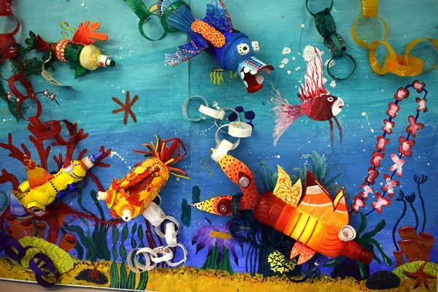
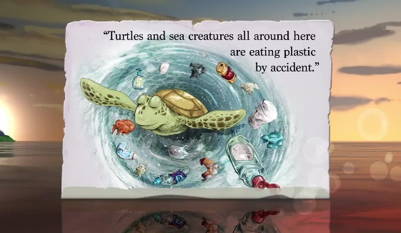


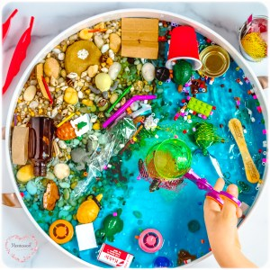


Tuesday
9am
Please visit Miss Lizell’s you tube channel for access to the morning wake up PE session which is at 9am everyday.
https://www.youtube.com/channel/UCo1Ce6-TzdWlBNvvJEF1K5w
9.30am
Maths – log onto the live lesson
11am
English – log onto the live lesson
1pm
Global Learning – log onto the live lesson
1.45pm
Collective Worship – log onto live lesson
2.15pm
Parents drop-in
For your parents to ask us any questions that they may have. They will need to use your log in details to access teams.

Extra lesson
This lesson is not live and to be completed in your own time.
Watch this video about Guru Nanak
https://www.bbc.co.uk/bitesize/topics/zsjpyrd/articles/zr86cqt
Who is Guru Nanak? Why is he important? Find out as much as you can about Guru Nanak. Create a poster or a powerpoint telling me all about Guru Nanak and his importance to the Sikh religion.

Wednesday
9am
Please visit Miss Lizell’s you tube channel for access to the morning wake up PE session which is at 9am everyday.
https://www.youtube.com/channel/UCo1Ce6-TzdWlBNvvJEF1K5w
9.30am
Maths – log onto the live lesson
11am
English – log onto the live lesson
1pm
Science – log onto the live lesson

Extra lesson
This lesson is not live and to be completed in your own time.
Continue with your plastic art based task set on Monday.

Thursday
9am
Please visit Miss Lizell’s you tube channel for access to the morning wake up PE session which is at 9am everyday.
https://www.youtube.com/channel/UCo1Ce6-TzdWlBNvvJEF1K5w
9.30am
Maths – log onto the live lesson
11am
English – log onto the live lesson
1pm
PE with Lizell – log onto the live lesson
1.45pm
Collective Worship – log onto live lesson
2.15pm
Parents drop-in
For your parents to ask us any questions that they may have. They will need to use your log in details to access teams.

Extra lesson
This lesson is not live and to be completed in your own time.
Spelling
Words ending in –able and –ible
The – able ending is used if there is a related word ending in –ation.

Adorable (adoration), applicable (application), Considerable (consideration), tolerable (toleration)

forcible, legible

In your Handwriting books try the following activities to practise your spellings
- Hidden Words – draw and colour a picture. Hide your spelling words inside the picture. See if someone can find your hidden words.
- Choo Choo Words – write your whole list of spelling words end-to-end as one whole word. Write each new word in a different colour.

Friday
9am
Please visit Miss Lizell’s you tube channel for access to the morning wake up PE session which is at 9am everyday.
https://www.youtube.com/channel/UCo1Ce6-TzdWlBNvvJEF1K5w
9.30am
Maths – log onto the live lesson
11am
English – log onto the live lesson

Collective Worship – A link will be added onto teams so that you can watch the assembly at whatever time during the day suits you best.

Extra lesson
This lesson is not live and to be completed in your own time.
Friday 5th February
Here at Buckden we have written our own Buckden School Curriculum and we have incorporated the 8 skills identified by Skills Builder into our lessons. In order to help reduce the amount of screen time, each Friday we would like you to choose 1 of the three challenges to do on a Friday afternoon (or at a convenient time) to practise your skills. The skills challenges will be the same across the school so that for families with more than one child in school there is the opportunity to do the challenge together.
If appropriate upload a photograph for your teacher to see and answer the reflection questions at the level you feel you are, this will change for different skills.
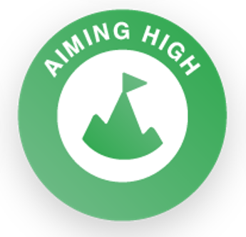 | What are your goals for 2021? Talk or write about 3 things you would like to do or to achieve this year. Try to make sure they are a challenge but achievable!  Reflection Questions  Beginner: How do you know if something is too difficult for you?  Intermediate: Why is it important to be willing to take on new challenges?  Advanced: What resources might you need to achieve your goals?  Expert: What steps do you need to put in place to make your goals happen?
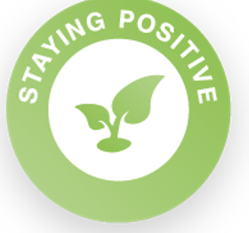 | Close your eyes and think of a place that makes you feel calm and happy. Find a photo, draw or paint a picture of this place. Tell others in your home about your happy place. Ask them where their happy place would be.  Reflection Questions  Beginner: How could this exercise be used to calm you down if something went wrong?  Intermediate: How could you use this to cheer other people up when something goes wrong?  Advanced: How could this help you to look on the bright side of something?  Expert: How can you manage your emotional response to best support others?
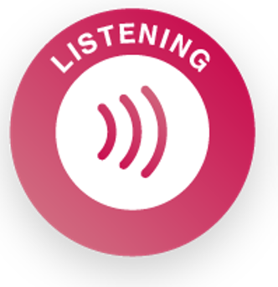 | Listen to an audio book or a podcast.  Write a review or talk to a family member all about it. Would you recommend it? What was the best part of it?  Reflection Questions  Beginner: Why do we listen?  Intermediate: Do you have any good ways to help maintain concentration when listening?  Advanced: What is the value of rephrasing what you have heard?  Expert: How can changes in language affect how you feel about something?

Maths games
https://play.ttrockstars.com/auth/school/student/76329
https://www.topmarks.co.uk/maths-games/7-11-years/times-tables
https://www.timestables.co.uk/

Activities that could be used to help you learn your spellings
In your handwriting books try the following spelling activities:
- Choo Choo Words – write your whole list of spelling words end-to-end as one whole word. Write each new word in a different colour.
- UPPER and lower – write your words once with all uppercase letters and one time with all lowercase letters.
- Rainbow Write – first, write the words in pencil. Then trace over them in two different colours.
- Other Handed – first, write your words in the way you usually do. Then, write the list using your other hand.
- Magazine Words – Use an old magazine or newspaper and find your words or letters that make up words. Glue them down.
- Hidden Words – draw and colour a picture. Hide your spelling words inside the picture. See if someone can find your hidden words.
Reading
Keep reading! Remember to read EVERYDAY.

The Accelerated Reader (AR) programme is also accessible from home during this time too, so once you’ve finished your books make sure you log on and take a quiz.
https://ukhosted2.renlearn.co.uk/2152328/

Mind Up
https://mindup.org.uk/families/

Skills builder
https://www.skillsbuilder.org/homelearning

French
(Log in – Username - Buckden Password – octopus)
https://www.linguascope.com/

An Optional Extra Activity
As a school we have registered for the Young Artists' Summer show. This is an opportunity for the children to explore and create a piece/s of artwork overtime and at their own pace. The Young Artists’ Summer Show is a free, open submission exhibition for young artists aged 5 - 19 years studying in the UK and British schools overseas. To take part, students or their parents/guardians can submit artworks. These artworks are then judged by a panel of artists and arts professionals with selected artworks displayed online and on-site at the Royal Academy of Arts. https://youngartists.royalacademy.org.uk/get-involved

