Year 3 – Chapters of the book crib sheet
The chapters of the book will be uploaded for the children to read before the session. On the home learning document, it will tell the children when they need to read the chapters.
Here is how to access them:
Go to the General Channel.
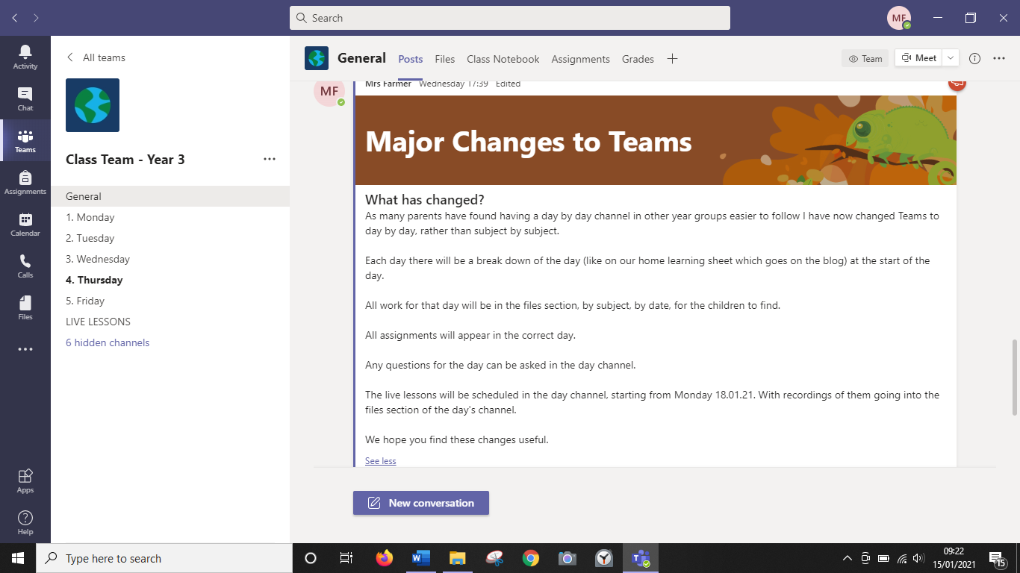
Go to files.
Then go to Why the Whales Came.

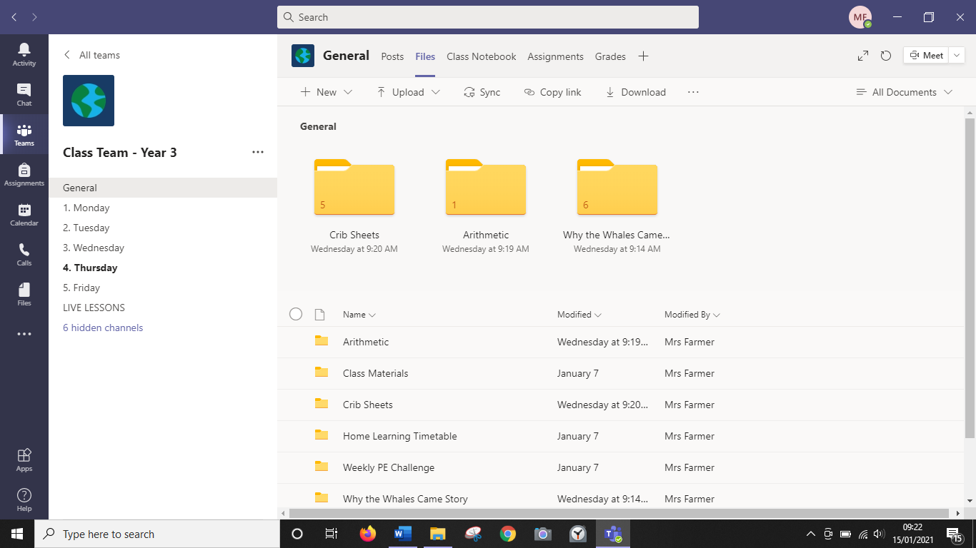
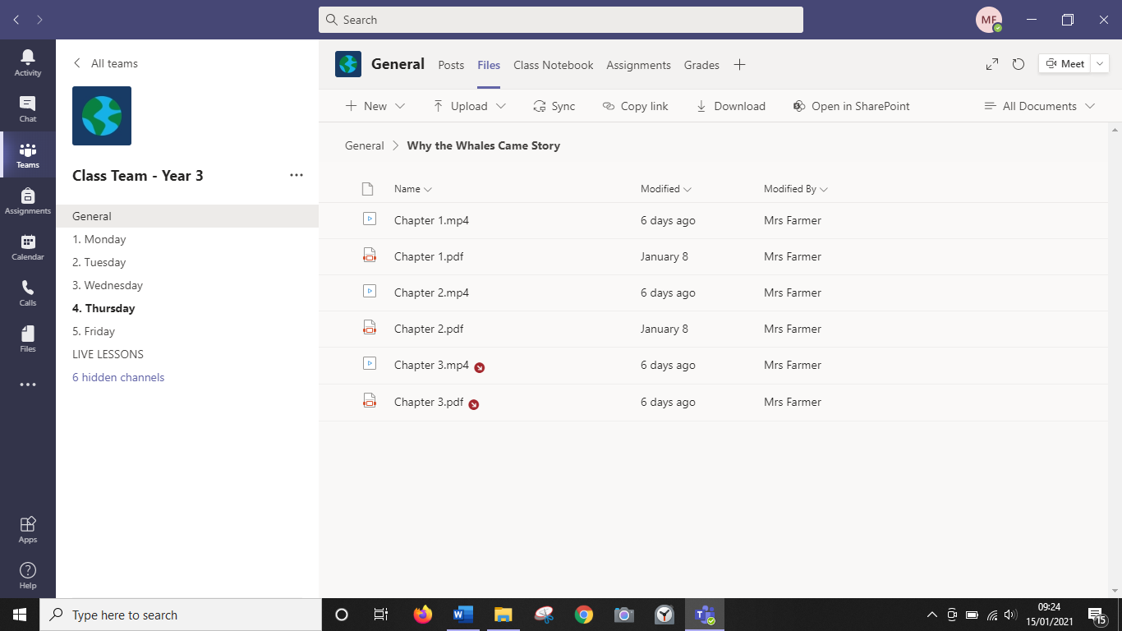
The chapters will be in here. There should be a pdf and a video. The children can either read the pdf or watch the video of me reading to them.

