How to turn off chat notifications
Click on your circle with your initials.
Go to settings.
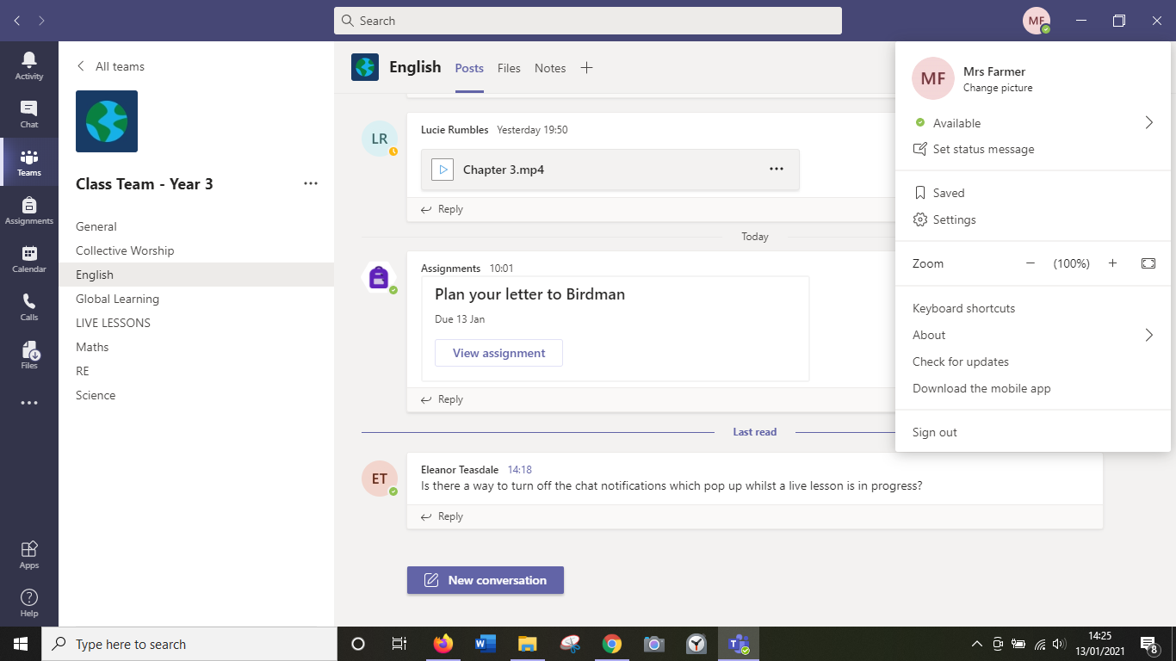
Go to notifications
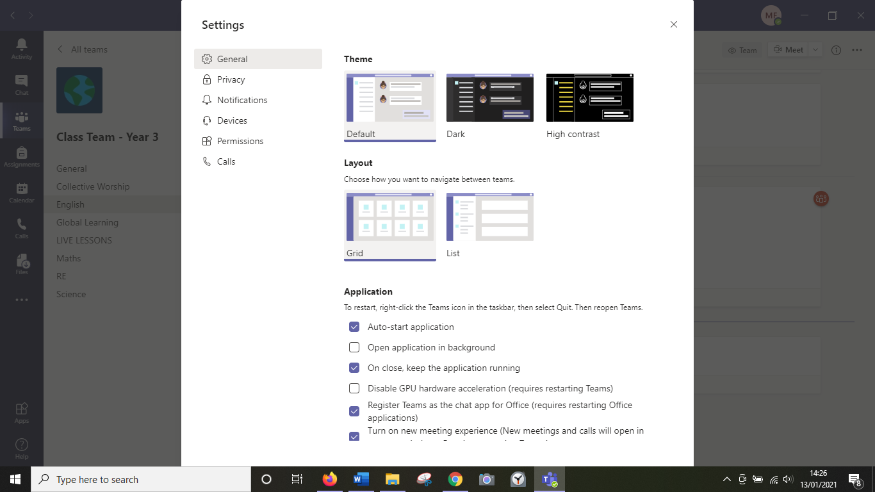
Change your preferences here.


