This week’s learning:

Collective Worship
LOGON TO MICROSOFT TEAMS AT 9:30-9:45am ON TUESDAY AND FRIDAY FOR CLASS ASSEMBLIES

Mathematics
This week we are continuing our learning about multiplication with making equal groups, multiplication as equal groups and then adding equal groups and using arrays. Then we will use what we have learnt to practise our 2, 5 and 10 times tables.

LOGON TO MICROSOFT TEAMS AT 10:00 DAILY FOR A LIVE MATHS LESSON
You can use Abacus (Power Maths) and the Whiterose website with this week’s learning objective as a focus for learning all free of charge.
Whiterose - https://whiterosemaths.com/homelearning/year-2/
Abacus - https://www.activelearnprimary.co.uk
The children have their own log in details and the school code is kmm7 in the bottom box.
On Abacus your child has been assigned the Power Maths Textbook and Workbook that we use in school
This week in school we will be working on Textbook A Unit 5 Multiplication lessons 5-8. The textbook has explanations and examples and the workbook has questions to practise multiplication skills.
Live lesson 11.1.21 Not Power Maths today but instead an arithmetic lesson - adding 2, two digit numbers
Live lesson 12.1.21 questions Textbook 2A p200 workbook 2A p146 Unit 5 lesson 5
Live lesson 13.1.21 questions Textbook 2A p204 workbook 2A p149 Unit 5 lesson 6
Live lesson 14.1.21 questions Textbook 2A p208 workbook 2A p152 Unit 5 lesson 7
Live lesson 15.1.21 questions Textbook 2A p212 workbook 2A p155 Unit 5 lesson 8

Times Table Rock Star – practise your times tables as much as you can!
https://play.ttrockstars.com/auth/school/student/76329
Other useful websites for times tables:
https://www.topmarks.co.uk/maths-games/7-11-years/times-tables
https://www.timestables.co.uk/

Revision
Number and Place Value
- To read and write numbers to 100 in words and numerals.
- To find the next multiple of 10 from a given number.
- To find 10 more and 10 less than a given number.
- To find multiples of 10 more and less than a given number.
- To practise recall of number bonds to 10 and 20 mentally i.e. 6 + 4, 5 + 5, 16 + 4, 15 + 5
- To practise recall of number facts to 10 mentally i.e. 6 = 4 + 2, 3 + 3, 5 + 1.
English
LOGON TO MICROSOFT TEAMS AT 11:30 DAILY FOR A LIVE ENGLISH LESSON
This week we will continue to read our book called The Lonely Beast by Chris Judge.
There are versions that you can listen to online here:
https://www.youtube.com/watch?v=hibEHyuYYrs
https://www.youtube.com/watch?v=UdYxM7JCFpg

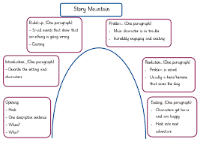
Monday Comprehension
Read the whole story. Discuss the main events and map them on a story mountain. Can you retell the story using your story mountain?

Tuesday
Re-read the underwater section of the Beast’s journey to the city from ‘He jumped in and started to swim…’ until ‘Just when he could swim no more, he hitched a lift from a friendly whale.’ Talk about the sea creatures that the Beast encounters on this leg of his journey and imagine the way in which they move in the water.
Activity: Draw on of the sea creatures and write at least four sentences to describe how it moves.
e.g. The huge whale glides through the sea like a powerful submarine.

Wednesday
• Watch Michael Rosen perform ‘ The Jellyfish’ on Poetryline https://clpe.org.uk/poetryline/poems/jellyfish-0
Can you read the poem?
Watch footage of jellyfish (http://www.youtube.com/watch?v=aJUuotjE3u8) eliciting descriptive words and phrases that come to mind: - What do they look like? - How do they move? - They remind Michael Rosen of polythene bags or that they could be waving frilly underwear. What do they remind you of? Pretend to be a jellyfish think carefully about how you are moving.
Now find some chalk, felt tip pens or paints and draw a picture to express the way the jelly fish move. Label your picture. Use words like pulse, glide, propel and shoot.

Thursday
Using yesterday’s words and phrases to describe the jellyfish underwater, write phrases about how jellyfish move on strips of paper. Put the strips together to form a poem, re-arranging the order as you read until it ‘sounds’ good.

Friday Grammar
An exclamation sentence makes a statement that conveys strong emotion or excitement
e.g. What a wonderful day!
Can you write some exclamation sentences to describe the Lonely Beast?

e.g. What sharp claws you have!

SPAG - https://www.topmarks.co.uk/english-games/7-11-years/spelling-and-grammar
- Read and spell the Year 1 Common Exception Words
- Read the Year 2 Common Exception Words
- Spell the Year 2 Common Exception Words
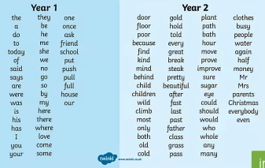
Practise a few at a time, little and often. Remember – Look, Cover, Write, Check! Make your learning as active as you can, use chalks outside, lots of colour pencils, make the words in playdough or write letters on beans and use those to spell the words.
Nessy – Reading and Spelling practise https://www.nessy.com/uk/

Phonics/Reading
Revise all phase 3 and phase 5 sounds
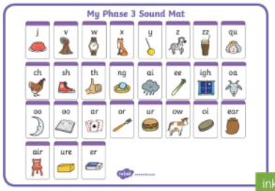 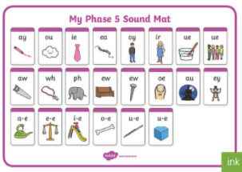
We have been looking at sound buttoning lots of ‘real’ and ‘alien’ words using these sounds, such as queek, splain, screet, scratch, train, etc. We have been spotting the digraphs and trigraphs in lots of words to help with blending and reading new and unfamiliar words correctly.
There are some apps which you may find useful to recap and practise the above sounds.
- Cambugs app (first one is free)
- Reading Eggs https://readingeggs.co.uk/ has many phonics games
Remember to read EVERYDAY.
When you read with your adult(s) at night, get them to ask you questions about the characters, the setting and the plot of the stories!
i.e. Can you describe the main character? What has just happened in the story? Where is the story set? What’s it like there? How does the character feel about what has happened? What do you think might happen next?
Here is a really useful website which offers lots of our banded books to read online, and is free to sign up! www.oxfordowl.co.uk

Global learning (Geography, History, DT, Art, R.E or P.E.)

LOGON TO MICROSOFT TEAMS AT 2:00 DAILY FOR A LIVE GLOBAL LESSON
This week we will continue our Global Learning topic: Clean Water and Sanitation.

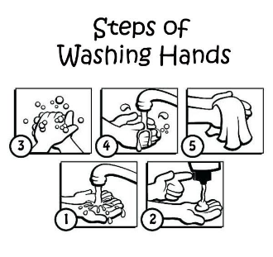
Monday Science
Why is hand hygiene so important?
Can you write some instructions to tell somebody how to wash their hands? Or Make a poster about the importance of hand hygiene.

Tuesday Geography
Using Google Earth or a map if you have one, can you locate Grafham water.
This website https://parallel.co.uk/os-openmap-cyo/#13/52.29548/-0.2474
allows you to print a map, can you find Grafham Water and colour in all water in blue.

Wednesday P.E. with Miss Lizell see link in Microsoft teams

Thursday Geography
Spend some time looking at our Geography Knowledge Organiser (attached to the Blog)
Do you know the meaning of the Key words and can you spell them.

Friday R.E.
What is a mosque like?
Can you find some pictures of mosques and research what they are like inside?

P.E. (2 hours a week)

LIZELL IS RUNNING A LIVE SESSION AT 9-9:30 EACH MORNING
THE YEAR 2 LIVE LESSON EACH WEDNESDAY (see above) WILL BE P.E. WITH LIZELL

Or you could try sessions of P.E. with Joe Wicks.
(I think he is running sessions on Mon, Wed and Fri starting 11th January)
https://www.youtube.com/c/TheBodyCoachTV/search?query=kids

Also try super movers to make sure you are keeping fit and active
https://www.bbc.co.uk/teach/supermovers/ks1-collection/zbr4scw

Mind Up https://mindup.org.uk/families/

Skills builder https://www.skillsbuilder.org/homelearning
Please take photos of any work you would like us to see and send to them to us at the year 2 email address Year2@buckdenacademy.org
or submit to your Microsoft class teams account.

