

5 oceans
Key Vocabulary
weather   | The way the air and the atmosphere feels. It includes: temperature, wind, rain, sun, snow, fog, or cloud.
climate | Like the weather, but over a long time.
local | An area near you or your neighbourhood.
Reservoir  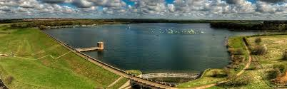 | A large lake used as a source of water supply.
rainfall | The quantity of rain falling within a given area in a given time.
field | An area of open land, planted with crops or pasture, bounded by hedges or fences.
dam | A barrier constructed to hold back water and raise its level, forming a reservoir used to generate electricity or as a water supply.
river | A large natural stream of water flowing in a channel to the sea, a lake, or another river.

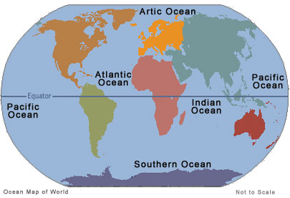

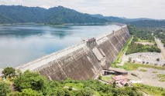
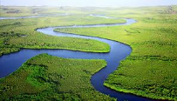
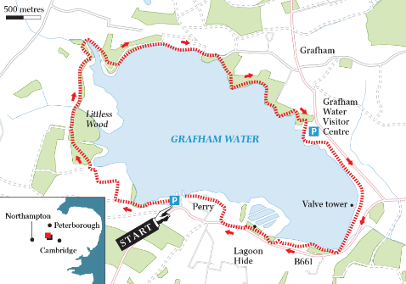
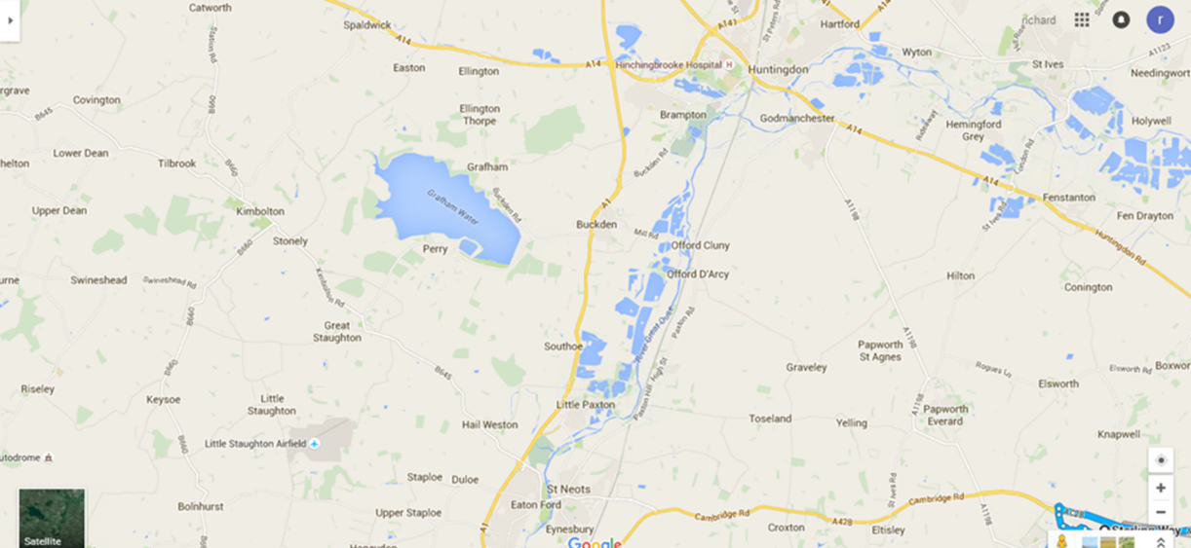
Location of Grafham Water
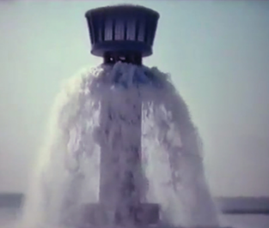
Key Information
Grafham water reservoir is located in an area of just over 6 square km in the valley of Diddington Brook.
A dam was constructed at Grafham Water in December 1964 The dam wall has a minimum thickness of 2.4m. The reservoir was built in 1965.
Water was pumped from the Great Ouse at
Offord Cluney through a huge underground
pipe into the new reservoir.
It took over a year for it to be filled.
Grafham is a site of special scientific interest (SSSI). That is because it has become a habitat for a wide range of birds, animals and insects.
When full the reservoir contains 6000 million litres of water covering two and a half square miles with a depth of 20m.

