^{13th} July 2020
Dear Kenny class,
We can see that lots of you have been having an amazing time with all the photos coming in, keeping them coming. Hopefully you will have the opportunity to watch the videos that have been put up a long with this week’s plan. There are Maths and Phonics videos to help guide you through the week. The videos won’t be long and might need to be paused at certain times while you are asked to do something. The work you produce this week can be emailed to EYFS@buckdenacademy.org.
This is a suggestion of how much learning to do over a day with a reception child. Aim for a maximum of 2 hours focused learning interspersed with play based learning and physical activity. Of course what is important is that you do what works best with your family. The work listed below is more than enough for 5 days of learning so choose the tasks that you would prefer to do.
am 30 min | Sports/ physical activity- try Boogie Beebies for a change if you like or cosmic yoga
am 20 min | Maths activity – Shapes
am 20 min | Fine Motor control activity- like lego, puzzle, drawing, writing, cutting.
10:30 | Snack time- can you help prepare it?
am 2 x 20 min | Reading/ Sharing a story/ Phonics online game- see ideas below  Focus on Phase 2,3 and 4 – Tricky words
12:30 | Lunchtime
pm 1 hour or longer if you are having fun! | An activity from the ideas below and/or independent learning through play time where your child makes choices.
Pm 20 min | Complete your journal for the day- draw and or write

Maths
Shapes-
- Look at a shape can you describe it properties?
- Guessing game, place shapes into a non see-through bag and in pairs or groups discuss the properties and guess the shape (1 person describes, one person guesses) .
- (2d) Describe the shape another person has to draw it, can they work out what they shape was from the drawing?
- Test 3d shapes according to these properties
  - Stackability
  - Roll abiltity
  - Balancing
Which was best of each category? Was there an overall winner?

Phonics- Tricky words Phase 2, 3 and 4
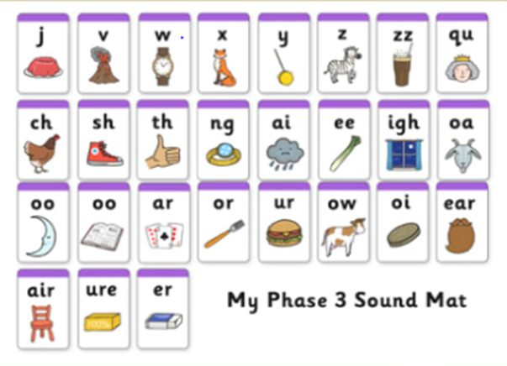
- word hunt Hide the tricky words around your house/ garden, your child needs to find them read them and put them in the keep pile
- Listen to and sing along with the Tricky word songs (WARNING: It will get stuck in your heads)
https://www.youtube.com/watch?v=TvMyssfAUx0
- Tricky word detectives – Read through your favourite story books, find the tricky word, and talk about it.
- Word builder – using letters/sounds written on Lego blocks and joined together.
- Use the words and make the silliest sentence you can.
- Use a timer, how many times can you write the words in 1 minute.
- Pirate ship game – write the words up and attach them to walls (one sound per wall) say a word and they have to run to the correct tricky word.
- Fashion 3 spaces near each other and label each with a word, kick a ball or throw an item into the box and say the sound that it corresponds to.
- Create your own phonics game.
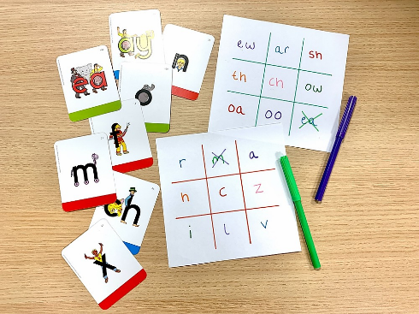
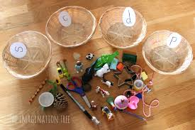
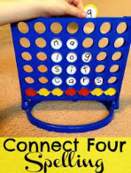

Final Week
Task 1
Buckden Enchanted forest
With permission, Mrs Fedorowicz is trying to organise an ‘enchanted walk’ at Buckden Towers. This is on the agreement that the trees will not be damaged and nothing will be used that could be harmful to nature.
The idea is to craft some simple items that could be ‘enchanted’ such as fairies, pixies, fairy doors, bunting, dream catchers, wind chimes, toadstools etc. So far, she has made fairies from lolly sticks, a mobile from cones and sticks found at the Towers and will be making dream catchers this week (which can be made from disposable plastic plates and wool). She will also be creating a ‘wishing’ area where children can write their wishes on cardboard tags and tie to a tree.
There are loads of ideas for crafting online! If you would like to create some items and take them along to the walk at Buckden Towers, that would be brilliant. Mrs Fedorowicz is planning to create a Facebook page and will share this once it is up and running. The walk starts in the far left corner of the car park and finishes at the main building.

Task 2
Art task to bring in with you in September

The whole school are being given the challenge of creating their own self portrait to bring in with them in September.
https://www.bbc.co.uk/teach/class-clips-video/how-to-draw-a-portrait/zk28qp3
This clip goes through lots of different techniques and materials you could use depending on what you have available at home.

Task 3
This week we have a special task for you. You are going to write a letter to your new teacher in year 1. It would be great if you can have this ready for your new class zoom meeting and pick one or 2 bits out of it that you might want to share.

Before you write the letter it will be useful to complete an ‘all about me’ sheet to get all of your ideas down. This doesn’t have to be written in big sections, words, phrases and bullet points if fine.

Once you have done that you can use it to write a letter to your new teacher.



