Art task to bring in with you in September

The whole school are being given the challenge of creating their own self portrait to bring in with them in September.
https://www.bbc.co.uk/teach/class-clips-video/how-to-draw-a-portrait/zk28qp3
This clip goes through lots of different techniques and materials you could use depending on what you have available at home.

Maths tasks week beginning 13th July 2020
Count forwards and backwards within 100
Count within 100, forwards and backwards, starting with any number.

Teaching guidance
Counting to and across 100, forwards and backwards, is a skill that will need to be
practised regularly throughout year 1.
Counting provides a good opportunity to link number names to numerals, and to the
position of numbers in the linear number system. Practice should include:
- reciting number names, without the support of visual representations, to allow
pupils to focus on and develop fluency in the verbal patterns
- counting with the support of visual representations and gestural patterns, for
example pupils can point to numerals on a 100 square or number line.
- starting the counting sequence with numbers other than 1 or 100

Counting backwards from 20 down to 10 requires additional focused practice, due to the irregularity of these number names. By the end of year 1, pupils must be able to count forwards and backwards, within 100, without visual aids.
Task 1
The 1st task this week is to give your child a blank 100 square (draw it in their book if you don’t have a printer) and ask them to fill it in completely independently. (we have done this before in school). This will give you a good idea on their confidence in being able to read and write all numbers to 100.
Below are some games that you can play on computers and tablets, but once your child has filled in their 100 square you can adapt some of these games and use the 100 square they have created.
There are lots of interactive games you can play on the computer or tablet. Here are some examples.
https://www.topmarks.co.uk/learning-to-count/helicopter-rescue
https://www.topmarks.co.uk/learning-to-count/paint-the-squares
https://www.ictgames.com/mobilePage/hundredHunt/
https://www.topmarks.co.uk/Flash.aspx?f=ThinkingOfANumberv3
https://www.ictgames.com/mobilePage/hundredSq/index.html
odds and even numbers http://www.sheppardsoftware.com/math/early-math/odd-even-fruit-splat-game/



Task 2
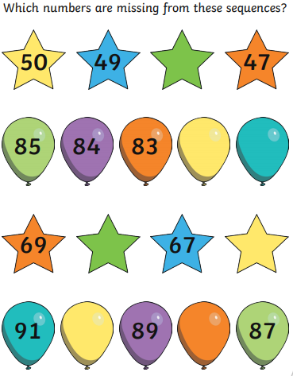
Missing numbers. This is looking at children being able to count on or back from any given number. You can create lots more of this kind of activity for the children at home.

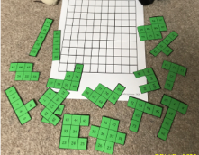
100 square jigsaw https://nrich.maths.org/5572/note (also a great website for maths investigations)
Cut up a 100 square and get the children to put it back together.

Task 3
Missing numbers but in a 100 square jigsaw format. Once they have had plenty of practice playing 100 sqaure games they should be able to use the pattrens they have discoved to work out the missing numbers. Children could also create their own missing number sections.

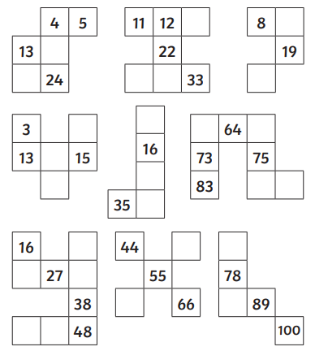

English tasks week beginning 13th July 2020
This week we have a special task for you. You are going to write a letter to your new teacher in year 2. It would be great if you can have this ready for your new class zoom meeting and pick one or 2 bits out of it that you might want to share.

Before you write the letter it will be useful to complete an ‘all about me’ sheet to get all of your ideas down. This doesn’t have to be written in big sections, words, phrases and bullet points if fine.

Once you have done that you can use it to write a letter to your new teacher.

All about me


:
My friends:
My favourite moment in year 1:


Things that I am good at

or want to improve:
My Family:

What I am looking forward to the most:

