10th July
Dear Year 2,
Hello everyone!
Next week is the final week of term and your last week of being in year 2. We are not setting formal learning with videos but below there are details of four activities for you to do this week. As a year group you have all been incredible and we are both very proud of your performance in Year 2. It has been very hard for us to not have you in school and we would have both really loved to have completed the year with you all. However, we both know you will do us proud as you move to KS2 and start your adventure in Year 3.
We are excited to see you at school for the first couple of days in September, until then have a fantastic summer and stay safe and be happy!
If you would like to you could continue your daily journals to capture what you are doing at home during this time and over the summer.
We can’t wait to see your journals when you return to school.
Mrs Jaynes and Mrs Tarpey
x
Activity one
Write a letter to your new teacher. Tell them all about yourself including your qualities, likes and enjoyments. You could include, if you have any pets, what is your favourite book and what is your favourite meal for tea?

Activity two
Draw a self portrait.
See the instructions attached

Activity three
Draw a relative that you really love, doing what they love to do.
https://www.accessart.org.uk/draw-your-granny-and-grandpa-or-any-relative-you-love/

Activity four
Buckden Enchanted forest
With permission, Mrs Fedorowicz is trying to organise an ‘enchanted walk’ at Buckden Towers. This is on the agreement that the trees will not be damaged and nothing will be used that could be harmful to nature.
The idea is to craft some simple items that could be ‘enchanted’ such as fairies, pixies, fairy doors, bunting, dream catchers, wind chimes, toadstools etc. So far, she has made fairies from lolly sticks, a mobile from cones and sticks found at the Towers and will be making dream catchers this week (which can be made from disposable plastic plates and wool). She will also be creating a ‘wishing’ area where children can write their wishes on cardboard tags and tie to a tree.
There are loads of ideas for crafting online! If you would like to create some items and take them along to the walk at Buckden Towers, that would be brilliant. Mrs Fedorowicz is planning to create a Facebook page and will share this once it is up and running. The walk starts in the far left corner of the car park and finishes at the main building.
How about making fairies out of pine cones or making a decorative stick wand.

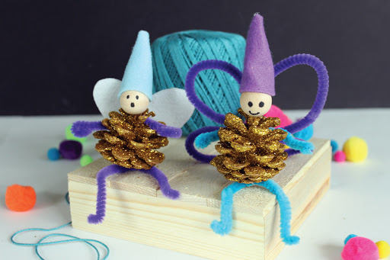

Things to get you ready for Year 3
Try to read every day over the summer
Practise telling the time, especially a quarter to and past the hour
Can you tie your tie?
Can you tie your laces?
Quickly recall your 2, 3, 5, and 10 timestables
Write a sentence every day in your best handwriting

Websites
https://www.topmarks.co.uk/maths-games/hit-the-button
https://www.timestables.co.uk/3-times-table.html
TT Rockstars https://ttrockstars.com/
Abacus https://www.activelearnprimary.co.uk/login?c=0
Nessy https://www.nessy.com/uk/
Rodocodo https://www.rodocodo.com/

