13.07.20

Well done for all you’ve done at home and we are incredibly proud of you keeping yourselves and family safe.

For the last three days I have listed some things that would be nice to do. Have an amazing summer! Take care Year 4!!! : )

English

You might want to watch the Iron Giant and compare it to our Power of Reading book The Iron Man, which it’s based on.

Write a letter to your new teacher and tell them about yourself and the things you are looking forward to in Year 5. Remember to include your favourite hobbies, your interests and your favourite subjects. This will be shared with your new teacher on your Zoom Meeting on Thursday.

Create a fact file on your favourite sports person.

Write a story, poems or letter to a friend or family member.

Design your ‘ideal’ pencil case for next year. What extras will you include?

Write some sports jokes and stick them around your house to entertain your family.

Make your own sports word search.

Mathematics

Key Mathematical areas;
Number - count in multiples of 6, 7, 9, 25 and 1000
Times tables recall multiplication and division facts for multiplication tables up to 12 × 12
Measures - Convert between different units of measure - kilometre to metre; hour to minute]
Money - estimate costs, compare costs and calculate amounts in £ and p
Time - read, write and convert time between analogue and digital 12- and 24-hour clocks
convert from hours to minutes; minutes to seconds; years to months; weeks to days.

Make sure you are practising your timestables as much as you can.
Abacus - The children can access this resource via the website https://www.activelearnprimary.co.uk
The password is year 4 and the school code kmm7 in the bottom box.
Make a map of your house and write co-ordinates for someone to find something hidden.

Have a race with members of your family and time them to see if they can beat their personal best.

Research your favourite sport and find out about it history.

DT/ART

Draw a portrait of yourself. https://www.bbc.co.uk/teach/class-clips-video/how-to-draw-a-portrait/zk28qp3 Use this video link to help you with your drawing.

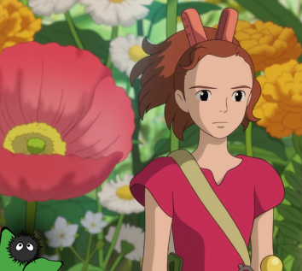
Draw cartoon of family members and friends. Here are some ideas of cartoon styles.

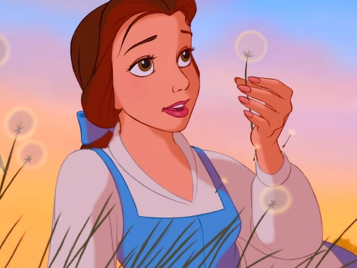


Design and make a sporting board game.

Make a bowling alley using bottles from around you house.

Make and decorate a twig tree, you could make some salt dough decorations to decorate or find natural objects.

Make the tallest tower using just newspapers and cellotape.

Make yourself a positive poster and stick it somewhere you will look everyday.
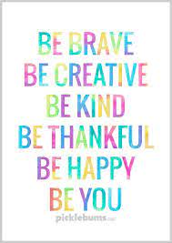

Buckden Enchanted forest
With permission, Mrs Fedorowicz is trying to organise an ‘enchanted walk’ at Buckden Towers. This is on the agreement that the trees will not be damaged and nothing will be used that could be harmful to nature.
The idea is to craft some simple items that could be ‘enchanted’ such as fairies, pixies, fairy doors, bunting, dream catchers, wind chimes, toadstools etc. So far, she has made fairies from lolly sticks, a mobile from cones and sticks found at the Towers and will be making dream catchers this week (which can be made from disposable plastic plates and wool). She will also be creating a ‘wishing’ area where children can write their wishes on cardboard tags and tie to a tree.
There are loads of ideas for crafting online! If you would like to create some items and take them along to the walk at Buckden Towers, that would be brilliant. Mrs Fedorowicz is planning to create a Facebook page and will share this once it is up and running. The walk starts in the far left corner of the car park and finishes at the main building.

Extras
- Yoga/GoNoddle/Cosmokids
- PE - Join Joe Wicks for a PE lesson. He is on YouTube every weekday.
https://www.youtube.com/watch?v=lEWcBIvqjDk
- Touchtyping - https://www.bbc.co.uk/bitesize/topics/zf2f9j6/articles/z3c6tfr
- Coding - https://scratch.mit.edu/
- Get in touch with a friend or family member
- Be mindful, do a random act of kindness for someone in your household.
- https://www.skulduggerypleasant.co.uk/books/
- https://www.anglianwater.co.uk/in-the-community/schools/learning-at-home/
- https://stories.audible.com/discovery
- French - (Log in – Username - Buckden Password – Starfish) https://www.linguascope.com/

In your journal you write:
- How you are feeling,
- What you have done (this can be any of the work you have done from the blog and anything that you have done whilst at home),
- What you have enjoyed each day.

