Hello Year 5!
This is your final week of home learning. For the last few days there are three tasks we would like to complete:
- Create a portrait of yourselves on A4 paper. Use can use any medium you wish e.g. pencils, pastels, paint, collage. You need to bring this artwork with you into school when we return in September so that we can put these in your art books. Here are some examples to inspire you:
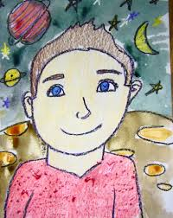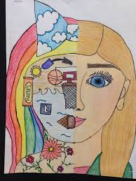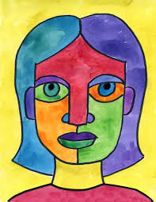
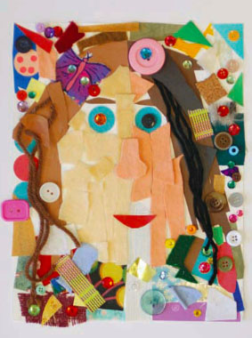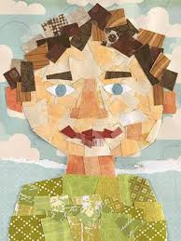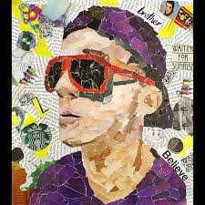

- Think of someone who you have missed during lockdown. Think about their qualities and what you like/love about them. Create a cartoon to reflect this person on A4 paper – again, using any medium you wish. Try a different medium from the one you chose in Task 1. Bring this into school with you when we return in September so they can be added to your art books.
- Write a letter to your new Year 6 teacher telling them about yourself. Ensure you include details about yourself which they will not know - especially if you have the same teacher as you had in Year 5! You need to have this letter ready to share with your teacher at your Zoom Meeting with your new class which is taking place on Thursday 16th July.

We hope you enjoy these tasks and we wish you a happy summer holiday. We look forward to seeing you all back in school in September.

Miss Fozzard, Mrs Purser and Miss Conlong

