6th July 2020
Dear Kenny class,
We can see that lots of you have been having an amazing time with all the photos coming in, keeping them coming. Hopefully you will have the opportunity to watch the videos that have been put up a long with this week’s plan. There are Maths and Phonics videos to help guide you through the week. The videos won’t be long and might need to be paused at certain times while you are asked to do something. The work you produce this week can be emailed to EYFS@buckdenacademy.org.
This is a suggestion of how much learning to do over a day with a reception child. Aim for a maximum of 2 hours focused learning interspersed with play based learning and physical activity. Of course what is important is that you do what works best with your family. The work listed below is more than enough for 5 days of learning so choose the tasks that you would prefer to do.
am 30 min | Sports/ physical activity- try Boogie Beebies for a change if you like or cosmic yoga
am 20 min | Maths activity – Capacity
am 20 min | Fine Motor control activity- like lego, puzzle, drawing, writing, cutting.
10:30 | Snack time- can you help prepare it?
am 2 x 20 min | Reading/ Sharing a story/ Phonics online game- see ideas below  Focus on Phase 3 – embed the learning ‘ear’ ‘air’ ‘ure’
12:30 | Lunchtime
pm 1 hour or longer if you are having fun! | An activity from the ideas below and/or independent learning through play time where your child makes choices.
Pm 20 min | Complete your journal for the day- draw and or write

Maths
Capacity -
- Using a container can you make it; full, empty, nearly full, nearly empty and about half full/empty. Can you find a container that holds more/less than theirs?
- Order containers based on which holds the most to the least. (could use a small container and how many of each they need until it is full) Use different shaped containers to really make them think i.e a tall thin container and a large shallow container.
- Provide a small container (like a matchbox) and give the children a competition to see how many things they can fit inside their container, could award bonus points for the smallest item, the prettiest item, the yellowest item etc.
- Using different pouring items, i.e ladel or metal spoon, wooden spoon etc, how many of each does it take to fill their container, which one was the best to use and why?
- Make their glitter jar/bottle or lava lamp – discuss the types of liquid going in and look at the capacity of the bottle/jar. Use the language mentioned in activity 1.
- Explore other ways you could fill a container, i.e sand, mud, leaves, etc.

Phonics- Recap phase 3 – make sure it is stuck in! Continue with ‘ear,’ ‘air,’ ‘ure’
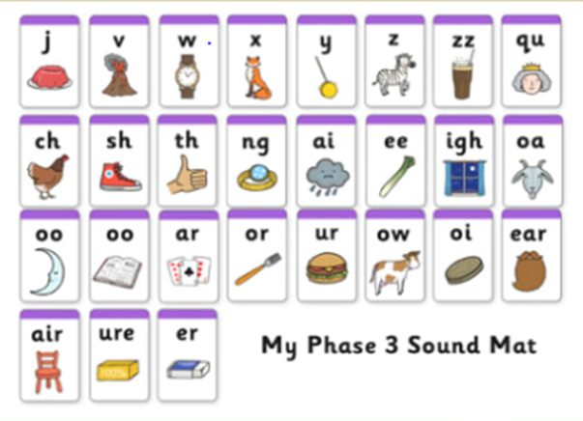
- House hunt - find objects in your house or garden, that start with the sound.
- Treasure or trash – write some words on pieces of paper, or using objects children decide whether the word starts with one of our sounds (treasure) – put these words in a ‘special box’ and if it isn’t treasure then its trash – put these words in the ‘bin.’ Alternatively, use https://www.phonicsplay.co.uk/BuriedTreasure2.html
- Sound detectives – Read through your favourite story books, find the sound, and talk about where it appears in the words.
- Word builder – using letters/sounds written on Lego blocks and joined together.
- Think of any words that have the sounds in and join together to make some silly sentences.
- Use a timer, how many times can you write the sound in 1 minute. Or repeat but writing of words containing our sounds.
- Pirate ship game – write the letters up and attach them to walls (one sound per wall) say a word and they have to run to the correct sound.
- Fashion 3 spaces near each other and label each with a sound, kick a ball or throw an item into the box and say the sound that it corresponds to.
- Create your own phonics game.
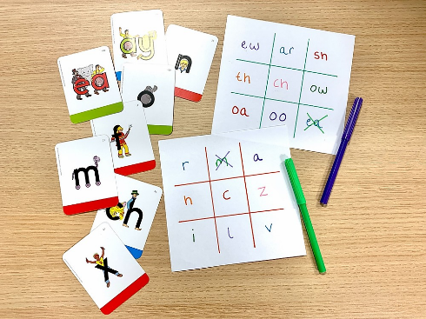
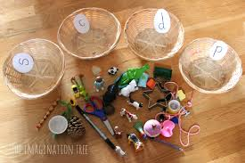
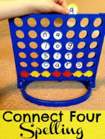

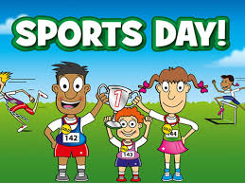

Sports

Running Races
Sack race – Children run between two objects whilst in a sack (could be a pillowcase)
Sprint race – a straight run between two points
Dress up race – Children could be in their summer PE kits (short and t shirts) and have to put on their winter PE kits over the top and maybe a hat and sunglasses.
Egg and spoon race - (hardboiled egg) – race to a second point, walk around and race back to the start. If the egg falls off they have to move off from where ever they dropped it.
Obstacle race – Children can go over, under, through different objects. Could use hurdles hoops and chairs.
Object on Head race – Bean bags and other similar items are good for this. Place an item on their head and without touching have to reach and end point, turn around and run back to the start (similar to egg and spoon race.
Shuttle run – Children have four objects laid out in front of them at equal distance away with the last object being the furthest one (objects in a straight line) children run to each object, pick it up and run back to the start to drop it off. NO THROWING!

Field Events
Throwing - Could use a bean bag or tennis ball. A safe object to throw. How far can you throw it. Can they measure the distance?
Hula Hooping – How long can you hula hoop for?
Standing Long Jump – How far can you jump with no run up?
Sergeant Jump – How high can you jump?
Backwards Throw – How far can you throw a safe throwing object behind you?
Target throwing/kicking – How many objects can you hit in 30 seconds by either throwing or kicking an object into another object.

Other Ideas
Using a variety of sport items, can you create your own game.
Remember:
Rules – Can you write them?
How to play – Must be clear
How to win – Is there 1 winner or can everyone win? How do you win? i.e direct competition or completion of game
What happens if… – i.e drop the egg in an egg and spoon race.
How many players are needed – Is it a team game (i.e football) or is it 1 on 1 (only 2 people at a time) or everyone against each other (like a sprint race)
Items List – If someone wanted else wanted to play this game what would they need?
Could you create/design/colour your own sports kit for your game? Do they need to wear any special clothes? – look at different safety equipment required in different sports and why they have them

