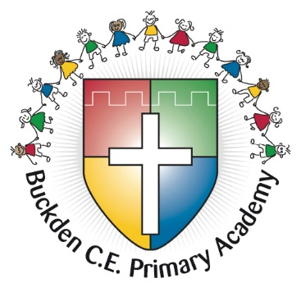

**Buckden CE Primary Modern Foreign Language**

**Subject Guidance**

Reviewed August 2025

**Whole School Curriculum Intent**

Every child is loved by God and is educated for wisdom, aspiration and global citizenship, to thrive in our community through a culture of dignity and respect. Their gifts, talents and wellness are cultivated with knowledge and skills to live life purposefully in all its fullness. In faith we ‘act’ ‘For nothing will be impossible with God’. Luke 1:37

The national curriculum for languages aims to ensure that all pupils:

* understand and respond to spoken and written language from a variety of authentic sources
* speak with increasing confidence, fluency and spontaneity, finding ways of communicating what they want to say, including through discussion and asking questions, and continually improving the accuracy of their pronunciation and intonation
* can write at varying length, for different purposes and audiences, using the variety of grammatical structures that they have learnt
* discover and develop an appreciation of a range of writing in the language studied.

Teaching and Learning

Our aim is to:

* introduce young children to another language in a way that is enjoyable and fun;
* foster an interest in learning other languages;
* stimulate and encourage children’s curiosity about language;
* encourage children to be aware that language has structure and that the structure

differs from one language to another;

* reinforce and expand their knowledge and understanding of their own language;
* help the children develop their awareness of cultural similarities and differences in other countries;
* increase their speaking and listening skills;
* develop language learning strategies that will lay the foundations for future study.

EYFS

Pupils are taught for 20 – 30 minutes a week, using their speaking and listening skills.

KS1

In KS1, pupils are taught for 30 minutes a week, either in one block lesson or a series of shorter lessons. They learn predominantly through the modalities of speaking and listening.

KS2

In KS2, pupils are taught for 45 minutes a week, either in one block lesson or a series of shorter lessons. They learn through all 4 modalities: speaking, listening, reading and writing.

In addition to the distinct subject time allocation, we have found that there are opportunities on a daily basis to reinforce language work and for children to practise their newly acquired MFL skills within the classroom and across the curriculum. For example, registration, numeracy mental warm-ups and class routines can and often are exploited to use the target foreign language.

Assessment in MFL

Assessments are made half termly. We use Insight to track learning and to inform us of the attainment and progress of pupils within MFL.

Dyslexia Friendly School

Many dyslexic children will enjoy the multi-sensory methods of language teaching which involve role play, games, singing and other group activities.

Strategies utilised include but are not limited to:

* Use of flashcards to help memorise vocabulary.
* Use of pictures, colour and shapes around words to associate a word with a visual image or colour.
* Use of colour to code grammar, e.g. different colours to distinguish between masculine and feminine nouns or to represent different parts of speech.
* To remember word order, put the words onto card, cut up the card, mix them up and practise putting them back together again.
* Use multi-sensory learning in order to remember vocabulary
* Talking tins and recording devices to record sentences.
* Making videos or creating animations in the foreign language.

Right respecting curriculum

Buckden is a Rights Respecting school and, as such, we ensure that we support and promote the wellbeing, participation, relationships and self-esteem of all pupils in MFL.

British Values

As with other areas of the curriculum the learning of a foreign language provides a valuable educational, social and cultural experience for all pupils. This links in with our British Values, particularly those values of mutual respect and tolerance of other faiths and beliefs. Learning another language raises awareness of the multilingual and multicultural world and introduces an international dimension to pupils’ learning, giving them an insight into their own culture and those of others.