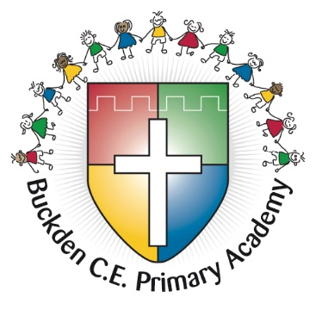

Buckden CE Primary History Subject Guidance
Intent
At Buckden CE School, we recognise the importance for our children to learn about the past in order to help them make informed decisions about the future. As they learn about History, they will learn to challenge their own thinking and to ask questions about past and present events.
At Buckden CE Primary, children are taught substantive knowledge alongside the disciplinary skills that will help them to understand and interpret the information. The learning journey, across the year groups, builds upon existing schemas so that children are able to make links both to previous learning and to the Sustainable Development Goals.
There is a focus on vocabulary alongside their definitions so children can access the information and develop their cultural capital. Visits and visitors are planned into the curriculum to give children experiences that will help them to develop their knowledge further. In Buckden, alongside a wide and diverse curriculum, there are specific links to the Sustainable Development Goals (SDGs), these help children to make connections to the wider world and also to think about the impact of history and that of their own actions upon the world.
The National Curriculum objectives are to ensure all pupils:
- know and understand the history of these islands as a coherent, chronological narrative, from the earliest times to the present day: how people’s lives have shaped this nation and how Britain has influenced and been influenced by the wider world
- know and understand significant aspects of the history of the wider world: the nature of ancient civilisations; the expansion and dissolution of empires; characteristic features of past non-European societies; achievements and follies of mankind
- gain and deploy a historically grounded understanding of abstract terms such as ‘empire’, ‘civilisation’, ‘parliament’ and ‘peasantry’
- understand historical concepts such as continuity and change, cause and consequence, similarity, difference and significance, and use them to make connections, draw contrasts, analyse trends, frame historically-valid questions and create their own structured accounts, including written narratives and analyses
- understand the methods of historical enquiry, including how evidence is used rigorously to make historical claims, and discern how and why contrasting arguments and interpretations of the past have been constructed

- gain historical perspective by placing their growing knowledge into different contexts, understanding the connections between local, regional, national and international history; between cultural, economic, military, political, religious and social history; and between short- and long-term timescales

Implementation
History is taught weekly at Buckden Primary School. The sequence of teaching allows children to build upon their existing knowledge. With the links to the SDGs, alternative year groups will have an opportunity to review their previous learning within a different era or event. For example, in Year 2, the SDG of Water Sanitation will explore the Sir Joseph Bazalgette’s impact on the Great Stink, then in Year 4 the SDG will focus on the impact of Roman innovations in Britain and finally in Year 6, the children will look at the impact of the River Nile and sanitation.

Overview
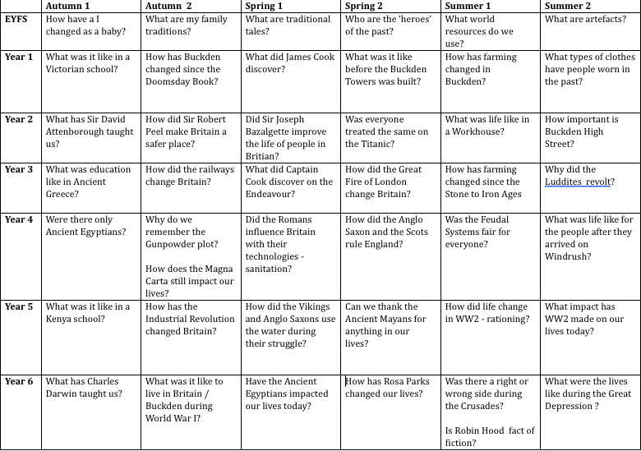

Knowledge and Skills
Pupils are taught both the substantive and disciplinary concepts during each unit. See example below.

Knowledge |  | Examples Year 4 – Roman innovations impact on Britain.
Substantive knowledge | Names, dates, places and events. | Who were the Romans?  When did they invade Britain?  Where did they settle in Britain?
Substantive (1st order) concepts | Civilisation, parliament, empire, monarchy, sovereignty, democracy, society, revolution, religion | Civilisation  Empire  Cultural Capital – arts, innovations.
Disciplinary (2nd order) concepts – to build on understanding | - Chronology - sequences  - Consequences and cause – how and why  - Change and continuity – changes and growth overtime  - Similarity and difference – identify changes and similarities  - Historical significance – long lasting impact | 1) Timeline of key events.  2) Why did they invade Britain?  2) Did the native Britain welcome or resist the Romans?  3) How did Romans’ innovation impact Britain?  4) Not applied in this unit.  5) What are the Roman’s impact on our lives today?
Disciplinary / historical skills | - Historical enquiry – to identify, investigate and ask questions  - Using evidence – evaluate a range of historical sources  - Communicating about the past – present, organise and communicate knowledge using historical vocabulary. | To think about the reasons why the Romans invaded and about the response from Boudicca.  To read historical notes, look at artwork and photographs of Roman sites.  Class discussion, learning partner and small group work.

Knowledge Organisers and Notes
Before each topic is taught, pupils are given a Knowledge Organiser (KO) to review. This KO will give pupils an understanding of what will be taught in this topic and will also act as a reference point and learning aid for children to refer to throughout the topic.
At the start of each lesson, a Knowledge Note is given out and this details the key points of the particular lesson. It is preceded by a disciplinary concept question, which will be answered during the lesson.

Communication
Throughout their learning, pupils are encouraged to discuss their ideas and thinking so they have an opportunity to solidify their learning or to sound out their ideas. This is down through class discussions, learning partners or small group work.

Independent work
Pupils are able to show their understanding through the work in their books. These are a mixture of mind- mapping, labelling and more in-depth writing opportunities.

SEN
Pupils with SEN needs are scaffolding with addition adult assistance, resources and the Knowledge Notes. Pupils are encouraged to verbalise their understanding with their learning partners and adults are able to scribe for them if necessary.

British Values
Children are taught about the development and importance of the rule of law, democratic leadership and individual liberty in History. They are also taught of the importance of tolerance and mutual respect through learning about time periods and cultures when these were not in evidence.

Dyslexic Friendly School
We recognise that some pupils, despite intellectual and other abilities, have unexpected difficulty learning to read and/or to spell and write fluently. These pupils may be described as having dyslexia. We recognise that some of these pupils have special educational needs; that these needs have to be met to the best of our ability and resources; and that these pupils have the same right of access to the maths curriculum and to all the activities of the school as all other pupils.

Assessment
After a unit of work, pupils are assessed by a short quiz as a formal assessment. This consists of a number of questions that will help them to recap their learning. If there are gaps in their learning, teachers provide support where necessary. There will also be more formative assessment throughout their learning and their discussions, ideas and participation will also be considered in their assessment.

Impact
Our History Curriculum is high quality, well thought out and is planned to demonstrate progression. Each topic covered will ensure children know more, remember more and understand more about our history and our world today.
The work in the History books, reveal the children’s learning and their understanding of their work. It shows the progress they are making throughout their year groups and provides them with a great resource for recapping their knowledge.

