Talking to Children about Relationships

Support and information for primary school families
In school we aim to help children to learn to respect themselves and others and move safely and confidently from childhood, through adolescence, into adulthood. We deliver much of this work through Relationships and Health Education, which are statutory parts of the broader subject, PSHE. As part of our programme we provide Relationships and Sex Education (RSE). This programme begins as soon as children arrive in school and continues until the end of secondary school. There is more information on our programme in this leaflet.
We are very aware that the RSE we deliver in school is only a small part of children’s learning about their bodies, keeping safe, emotions, relationships, sexual behaviour, sexuality, sexual health and themselves. The majority of children’s learning in this area takes place with you at home.
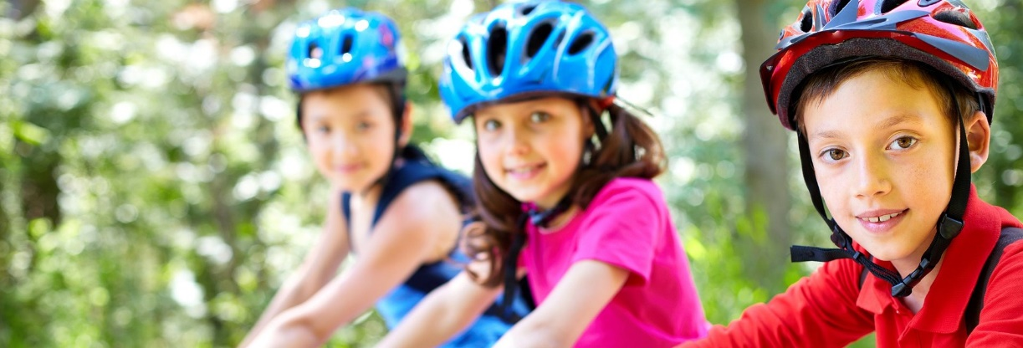
We hope this leaflet gives you some more information about our partnership in developing children’s knowledge, skills and attitudes relating to RSE.

Why should parents/carers talk to their children about relationships, bodies and sex?
- Children tell us they want their parents/carers to be the first ones to talk to them about puberty, sex and relationships.
- If families start talking to their children about bodies, puberty, sex and relationships, they are less likely to get ideas that worry or confuse them and they learn that it’s alright to talk about these things at home and to ask for help if they need it.
- Children learn most about values and relationships from family experiences. Close, loving relationships are the best way of showing a young person how your family ‘does things’ based on your values, culture, faith and beliefs.
If families talk about relationships, bodies and sex openly and honestly, young people as they get older are:
- more likely to be able to keep themselves safe from abuse and report it
- more prepared for puberty and the changes they will experience
- more likely to delay having sex for the first time
- more likely to avoid non-consensual or unwanted sexual activity
- more likely to use contraception if they do have sex
- less likely to have an unplanned pregnancy or to get a sexually transmitted infection.

How can I talk to my child about sex and relationships?
- Read a book, leaflet or watch a video with your child.
- Talk while you’re doing something else like washing up or driving.
- Enjoy talking. Laugh with each other, not at each other – it can reduce embarrassment and stress.
- Listen rather than judge. Ask them what they think.
- Answer questions and don’t be afraid to say you don’t know.
- Have a phrase ready for awkward moments – ‘That’s a good question. Let’s talk about it when we get home.’
- Always respond – don’t change the subject. Give the message it’s important to talk about sex and relationships.
- If it feels too personal, talk about people in books, films or soaps.
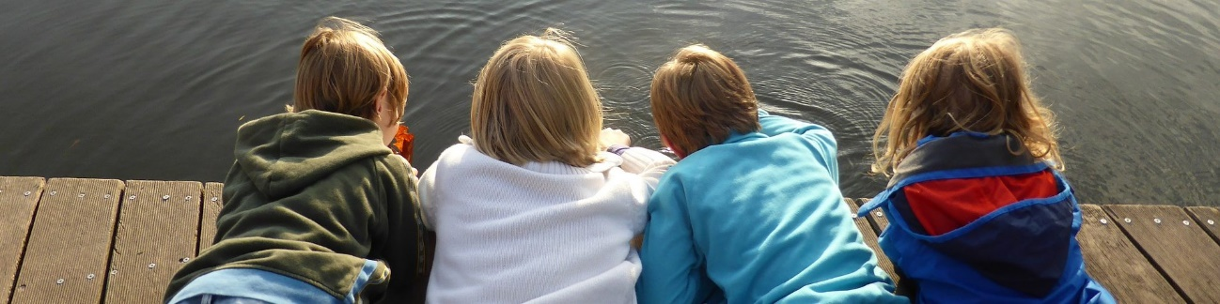

What do children and young people think?
Children and young people want to talk to their parents/carers about sex and relationships, but that can be daunting for a parent/carer. One group of 10-16-year-olds came up with these helpful pieces of advice for parents/carers:
- Take responsibility for talking to us. Don’t just wait for us to ask.
- If we ask you things, always tell the truth. Don’t put if off or say ‘I’ll tell you when you’re older’.
- Don’t be angry and try not to be embarrassed.
- Don’t save it all up for a one-off ‘birds and bees’ lecture. We’d rather you talked naturally, little and often.
- Wait until we’re at home and on our own together to avoid embarrassment.
- Make sure we know what you’re talking about and let us ask you questions.
- If we ask what a word means, ask us what we think the word means first.
- Don’t laugh at us or spread gossip about what we have been talking about.
- If you don’t know something, be honest and say that you don’t know.
- Give us books or leaflets, but talk to us too.
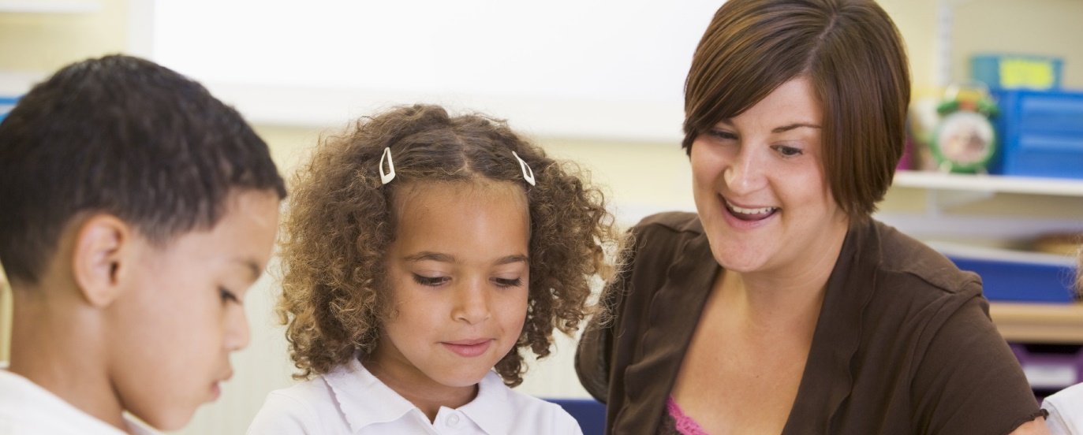
- Don’t expect school to tell us everything – we want to hear from our parents/carers as well.

What do children learn in RSE in school?
 | Questions children will consider | Content Areas
Age 3-5 (EYFS) | - What does my body look like?  - How has my body changed as it has grown?  - What can my body do?  - What differences and similarities are there between our bodies?  - How can I look after my body and keep it clean?  - How am I learning to take care of myself and what do I still need help with?  - Who are the members of my family and trusted people who look after me?  - How do I feel about growing up?  - How can I be a good friend?  - Can I recognise and show my emotions? | - Valuing the body  - Body parts  - My teeth  - Shapes and sizes  - Self-care skills  - Change and responsibilities  - Identifying and managing emotions
Age 5-7 (Y1/2) | - What are the names of the main parts of the body? (R)  - What can my amazing body do?  - When am I in charge of my actions and my body? (R)  - How can I keep my body clean? (H)  - How can I avoid spreading common illnesses and diseases? (H)  - How do babies change and grow? (Science)  - How have I changed since I was a baby? (Science)  - What’s growing in that bump? (Science)  - What do babies and children need from their families? (R)  - Which stable, caring relationships are at the heart of families I know? (R)  - What are my responsibilities now I’m growing up? (H) | - External parts of the body  - Valuing the body  - Personal hygiene  - Babies to children to adults  - Growing up  - Changing responsibilities
Age 7-9 (Y3/4) | - How are male and female bodies different and what are the different parts called? (R)  - When do we talk about our bodies, how they change, and who do we talk to? (R)  - What can my body do and how is it special?  - Why is it important to keep myself clean? (H)  - What can I do for myself to stay clean and how will this change in the future? (H)  - How do different illnesses and diseases spread and what can I do to prevent this? (H)  - What are the main stages of the human life cycle? (Science)  - How did I begin? (Sex Ed)  - What does it mean to be ‘grown up’? (H)  - What am I responsible for now and how will this change? (H)  - How do different caring, stable, adult relationships create a secure environment for children to grow up? (R) | - Difference between males and females  - Valuing the body  - Responsibilities for hygiene  - Stages of human life  - Sperm+egg=baby  - Being grown up  - My responsibilities  - Parents/carers’ responsibilities
Age 9-11 (Y5/6) | - What are male and female sexual parts called and what are their functions? (R)  - How can I talk about bodies confidently and appropriately? (R)  - What happens to different bodies at puberty? (H)  - What might influence my view of my body?  - How can I keep my growing and changing body clean? (H)  - How can I reduce the spread of viruses and bacteria? (H)  - What are different ways babies are conceived and born? (Sex Ed)  - What effect might puberty have on people’s feelings and emotions? (H)  - How can my words or actions affect how others feel, and what are my responsibilities? (H)  - What should adults think about before they have children? (R)  - Why might people get married or become civil partners? (R)  - What are different families like? (R) | - Names of sexual parts  - Puberty  - Menstruation  - Body image  - Changing hygiene routines  - Viruses and bacteria  - Human lifecycle  - Human sexual reproduction  - Changing emotions  - Responsibility for others  - Love, marriage and families
- (R) after a question shows that this is part of statutory Relationships Education. (H) shows the question is part of statutory Health Education.

What can I say to my child?
Get ideas about what to say from a book like ‘Questions Children Ask’ by Miriam Stoppard, or ‘Let’s Talk about Where Babies Come From’ by Robie Harris.

For more information
The programme above sets out the questions children will consider during this topic. If you would like to know more about the structure of the lessons or the resources we use, please get in touch through the school office. Parents/carers have the right to withdraw their children from the parts marked as ‘Sex Education’ which cover how a baby is made and how a baby is born. If you’d like more information about how to withdraw your child, please make an appointment with the school office.
To read the government guidance for Primary parents on RSE follow this link assets.publishing.service.gov.uk/government/uploads/system/uploads/attachment_data/file/812593/RSE_primary_schools_guide_for_parents.pdf

Useful contacts
For information on talking about RSE to your children, try
www.bigtalkeducation.co.uk/parents/how-to-talk-about-sex/
www.nspcc.org.uk/preventing-abuse/keeping-children-safe/healthy-sexual-behaviour-children-young-people/
For a short film to introduce importance of privacy and not taking or sharing sensitive images search for ‘NSPCC Share Aware’.

